Writing Persuasive Sentences using Conjunctions (30.03.20)
Look at the arguments which are either for or against cancelling break time at school. What do you think? Can you join any 2 statements using a conjunction to form an argument? Eg.
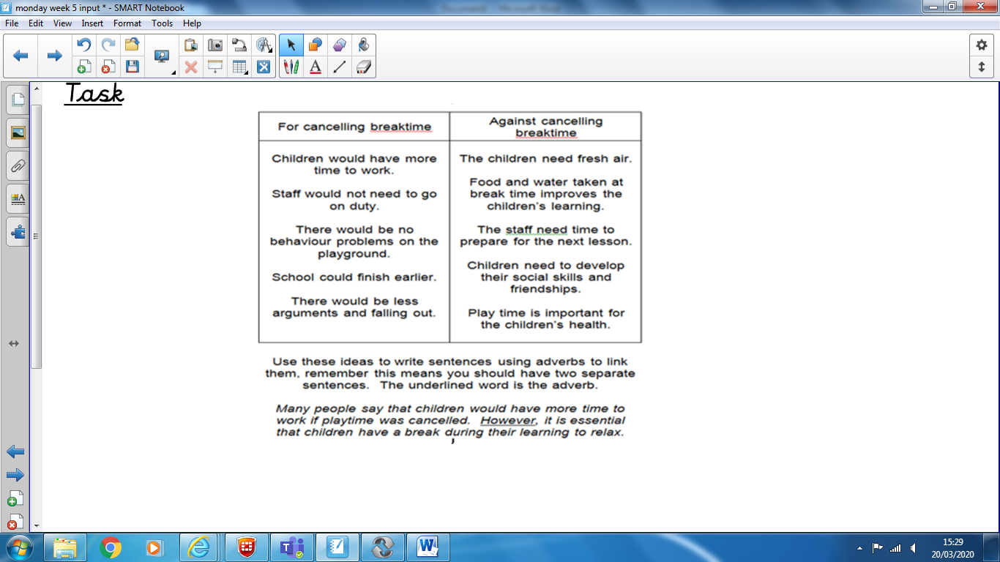
Children would have more time to work however staff need time to prepare for the next lesson.
Some Useful Conjunctions
However as well as
Also so
Because as a result of

