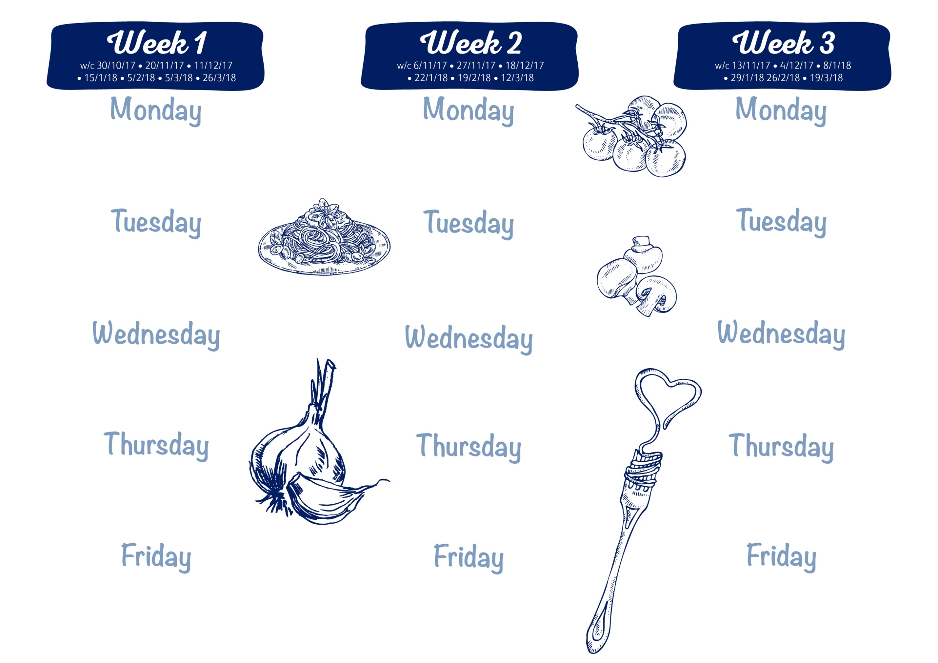
Chicken Curry, Naan Bread
Vegetable Fingers or Quorn Nuggets (v)
Jacket Potato/ Sandwich
50:50 Rice, Seasonal Vegetables
Mini Doughnuts, Yoghurt Dip
Beef Burger & Gravy
Sweet Potato Fishcake
Jacket Potato/ Sandwich
Duchess Potatoes; Seasonal Vegetables
Cheese & Crackers/ Fruit Yoghurt

Chicken with BBQ Sauce and cheddar
Sausage Roll (v)
Jacket Potato/ Sandwich
Potato Rosti/Waffle; Seasonal Vegetables
Cook’s Cookie of the Day

Chicken/Steak Pie
Cheese (v) or Tuna Melt Panini
Jacket Potato/ Sandwich
Mashed Potato; Seasonal Vegetables
Sticky Toffee Pudding, Toffee custard

Roasted Pork Loin & Gravy
Tomato & Basil Spaghetti (v)
Jacket Potato/ Sandwich
Roast Potatoes; Seasonal Vegetables
Fruit Jelly

Pork Meatballs & Gravy
Cheddar Cheese & Onion Quiche (v)
Jacket Potato/ Sandwich
Mashed Potato; Seasonal Vegetables
Chocolate Surprise Cake

Breaded Chicken Bites
Quorn & Vegetable Curry (v)
Jacket Potato/ Sandwich
50:50 Rice; Herby Diced Potatoes
Vanilla Raspberry Ripple Ice Cream

Roast Chicken, stuffing & Gravy
Veg & Potato Puff Pastry Pie (v)
Jacket Potato/ Sandwich
Roast Potatoes; Seasonal Vegetables
Home-made Gingerbread biscuit
Cottage Pie
Cheese & Tomato Pasta Bake (v)
Jacket Potato/ Sandwich
Seasonal Vegetables
Cook’s Fruit Crumble & custard
Battered Fish
Home-made pizza (v)
Sandwich or Wrap
Chips; Peas; Sweetcorn
Fresh fruit salad & Ice Cream
Battered Fish
Home-made pizza (v)
Sandwich or Wrap
Chips; Peas; Sweetcorn
Vanilla Ice Cream
Battered Fish
Home-made pizza (v)
Sandwich or Wrap
Chips; Peas; Sweetcorn
Fresh fruit salad & Ice Cream
Spaghetti Bolognese, garlic bread
Quorn burger on a bun (v)
Jacket Potato/ Sandwich
Seasonal Vegetables
Blueberry Cake

W/C: 29/10/18; 19/11/18; 10/12/18; 14/1/19; 4/2/19; 4/3/19; 25/3/19.

Roast Beef, Yorkshire Pudding, Gravy
Macaroni Cheese (v)
Jacket Potato/ Sandwich
Roast Potatoes; Seasonal Vegetables
Fruit Flapjack
Sausages & Onion Gravy
Cheese & Tomato Quesadilla (v)
Jacket Potato/ Sandwich
Mashed Potato; Seasonal Vegetables
Cook’s Fruit Muffin
Dates: 12/11/18; 3/12/18; 7/1/19; 28/1/19; 25/2/19; 18/3/19.

Dates : 5/11/18; 26/11/18; 17/12/18; 21/1/19; 11/2/19; 11/3/19; 1/4/19.

