
Garswood ‘Teams’ Guide:

Garswood will be using an online forum developed by Microsoft and GDPR compliant called Microsoft Teams to upload resources, presentations and work for children to access during school closures. Teachers and class members will also be able to engage in a fully visible conversation if needed.

To access Microsoft teams, children’s usernames will take the format of….gar-year of entry-initials and no.1 for example John Smith who attends Garswood’s Year 3 class would have the username gar-16-js1. Some children who have the same initials as another child in their class will end their username with 2 but I will email those children separately.

Passwords, initially, have been set to their date of birth. For example a child born on 27th February 2014 will have the password 27-Feb-14. The first time your child logs onto TEAMS they will be asked to change their password via the St. Helens Portal so it is personal.
(See parental letter for additional details)

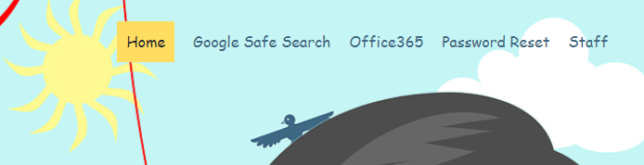
1. Microsoft teams can be found by clicking on the link https://www.sthelens.org.uk/ and clicking on ‘Office 365’ in the top right corner.
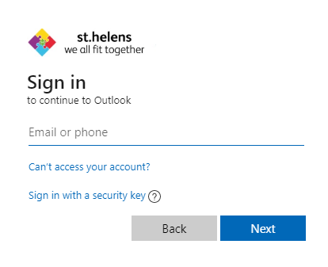
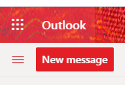
2.You will be asked to sign in using the username and password allocated to you (Please see above)
Once signed in click on the square of dots next to the word Outlook in the top right hand corner of the screen.
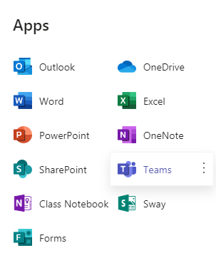
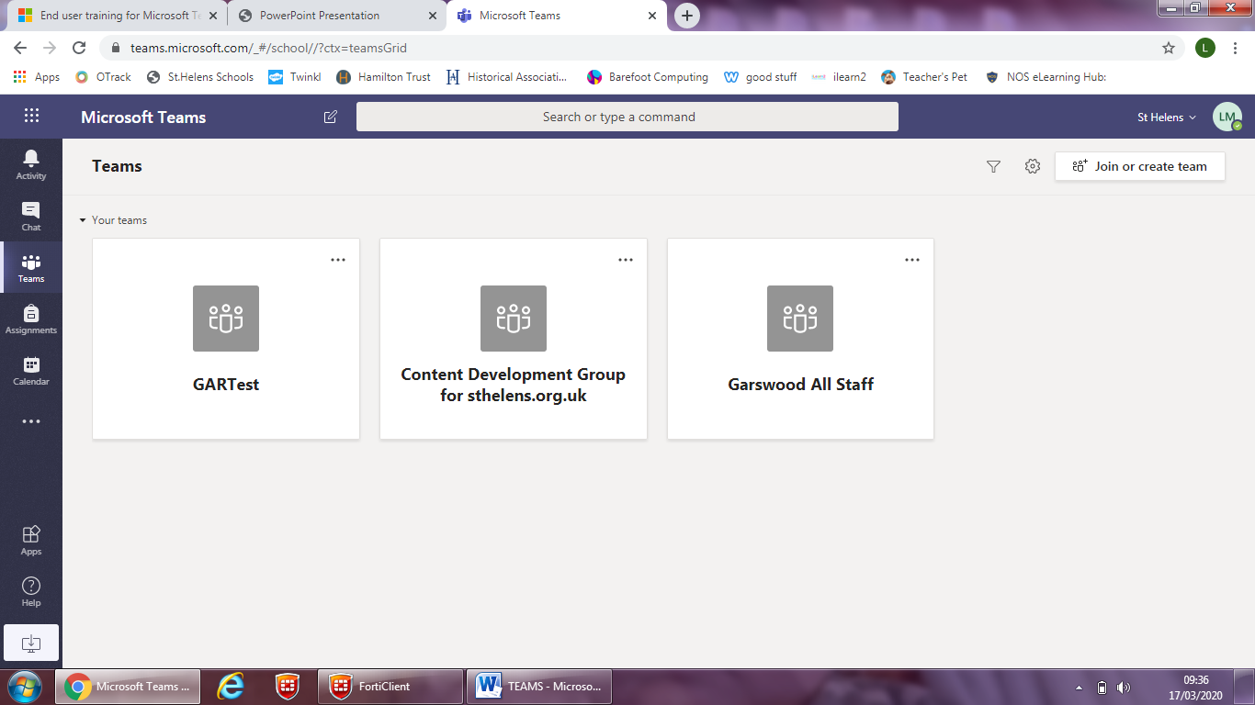
3. From the Apps menu, click on the work Teams to access. There are also free versions of Word, PowerPoint etc… to use here too.
4. Use the Teams toolbar to access your resources.
Clicking on the Teams tab it will allow you to talk to your class as a whole (visible to all) and access uploaded files and folders of work.
The chat facility will be disabled.

5. By clicking on the white icon from the bottom of the toolbar, you can download ‘Teams’ onto your desktop for easy access.
Click on this online demonstration for more information https://teamsdemo.office.com/

