


COSMIC CLUB
Contract

Quality wrap around care for children at
Overleigh St Mary’s CE Primary School

Cosmic Club/Minis

We provide quality childcare for the children of Overleigh St Mary’s CE Primary School for children age 3-11. We aim to provide nutritious and filling breakfast/afternoon snacks which will prepare your child for the school day. We are committed to providing equal opportunities for play and participation and we will ensure that your child(ren) have a happy and safe time while at Cosmic Club/Minis.

Opening Times
We are open every day of the week during term time, from 7.30 – 8.40am (breakfast is served until 8.30am) your child(ren) can be dropped off at any time between these times. Children should enter Cosmic Club in the morning via the Gym door and the Minis entrance is to the right hand side of school where there is a buzzer on a brown gate labelled minis.

The afternoon session runs from 3.20pm until 6.00pm prompt. Children can be collected at any time between these times from the school Gym. If you are late to collect your child(ren) this may result in you being withdrawn from the club with immediate effect.

Cost
The morning session costs £7 and the afternoon session £13 per session per day. The cost includes breakfast/afternoon snack and activities. The cost remains the same whatever time you arrive or collect.

Payment should be made via our online system ‘SCOPay’, through the Government Tax Free Childcare Scheme or with Childcare Vouchers.

Child Information Sheets
Please fill in the attached forms electronically with as much detail as possible. Please then send it to cosmicclub@osm.cheshire.sch.uk. The details will be held by the Cosmic Club staff.

Policies
We have a vast range of policies and procedures which you are welcome to come and have a look at any time during our opening hours.

General
- Please enter and exit the club through the Gym door or Nursery entrance. Please note that on a Friday, Cosmic and Cosmic Minis are all based in the gym.
- We offer a range of activities including a homework area, reading area, craft corner and outside play; weather permitting.
- We offer a range of Breakfast cereals with semi-skimmed milk or oat milk. Toast with dairy free margarine with or without jam, yoghurts, malt loaf and fruit in the morning and have a range of snacks on offer in the afternoons. If you would like to see our menu it is on the next page of this contract and also you can visit the schools Instagram page: @overleighschool or our section of the website.
- Children in Foundation stage, year 1 and year 2 will be escorted between the club and their classroom. Children in years 3, 4, 5 & 6 will make their own way from/to their classroom.
- We are always open to new ideas and suggestions or thoughts regarding Cosmic Club as we do appreciate your feedback.

Ofsted Registration Number: 111290

Contact Details

Address: Overleigh St Mary’s C of E Primary School
Old Wrexham Road
Handbridge
Chester
CH4 7HS

Manager: Sarah Smith

Play Worker: Dawn Barber
Play Worker: Nicola Warwick
Play Worker: Karen Stevens
Play Worker: Alison Ashley

Play Worker: Tracy Corry
Play Worker: Lucy John
Play Worker: Karen Stanway
Play Worker: Sue Jenkins

Tel: 07902 290984

Please use the mobile number above during club opening times and the school number (01244 267526) at any other time.

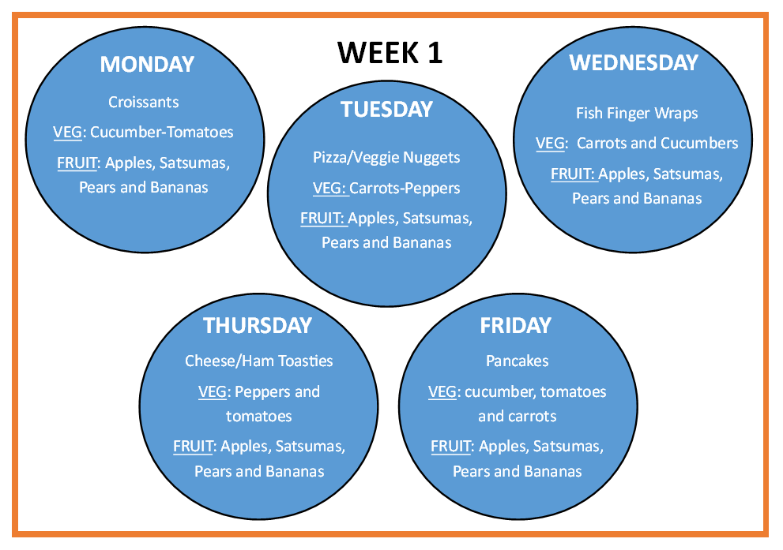
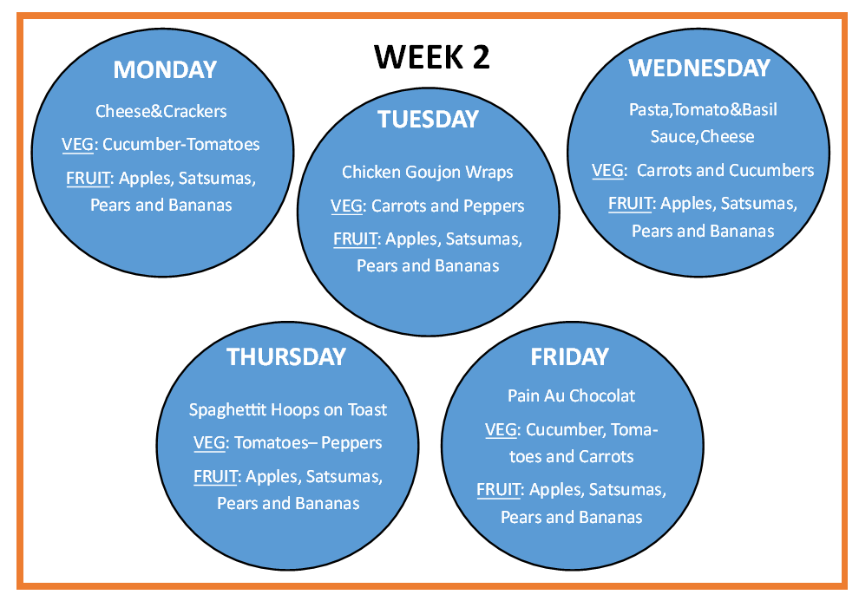
Menus may change termly and will be adapted for specific dietary requirements.

Cosmic Club Child Information Sheet

A separate form is to be completed for each child

Child

Full Name:
Preferred Name:
Home Address:

Age: |  | Date of Birth:

Parent/Carer

Full Name:
Home Address:

Phone: |  | Mobile:
Email:

Contacts in case of emergency (above will be called first)

1 | Name:
1 | Address:
1 | Telephone:

2 | Name:
2 | Address:
2 | Telephone:

Collection Arrangements:

The child named will be collected by the following adults only:

Care Information

Please give details of any allergies, illness, special needs, dietary restrictions etc

Doctor

Please give details of doctor and surgery that your child is registered with:
Surgery Name:
Address:
Telephone:

Medication

I will notify the Club Manager of any specific medication which may need to be administered to my child, and I understand that I will need to complete an additional consent form.

I agree to inform you in advance of any alterations in the above arrangements for collection my child.

Cosmic Club Emergency Consent

In an emergency, when a parent’s attendance cannot be immediate, it may be necessary to obtain treatment for a child from a doctor or the casualty department of a hospital. We would ask that you give your consent below in the unlikely event of this occurring.

Signed: (parent/guardian)
Name of Child:
Date of signature:

Booking

Bookings are to be made using the SCOpay booking System. Once your contract has been received by Cosmic Club/Minis you will be able to use the App to book any sessions available. You will be able to book sessions up to a half term in advance.

Please remember:
The cost does not change depending on the time you arrive or collect. Payment must be made in advance and cancellation must be 4 weeks notice. We accept payment through Parentmail or childcare vouchers only. We do not offer credit.

We reserve the right to refuse further bookings if the full fee is not paid in advance.

Signed: (parent/carer)
Parent/carer name:
Date of signature:

PASSWORD
We may be operating a password system when your child is collected from the club. Please ensure that any adult who has permission to collect your child is aware of the password. Please write your chosen password below.

Collection Password

