  YEAR 3  2025-2026 | AUTUMN |  |  | SPRING |  | SUMMER
 | Autumn 1 | Autumn 2 | Spring 1 |  | Spring 2 |  | Summer 1 | Summer 2
THEME | Stone Age | Iron Age | Our local area –  Edgar’s Field |  | The UK |  | Ancient Civilisations - Egypt | Egypt (Geography)
LITERACY | Narrative: Historical  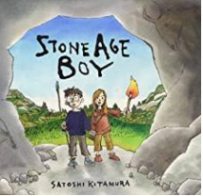  Non-Fiction: Instructions  Write a set of instructions on how to wash a woolly mammoth.  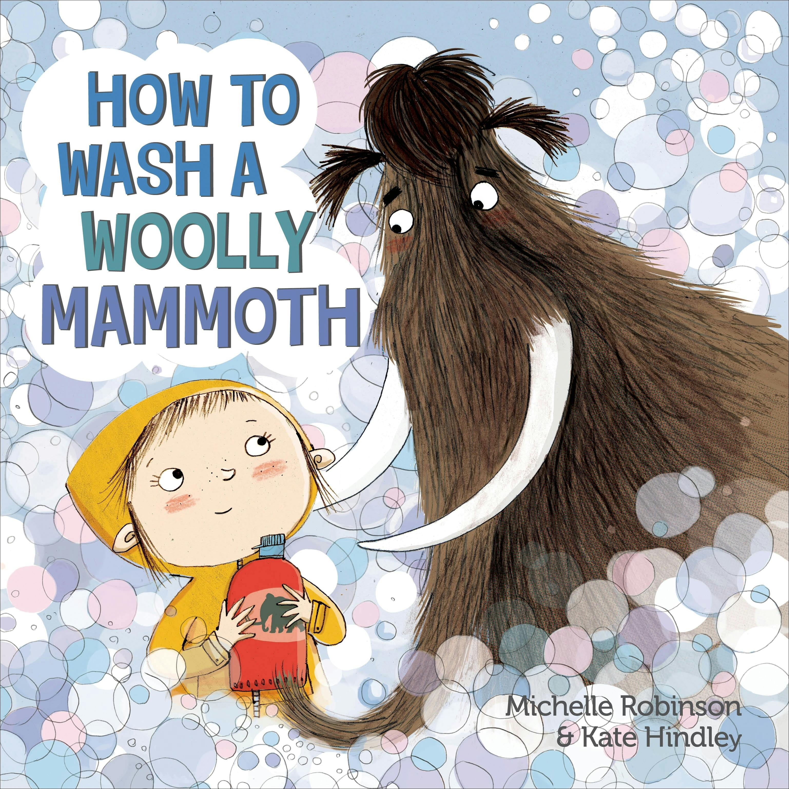  Reading  My Neolithic Diary…  Stone Girl, Bone Girl – Mary Anning  Love for reading book:  The Wild Way Home by Sophis Kirtley | Narrative: Science Fiction  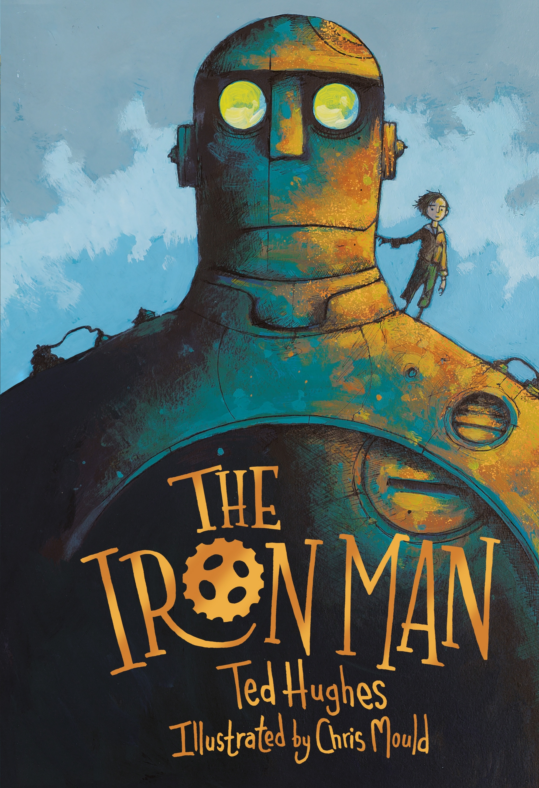  Non-Fiction: Explanation  Explain how you trap the Iron Man / dragon  Reading  The Street Beneath My Feet  The Wild Robot by Peter Brown  Love for reading book:  The Diary of a Christmas Elf  Ben Miller | Narrative: Magical  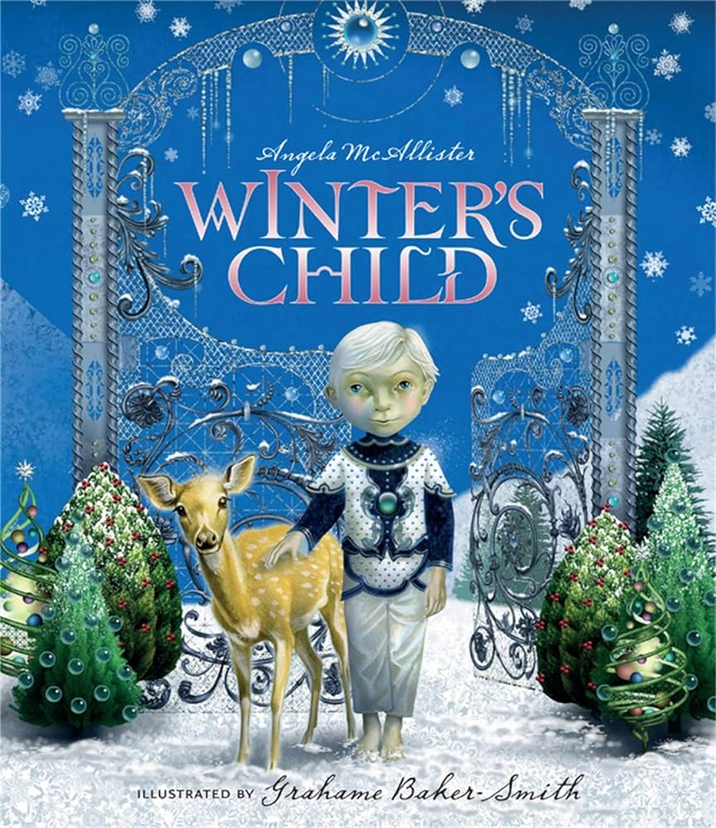  Non-Fiction: Recount  Write a diary entry from the point of view of the main character.  Reading  Ice Palace by Robert Swindles  Love for reading book:  The Abominables  Eva Ibbotson |  | Narrative: Fantasy adventure  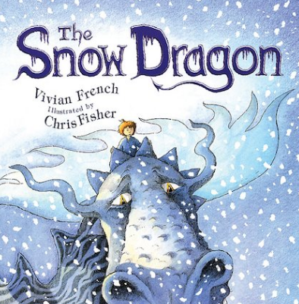  Non-Fiction: Information  Write a non-chron report about Dragons  The Dragon Atlas  By Anna Claybourne  Dragon World  By T. Macfarlane  Reading  The Boy who Grew Dragons - Andy Shepherd  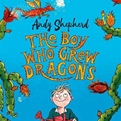  Love for reading book:  How to Train A Dragon  Cressida Cowell  Poetry  Evidence of Dragons –Pie Corbett  Dragons by Nick Toczek |  | Narrative: Historical / Traditional Tale  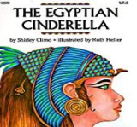  Non-fiction: Recount  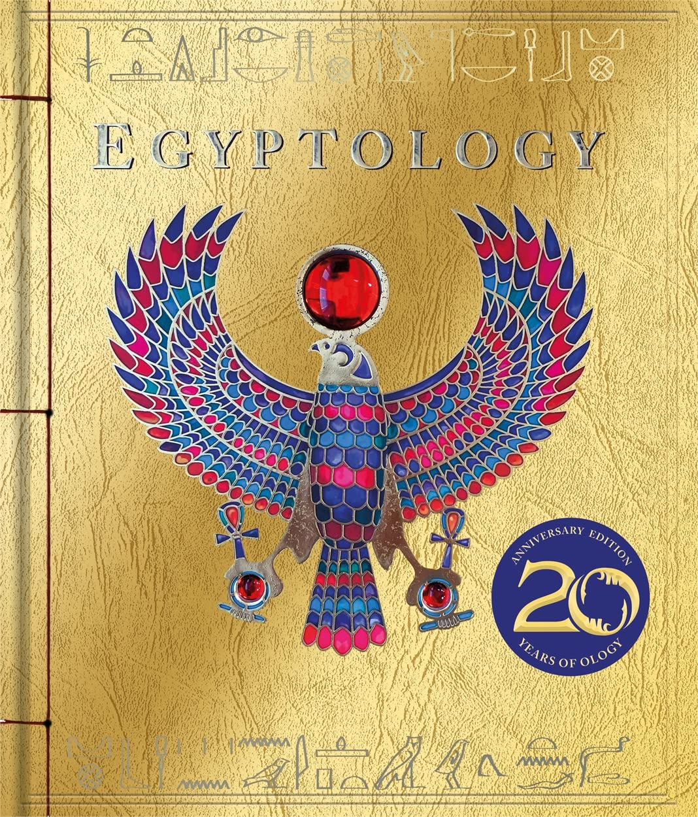  Write a journal  Reading  Marcy and the Riddle of the Sphinx  Joe Todd-Stanton  Love for reading book:  The Ancient Egypt Sleepover by Stephen Davies | 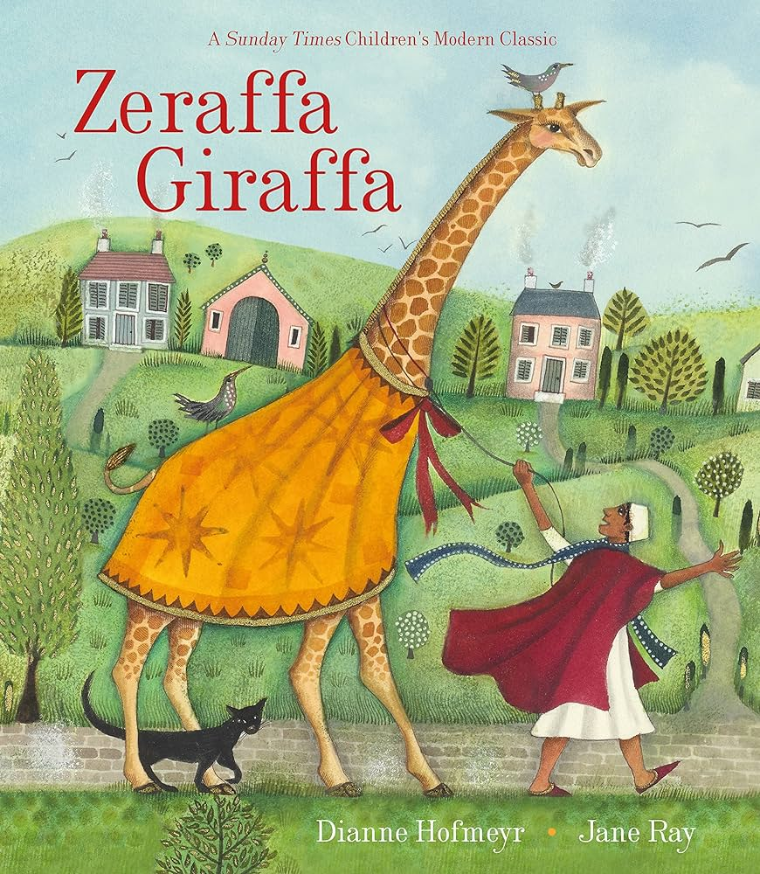  Narrative: Journey/ Adventure (from boy’s viewpoint)  Non-fiction: Persuasion  Persuasive letter to mayor to choose invention to transport the giraffe  Reading  Non-fiction about modern day Egypt (from a range of books, atlases and websites)  Love for Reading book:  Accidental Trouble Magnet Zanib Mian
MATHS | WHITE ROSE  Power Maths  Place Value within 1000  Addition and Subtraction | WHITE ROSE  Power Maths  Addition and Subtraction  Multiplication and Division | WHITE ROSE  Power Maths  Multiplication and Division  Money  Statistics |  | WHITE ROSE  Power Maths  Fractions  Length and Perimeter |  | WHITE ROSE  Power Maths  Fractions  Time  Angles and properties of shape | WHITE ROSE  Power Maths  Mass  Capacity
SCIENCE | Rocks  Compare and group together different kinds of rocks on the basis of their appearance and simple physical properties. | Fossils  Describe in simple terms how fossils are formed when things that have lived are trapped within rock.  Soils  Recognise that soils are made from rocks and organic matter. | Forces and Magnets  Compare how things move on different surfaces.  Notice that some forces need contact between two objects, but magnetic forces can act at a distance.  Observe how magnets attract or repel each other and attract some materials and not others.  Compare and group together a variety of everyday materials on the basis of whether they are attracted to a magnet, and identify some magnetic materials.  Describe magnets as having two poles.  Predict whether two magnets will attract or repel each other, depending on which poles are facing. |  | Plants  Identify and describe the functions of different parts of flowering plants: roots, stem/trunk, leaves and flowers.  Explore the requirements of plants for life and growth (air, light, water, nutrients from soil, and room to grow) and how they vary from plant to plant.  Investigate the way in which water is transported within plants.  Explore the part that flowers play in the life cycle of flowering plants, including pollination, seed formation and seed dispersal. |  | Animals including Humans  Skeletons  Identify that humans and some other animals have skeletons and muscles for support, protection and movement.  Nutrition and Diet  Identify that animals, including humans, need the right types and amount of nutrition, and that they cannot make their own food; they get nutrition from what they eat. | Light  Recognise that they need light in order to see things and that dark is the absence of light.  Notice that light is reflected from surfaces.  Recognise that light from the sun can be dangerous and that there are ways to protect their eyes.  Recognise that shadows are formed when the light from a light source is blocked by an opaque object.  Find patterns in the way that the size of shadows change.
HISTORY | Changes in Britain from the Stone Age to the Iron Age – Stone Age  Children will be introduced to the idea that people have been living in Britain for a very long time. They can learn about the changes that occurred from the three periods of the Stone Age.  To place the Stone Age within a historical timeline and understand the concept of prehistory.  To understand what life was like for early hunter gatherers  To explore how early humans made tools  To understand how life changed in the Mesolithic period  To understand the impact of farming on Stone Age life.  To explore the significance and purpose of the Stone Henge | Changes in Britain from the Stone Age to the Iron Age – Iron Age  Children will explore how early Stone Age then evolved into the Bronze Age and then the Iron Age – a period of over 10,000 years!  To understand how and why the Bronze Age began  To explore what life was like in the Bronze Age  To learn about Iron Age homes and defences  To understand roles and structure in the Iron Age  To compare life across the Stone Age, Bronze Age and Iron Age | Geography Focus |  | Geography Focus |  | Ancient civilisations -  Egypt  Children will develop an understanding of the achievements of the earliest civilizations studying Ancient Egypt in depth.  Understand what an ancient civilization is and describe key achievements of the earliest civilizations (Mesopotamia, Ancient Egypt, Indus Valley, Shang Dynasty)  Describe everyday aspects of Ancient Egyptian life, including homes, food, clothing and jobs  Explain the importance of the River Nile to Ancient Egypt  Explore Ancient Egyptian beliefs and the afterlife  Explore Ancient Egyptian beliefs about the afterlife and the purpose of mummification  Understand Ancient Egyptian hieroglyphics and their importance as a writing system  Explain the significance of pyramids | Geography
GEOGRAPHY | History Focus | History Focus | Our local area – Edgar’s Field  Children will develop and extend their knowledge and understanding of Chester and the locality identifying physical and human features (Edgar’s Field)  What are side views and birds eye views? How are they created?  How to create directions using points of the compass and grid references  Use positional language to precisely plot a journey  Identify key human and physical features in the local area.  Describe how the local area has changed over time |  | The U.K  Children will be exploring the geography of the United Kingdom. Through a mix of map work, discussion, hands on activities, they will gain an understanding of how humans and nature interact within it.  Name and locate the different countries and cities of the UK.  Understand where the main rivers and seas of the UK are located.  Understand how the UK is split into different counties.  Describe and understand the different topography found around the UK  How to find and use for figure grid references |  | History Focus | Egypt  In this unit, pupils will develop their geographical knowledge and skills by exploring Egypt.  Children will locate Egypt on a world map and describe its position in relation to seas and neighbouring countries.  Explain how the River Nile supports people, and how it has influenced where people live  Identify Egypt’s climate zone and biome  Compare urban and rural areas in Egypt  Compare and contrast Egypt and the UK
RE | Christianity – The Bible  What is a sacred text?  Who wrote the Bible?  Why are there different types of Bible? Translations over time.  How is art used in the Bible? – by monks mainly to illuminate the pages, but also to help who couldn’t read to access the word of God and stories.  Can you find the first verse in the Bible Genesis, 1 v1?  Can you find Luke 1 v1-7? What do you think this verse tells us about?  Can you find Mark 12 v28-31? What do you think this teaches Christians?  Can you find Luke 19 1-10? What do you think Christians learn from this?  What do you think the Bible means to Christians today? | Christianity – Jesus at Christmas  What is incarnation and why is this important to Christians?  What is a Christingle and what do its parts symbolise?  Why do you think the angels told the shepherds about Jesus?  How did the wise men know that Jesus was a very special/important baby?  Why did the Angel Gabriel tell Mary to call the baby Jesus?  What or who did the Angel tell Joseph had visited Mary so she became pregnant, (with child)? (Holy Spirit) | Christianity – Parables  What values do Christians learn from the parables?  Who did Jesus say God would be pleased with in the parable of the Pharisee and the Tax collector? Why?  What does the parable of the friend at midnight and the parable of the widow and the judge teach Christians about God?  What is the Kingdom of God?  How does Jesus use the parable of the mustard seed to explain the Kingdom of God? |  | Islam  What can you remember about Islam? What happened on the Night of Power? Who spoke to Mohammad (PBUH)?  Where do Muslim worship?  How do Muslims prepare to pray?  What do Muslims believe about the Qu’ran?  What do Muslims believe about angels?  How is art used to express belief in Islam? |  | Baha’I Faith  Who was Baha’u’llah?  What do Baha’is believe about the Oneness of religion?  What is God like?  What does the Baha’i Faith teach about children and behaviour?  How and where do Baha’is worship?  How important is community life? | Hinduism  Is Hinduism monotheistic or polytheistic?  What is Puja?  What is the Mandir?  What is the bell used for?  How do Hindu’s worship and celebrate Holi?  What is the story of Holi?  Who is Vishnu?
COMPUTING | My online life  We will develop children’s knowledge of the risks of their online lives and to develop skills when using online services. It takes a holistic approach  to each of the different elements of their online lives. The resources included in this activity  are aimed at stimulating classroom discussions about certain situations that may arise online and to get the children to think critically about their online lives.  Essential aspects of online  Safety will be taught, aligned with the objectives set out in the Education for a Connected World  framework*.  Digital Skills:  Online Safety, Digital Citizenship, Web Skills, Search Engine/Research. | Rainforests  In this activity, the children will explore the rainforests of the world. Children will research rainforests, create an informative digital poster, record data, and finally record their own  David Attenborough style voiceover for a video clip of the rainforest.  Key Skills: Researching (web skills), data, basic digital skills, audio production and video  editing. | Dancing Robot  This unit introduces children to visual coding with the Scratch Jr app.  ScratchJr is an amazing app for young coders. The children will be using some of Scratch Jr’s more advanced coding blocks to create their own interactive dancing robot game. The children will learn the important skills of critical thinking, problem solving and debugging. They will also be documenting their coding by creating a journal in Book Creator which is available across all platforms. |  | Online Detectives  This unit will support children in mastering the art of advanced internet  searching and using the web as a research tool. They will learn new tricks to improve their  searches while they try to solve puzzles and challenges.  Digital Skills:  Web Skills, Search Engine/Research. |  | Be Digitally Awesome  In this activity, the children will explore how digital tools help us create, communicate and  solve problems. They begin by learning essential keyboard and typing skills, then become  creative digital makers as they design posters and birthday cards and learn how to build a  presentation using slides, images and text.  Throughout the  unit, children build confidence using technology in fun and purposeful ways.  Digital Skills:  Digital Skills (Word Processing, Presentation and Spreadsheets), Keyboard Skills, Web  Skills, Search Engine/Research. | Programming a Robot  Robots can be found almost everywhere. In this unit, the children will explore robots in the  world around them, learn about driverless cars and automation, create graphics and  programs using Scratch, and learn about repeat, variables, and conditional commands. In  the final challenge, the children will create a program for a driverless car to navigate a city  map.  Digital Skills:  Programming, Graphics, Digital Drawing.
ART AND DESIGN | Drawing – Freida McKitrick  Create sketch books to record their observations and use them to review and revisit ideas  Improve their mastery of art and design techniques, including drawing, painting and sculpture with a range of materials  Learn about great artists, architects and designers in history. |  |  |  | Sculpture: Dragon Eye  Create sketch books to record their observations and use them to review and revisit ideas  Improve their mastery of art and design techniques, including drawing, painting and sculpture with a range of materials  Learn about great artists, architects and designers in history. |  |  | Printing: Egyptian  Children will develop a wide range of art and design techniques in using colour, pattern, texture,  line, shape, form and space through printing.  Children will research and evaluate stamps that have already been created and explore the processes used to create a simple printing block.  They will use pattern and mirror image designs to create an effective print based on Egyptian designs before evaluating their work.
DESIGN TECHNOLOGY |  | 2D to 3D shape product (textiles) – waterproof bags  1. Use research and develop design criteria to inform the design of innovative, functional, appealing products that are fit for purpose, aimed at particular individuals or groups  2. Generate, develop, model and communicate their ideas through discussion, annotated sketches, cross-sectional and exploded diagrams, prototypes, pattern pieces and computer-aided design  3. Select from and use a wider range of tools and equipment to perform practical tasks [for example, cutting, shaping, joining and finishing], accurately  4. Select from and use a wider range of materials and components, including construction materials, textiles and ingredients, according to their functional properties and aesthetic qualities  5. Investigate and analyse a range of existing products  6. Evaluate their ideas and products against their own design criteria and consider the views of others to improve their work  7. Understand how key events and individuals in design and technology have helped shape the world  8. Understand and use mechanical systems in their products. | Levers and Linkages – Pop-up spring scene  1. Use research and develop design criteria to inform the design of innovative, functional, appealing products that are fit for purpose, aimed at particular individuals or groups  2. Generate, develop, model and communicate their ideas through discussion, annotated sketches, cross-sectional and exploded diagrams, prototypes, pattern pieces and computer-aided design  3. Select from and use a wider range of tools and equipment to perform practical tasks [for example, cutting, shaping, joining and finishing], accurately  4. Select from and use a wider range of materials and components, including construction materials, textiles and ingredients, according to their functional properties and aesthetic qualities  5. Investigate and analyse a range of existing products  6. Evaluate their ideas and products against their own design criteria and consider the views of others to improve their work  7. Understand how key events and individuals in design and technology have helped shape the world  8. Understand and use mechanical systems in their products. |  |  |  | Healthy and varied diet – a balanced meal  1. Understand and apply the principles of a healthy and varied diet  2. Prepare and cook a variety of predominantly savoury dishes using a range of cooking techniques  3. Understand seasonality, and know where and how a variety of ingredients are grown, reared, caught and processed.
MUSIC | Hear it! Play it! Exploring Rhythmic Patterns  - To recognise and define the duration of different note values  - To develop ensemble skills  - To combine simple rhythm patterns  - To copy and create simple call and response  - Identify dynamics | Hear it! Play it! Exploring Rhythmic Patterns  - Compare musical features  - Maintain own part while accompanying a song with a rhythmic ostinato.  - Create melodies by ordering sequence of notes  - Control tempo, dynamics and timbre when playing an instrument.  - Improvise a short musical idea. | Painting Pictures with Sound  - Control Dynamics  - Explain responses to music using growing range of vocabulary  - Carefully select instrumental sounds to match a song  - Copy rhythms accurately  - Experiment with different dynamics and articulation |  | Painting Pictures with Sound  - Improvise suitable sounds to create an effect  - Follow performance directions.  - Follow performance directions.  - Maintain own part in a group, recognising how this part fits with others  - Create and follow graphic notation |  | Sing, Play, Notate!  - To represent pitch using actions and identify note names  - To sing a solo line at accurate pitch  - Compose simple melodic motifs to create effect  - Represent pitch using graphic notation  - Create and play simple call and response phrases | Sing, Play, Notate!  - Improvise a pentatonic melody to a steady pulse  - Compose a pentatonic melody to compliment word rhythm & meaning  - Sing a song in two parts, maintaining their part.  - Evaluate the performance of others, suggesting improvements  - Perform music combining two or more parts
PHYSICAL EDUCATION | Gymnastics  To be able to travel and balance in a stretched and curled shape.  To be able to jump in a straight and curled shape.  To be able to perform a curled and straight shape within a sequence.  To be able to perform a sequence at different speeds.  To able to link movements and actions together using contrasting actions.  To be able to make simple judgements about their own and others sequences. | Games (Basketball)  To be able to improve skills of pass, send and dribble in small-sided games.  To be able to pass, send and dribble on the move, signalling for the ball and moving for the ball.  To be able to understand how to defend and to attack in 1v1, 2v2, 3 v3 invasion games.  To be able to work with others to improve the skills of send, receive, strike and travel.  To be able to develop their own simple games and work with each other to plan and make simple judgements about their games and that of others.  To be able to use simple tactics in competitive games to defend a target area or goal. | Net and Wall  To be able to improve skills of sending, receiving and striking a ball.  To be able to accurately “feed” to a partner with a racket and striking a ball into the court.  to be able to understand which shot to use in a game situation.  To be able to work with others to improve the skills of serving and returning the ball.  To be able to develop their own simple games and work with each other to plan and make simple judgements about their games and that of others.  To be able to use simple shots in competitive games to defend the court. |  | OAA  To be able to understand what simple map symbols represent.  To be able to find follow directions on a simple map.  To able to follow a route from a map.  To be able to work effectively in a team.  To be able to worth with a partner or small group to solve problems.  To be able to observe others and give feedback to improve their work. |  | Athletics  To be able to understand the changes in their body when running at different pace.  To be able to jump to alternating feet and feet together.  To be able to throw with distance and with greater accuracy.  To be able to pace and run at different speeds for the set task.  To be able to challenges themselves in throwing activities, and to choose the best way to throw to succeed in the task.  To be able to explain what is successful and how they can improve.  Dance  To improvise freely on their own and with a partner, translating ideas from a stimulus into movement.  To create and link dance phrases using dance structure or motif.  To perform dances with awareness of rhythmic, dynamic and expressive qualities, on their own with a partner and in small groups. | Striking & Fielding  Comps/Games  To be able to improve skills of sending, receiving, and striking a ball.  To be able to accurately “feed” to a partner with a bat and return by striking the ball along the ground.  To be able to understand how to defend and to attack in 1v1, 2v2, 3 v3 striking and fielding games.  To be able to work with others to improve the skills of send, receive, striking the ball.  To be able to develop their own simple games and work with each other to plan and make simple judgements about their games and that of others.  To be able to use simple shots in competitive games to defend a target.
PSHCE  Heartsmart | PSHE Heart smart  Get Heart smart | PSHE Heart smart  Don’t forget to let love in! | PSHE Heart smart  Too much selfie isn’t healthy. |  | PSHE Heart smart  Don’t hold on to what’s wrong! |  | PSHE Heart smart  Fake is a mistake | PSHE Heart smart  No way through, isn’t true
MFL  French | A New Start  Discover where France is in the world  Learn how to say greetings in French  Learn how to ask and answer how they are feeling  Learn how to ask somebody their name, and how to introduce their name in French  Numbers from 1 to 10  Learn to say colours in French | Calendars and Celebrations  Learn the names of days of the week  Follow a story about days of the week  Learn the months of the year  Recognise the nouns written down  Express their birthday month | Animals  Learn the nouns for animals  Learn the two ways to say ‘a’ in French  Learn how to express opinions about animals and say their favourite animal  Learn the plurals of animals  Follow a story about animals |  | Carnival and Numbers  Cultural insight into  Carnival in France  Numbers to 20  Introduce the age question and answer  Revisit days and months to say |  | The Hungry Giant  Fruit nouns and polite requests  Revisit 1-15 in French  Singular and plural nouns for fruits and some vegetables  Play a simple board game  Follow and understand a simple story  Write a simple sentence in French. | Going on a Picnic  I can say where I live  I can ask and answer simple questions  I can complete some simple sentences  I can listen to and join in with a story  I can recall noun items for a picnic
Other opportunities | Beeston castle  Stone Age Expert Visit | Cathedral visit? | Walk to Edgar’s Field |  | Cathedral visit? |  | Egyptian World Museum  Baha’I garden – Grosvenor park | Sports day

