

British Values
29th March – 4th April 2021
Individual Liberty
BT are offering red telephone boxes to communities for £1. This offer gives people a choice of whether to have them removed or reuse them for a different purpose. In this way, the iconic red telephone boxes can be preserved as a symbol of British culture.



29th March 2021

UN Rights of a Child

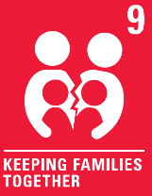
Communicating by phone can be a good way to make sure that we can remain in contact with our families when we are unable to be together.

