Rockcliffe CE School – Whole School Computing Overview
Below is an overview of the Computing learning focus for each term in each class.
Class teachers may choose to adapt the schemes of work to suit their class but must ensure full coverage across the year in line with the skills progression document.
2026-27

 |  |  | Autumn |  |  |  | Spring |  |  |  | Summer
EYFS |  |  | Barefoot Computing-  Awesome Autumn  Technology around us  https://www.ilearn2.co.uk/computerdiscoveryfree.html  http://code-it.co.uk/wp-content/uploads/2015/05/bankplan.pdf  http://code-it.co.uk/wp-content/uploads/2015/05/supermarketplan.pdf  http://www.crickweb.co.uk/Early-Years.html  https://www.nurseryworld.co.uk/News/article/ict-in-role-play-check-it-out |  |  | Barefoot Computing-  Winter Warmers  Toys  Coding Critters  Sphero Indi  https://sphero.com/pages/sphero-indi | Barefoot Computing-  Busy Bodies  Head, Shoulder, Knees and Toes  Music creation  https://www.ilearn2.co.uk/freeyear1musiccreation.html/  https://springroll-tc.pbskids.org/music-maker/d0f261dffc3c8f713fa5a22bb99d7f9afd04cb56/release/index.html  https://musiclab.chromeexperiments.com/Voice-Spinner/ |  |  | Barefoot Computing -  Springtime  Cooking  Jam sandwich  http://swaygrantham.co.uk/wp-content/uploads/2016/09/JamSandwichAlgorithm.pdf  Pizza  https://www.barefootcomputing.org/docs/default-source/at-home/pizza_party_activity.pdf?sfvrsn=154d91ea_2 | Barefoot Computing-  Boats Ahoy  Art  https://www.j2e.com/jit5  Art and algorithms |  | Barefoot Computing-  Summer Fun  Other ideas  Lego Building  Crazy  Characters
 |  |  | Networks |  |  | Digital Literacy |  | Computer Science |  | Computer Science | IT – Media | IT – Media
 |  |  | (Information) Technology around us |  |  | Self image and identity | Programming – Robot algorithms |  |  | Programming quizzes | Digital - Writing |  | Digital - Painting
Year 1 /2 |  |  | Teach Computing unit:  https://teachcomputing.org/curriculum/key-stage-1/computing-systems-and-networks-it-around-us  Oak National Academy:  https://www.thenational.academy/teachers/programmes/computing-primary-ks1/units/information-technology-in-the-world-beyond-school/lessons |  |  | https://www.thenational.academy/teachers/programmes/rshe-pshe-primary-ks1/units/our-online-lives-what-should-i-do-if-i-feel-unsafe-online/lessons | https://teachcomputing.org/curriculum/key-stage-1/programming-a-robot-algorithms |  |  | https://teachcomputing.org/curriculum/key-stage-1/programming-b-programming-quizzes | Teach Computing unit:  https://teachcomputing.org/curriculum/key-stage-1/creating-media-digital-writing  Oak National Academy:  https://www.thenational.academy/teachers/programmes/computing-primary-ks1/units/digital-writing/lessons |  | Teach Computing unit:  https://teachcomputing.org/curriculum/key-stage-1/creating-media-digital-painting  Oak National Academy:  https://www.thenational.academy/teachers/programmes/computing-primary-ks1/units/digital-painting/lessons
 |  |  | Digital Literacy | Computer Science |  |  |  | IT - Data |  | IT – Data | Computer Science | IT - media
 |  |  | Online Safety – Self image |  |  | Networks – Connecting Computers | Data – Grouping data |  |  | Data - Branching databases | Programming – Events and actions in Programs |  | Creating Media – Stop frame animation
Year  2/3 |  |  | https://www.thenational.academy/teachers/programmes/rshe-pshe-primary-ks1/units/our-online-lives-who-should-i-talk-to-online/lessons |  |  | Teach Computing unit:  https://teachcomputing.org/curriculum/key-stage-2/computing-systems-and-networks-connecting-computers  Oak National Academy:  https://www.thenational.academy/teachers/programmes/computing-primary-ks2/units/computer-networks/lessons  ONLINE SAFETY – PROJECT EVOLVE  Online relationships  KS1  KS2 | Teach Computing unit:  https://teachcomputing.org/curriculum/key-stage-1/data-and-information-grouping-data  Oak National Academy:  https://www.thenational.academy/teachers/programmes/computing-primary-ks1/units/using-it-to-organise-and-present-data/lessons  ONLINE SAFETY – PROJECT EVOLVE  Online Reputation  KS1  KS2 |  |  | Oak National Academy:  https://www.thenational.academy/teachers/programmes/computing-primary-ks2/units/organising-data-using-databases/lessons  ONLINE SAFETY – PROJECT EVOLVE  Managing online information  KS1  KS2 | https://teachcomputing.org/curriculum/key-stage-2/programming-b-events-and-actions  ONLINE SAFETY – PROJECT EVOLVE  Health wellbeing and lifestyle  KS1  KS2 |  | https://teachcomputing.org/curriculum/key-stage-2/creating-media-animation  ONLINE SAFETY – PROJECT EVOLVE  Privacy & security  KS1  KS2  Copyright & ownership  KS1  KS2
 |  |  | Networks | Networks |  |  |  | Computer Science |  | Computer Science | IT – Media | IT - Data
 |  |  | Networks – The Internet |  |  | Networks – Systems and searching | Programming – Repetition in programming |  |  | Programming - Debugging | Creating Media – Audio production |  | Data – Flat File databases
Year 4/5 |  |  | TCC:  https://teachcomputing.org/curriculum/key-stage-2/computing-systems-and-networks-the-internet  ONA:  https://www.thenational.academy/teachers/programmes/computing-primary-ks2/units/the-internet/lessons  ONLINE SAFETY – PROJECT EVOLVE  Self image and identity |  |  | TCC:  https://teachcomputing.org/curriculum/key-stage-2/computing-systems-and-networks-systems-and-searching  ONA:  https://www.thenational.academy/teachers/programmes/computing-primary-ks2/units/introduction-to-computer-systems/lessons  ONLINE SAFETY – PROJECT EVOLVE  Online relationships | TCC:  https://teachcomputing.org/curriculum/key-stage-2/programming-b-repetition-in-games  ONLINE SAFETY – PROJECT EVOLVE  Online reputation |  |  | ONA:  https://www.thenational.academy/teachers/programmes/computing-primary-ks2/units/repetition-in-programs/lessons  ONLINE SAFETY – PROJECT EVOLVE  Managing online information | https://teachcomputing.org/curriculum/key-stage-2/creating-media-audio-editing  ONLINE SAFETY – PROJECT EVOLVE  Health, well-being & lifestyle |  | TCC:  https://teachcomputing.org/curriculum/key-stage-2/data-and-information-flat-file-databases  ONA:  https://www.thenational.academy/teachers/programmes/computing-primary-ks2/units/flat-file-databases/lessons  ONLINE SAFETY – PROJECT EVOLVE  Privacy & security  Copyright & ownership
 | Networks |  |  | Networks |  |  |  | Computer Science |  | IT – Data | IT - Media | IT - Media
 |  | Networks – Communication and collaboration |  |  | Networks – Data packets |  |  |  | Programming – Selection in quizzes | Programming - Variables | Creating Media – Web design | Creating Media – 3D modelling
Year 5/6 |  | https://teachcomputing.org/curriculum/key-stage-2/computing-systems-and-networks-communication  ONLINE SAFETY – PROJECT EVOLVE  Self image and identity |  |  | https://www.thenational.academy/teachers/programmes/computing-primary-ks2/units/communication-and-the-internet/lessons  ***check unit contents to avoid repetition from TCC in Aut1***  ONLINE SAFETY – PROJECT EVOLVE  Online relationships |  |  |  | https://www.thenational.academy/teachers/programmes/computing-primary-ks2/units/using-selection-in-programming-to-develop-a-quiz/lessons  ONLINE SAFETY – PROJECT EVOLVE  Online reputation | https://www.thenational.academy/teachers/programmes/computing-primary-ks2/units/using-variables-in-programming-to-develop-a-game/lessons  ONLINE SAFETY – PROJECT EVOLVE  Managing online information | https://www.thenational.academy/teachers/programmes/computing-primary-ks2/units/web-page-creation/lessons  ONLINE SAFETY – PROJECT EVOLVE  Health, well-being & lifestyle | https://teachcomputing.org/curriculum/key-stage-2/creating-media-3d-modelling  ONLINE SAFETY – PROJECT EVOLVE  Privacy and security  Copyright and ownership

Project Evolve half termly lessons for Online Safety – see below for progression and objectives to be covered under each strand. Whilst it looks like a lot, multiples can be covered in one lesson. The resources on PE can be joined and amalgamated into one lesson. Click on the link and in resources, choose your year group, then the strand. The year groups can be easily joined too. Help is on hand if required.

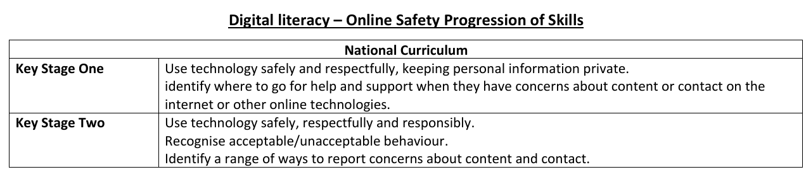
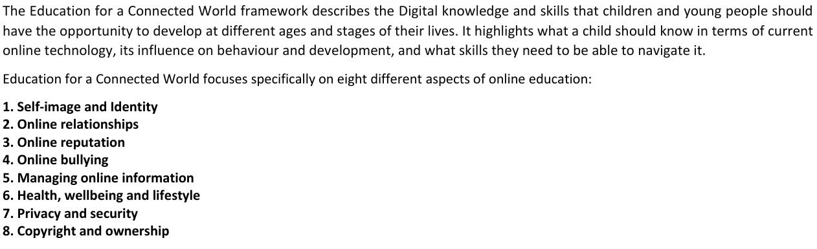
Note the addition of AI Literacy & Emerging Technologies and Digital Citizenship.
Many of the below objectives are interwoven into the TCC and ONA as above, but some will require standalone coverage too. Please use the below table as a checklist to highlight when they are covered.

Primary Computing – Online Safety Progression of Skills (EYFS–Year 6)
Year Group | Self-Image & Identity | Online Relationships | Online Reputation | Online Bullying | Managing Online Information | Health, Wellbeing & Lifestyle | Privacy & Security | Copyright & Ownership | AI Literacy & Emerging Technologies | Digital Citizenship
EYFS | • Know people can be different  • Know online and offline identities may differ  • Talk about likes and interests | • Know technology can help people communicate  • Be kind when using devices  • Tell an adult if worried | • Know things shared online can be seen by others | • Recognise unkind behaviour  • Tell an adult if something feels wrong | • Know not everything online is real  • Ask an adult for help | • Talk about balancing screen time  • Recognise when to take a break | • Know personal information should be kept private  •Understand passwords help keep things safe | • Know stories, pictures and videos belong to someone | • Know computers can answer questions  •Understand technology can make mistakes | • Follow classroom rules for technology use
Year 1 | • Describe positive things about themselves  •Understand people may present differently online | • Use kind and respectful language online  • Identify trusted adults | • Know information can stay online | • Identify unkind online behaviour  • Know how to seek help | • Begin to question information seen online  • Distinguish simple fact from fiction | • Recognise feelings when using technology  •Understand importance of breaks | • Know what personal information is  • Keep passwords private | • Understand work belongs to its creator | • Recognise simple AI tools  •Understand AI can be wrong | • Follow agreed rules when using devices
Year 2 | •Understand online identities can differ from real life | • Communicate safely online  • Recognise trusted contacts | • Understand online actions affect others | • Recognise repeated unkind behaviour  • Know reporting routes | • Compare information from different sources  • Recognise persuasive content | • Identify healthy and unhealthy technology habits | • Create passwords with support  • Protect information | • Ask permission before using others' work  • Recognise ownership | •Understand AI uses information  • AI may be inaccurate | • Use shared technology responsibly
Year 3 | • Explain how online activities contribute to identity  • Recognise fake profiles | • Recognise appropriate contact  • Understand consent | • Explain digital footprints | • Recognise cyberbullying  • Use reporting tools | • Check information  • Recognise advertising | • Discuss positive and negative impacts | • Create secure passwords  •Understand security settings | • Identify reusable content  • Reference sources | •Understand AI-generated media  • Question AI responses | • Understand rights and responsibilities
Year 4 | • Explain influence of online content on self-image | • Recognise stranger risks  • Understand grooming | • Explain long-term footprint consequences | • Support others experiencing cyberbullying | • Evaluate website reliability  • Recognise misinformation | •Understand excessive screen-time impacts | • Use privacy settings  • Recognise phishing | • Understand plagiarism  • Credit creators | • Identify AI-generated content  •Understand AI bias | • Understand online laws and expectations
Year 5 | • Evaluate effects on self-esteem | • Recognise healthy/unhealthy relationships  • Understand manipulation | • Manage digital footprint | •Understand impacts of cyberbullying | • Identify fake news and disinformation  • Evaluate credibility | •Understand algorithm influence | • Recognise scams  •Understand 2FA | • Understand Creative Commons | • Evaluate AI critically  •Understand AI privacy issues | • Understand age restrictions and consumer risks
Year 6 | • Critically evaluate online identities | • Recognise exploitation and grooming risks  • Seek help appropriately | • Manage positive footprint | •Understand reporting systems and legal implications | • Evaluate multiple sources  • Identify conspiracy theories | •Understand social media impacts | •Understand malware, phishing and data protection | • Apply copyright independently | • Recognise deepfakes  • Verify AI content | • Demonstrate responsible digital citizenship

Primary Computing Vocabulary Progression Map (EYFS–Year 6)
Year Group | Computer Science (Programming) | Systems & Networks | Data & Information | Creating Media / IT | Digital Literacy & Online Safety
EYFS | instruction, sequence, command, forward, backward, turn | computer, tablet, device, screen, keyboard, mouse | sort, group, information | camera, photograph, video, create | online, safe, share, password
Year 1 | algorithm, program, command, instruction, debug, predict | technology, device, computer | information, organise | save, open, file, digital content, create | internet, online, personal information, private, trusted adult
Year 2 | sequence, outcome, bug, logical reasoning, test | hardware, input, output | data, pictogram, tally chart, label | document, text, image, organise, retrieve | digital footprint, permission, ownership, copyright
Year 3 | repetition, loop, event, sprite, decomposition | network, connection, server, switch | branch database, record, field, search | audio, recording, edit, media | identity, reputation, cyberbullying
Year 4 | selection, condition, variable, operator, input, output | internet, website, webpage, browser, router | database, data collection, analyse, format | animation, transition, design | phishing, privacy, reliability, security
Year 5 | abstraction, pattern recognition, efficiency, procedure, control | wireless, communication, protocol, transmission | spreadsheet, cell, formula, calculate, data validation | vector, layer, multimedia, audience | encryption, secure, malware, scam
Year 6 | algorithm design, function, debugging, evaluation, variable, flowchart | World Wide Web, packet, IP address, domain name, DNS | dataset, interpretation, trend, accuracy, automated | collaborate, publish, attribution, copyright | digital citizen, consent, two-factor authentication, misinformation, artificial intelligence (AI)

