Important information
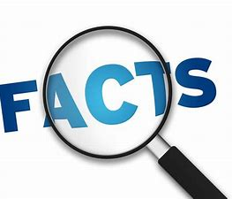

Safe
Trust
Trusted
KS
Kid Safe
Sad
Scared
Worried
Feelings
Bullying
Yucky feelings
E- safety
Private
Share



Pupils will explore what trust is and who are the people we can trust to share information and feelings with.

Pupils will explore what bullying means and when we use the word ‘bullying’. We will revisit trusted adults and who to go to with unwanted ‘yucky’ feelings.

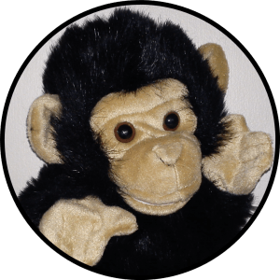
Pupils will look at how we stay safe online and what information is safe to share/not safe to share. We will look at how to keep ourselves safe and share where are our private areas. Saying no and recognising those ‘yucky’ feelings.

 | Lesson Question | What you will learn | Learning Review
1 | What is trust?  How do we build trust with others?  How can we show trust?  When do we feel sad, scared or worried? | How we can identify and show trust.  Identify yucky feelings and what we can do about them – who we can talk to. | If I feel sad I could tell  .
2 | What is bullying?  What does S.T.O.P mean?  How can you use your voice to stop bullying? | What we can do when others bully and what bullying looks like. How to stop bullying without hurting others. | S.T.O.P means…..  S .  T .  O .  P .
3 | How can we stay safe online?  What should I not be watching on TV and why? | When is it ok to say no to a friend?  Why should you make sure you’re watching age appropriate content? | I shouldn’t be watching age inappropriate content because…  .  .
4 | Where are your private places?  When is it ok for someone to see your private places?  Rules for your private places. | Rules for private places.  There are some people like Doctors who may need to see your private areas. | One rule for keeping my body safe is…
5 | What are yucky feelings? What can we do when we have yucky feelings? If a trusted adult gives us yucky feelings who can we talk to. | The importance of having a number of trusted adults in different places. | My trusted adults are  1.  2.  3.  4.  5.
6 | Recap above sessions key points. | As above. | Name on thing you have learned from KS. ,  .

