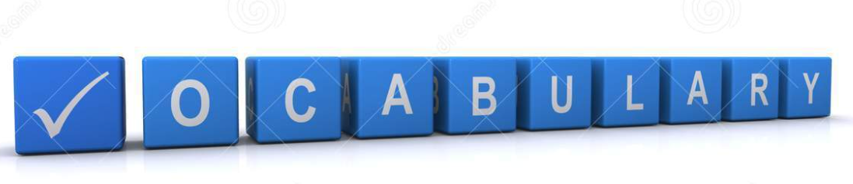
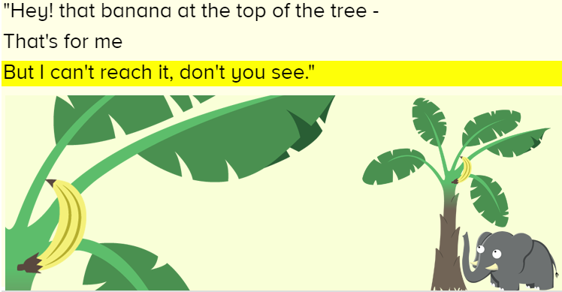
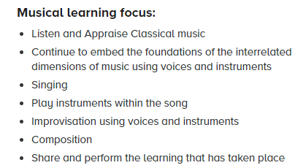
Pulse
Rhythm
Pitch
Improvise
Compose
Perform
Audience
Listen
Appraise
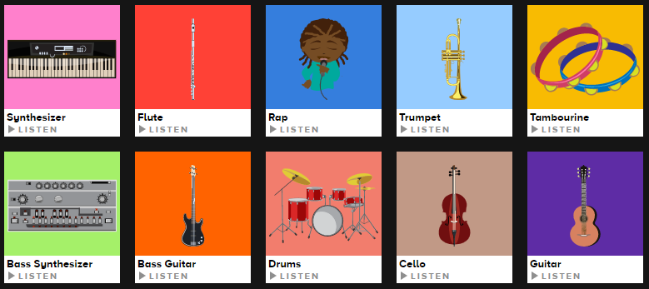

We will be looking back at all the songs you have learnt this year and doing some new activities too.
Lesson | Learning Outcome | What will you learn | Learning Review
1 | I can create a composition using Charanga | You will reflect on lots of different things you have done this year. You will listen to music, appraise and sing some. You will get to create a composition as a class | Did you like the song we created?  
2 | I can identify what I can hear in a piece of music? | You will reflect on lots of different things you have done this year. You will listen to music, appraise and sing some. You will try remember your knowledge of different types of instruments to see if you can name some in a song or name the type of instrument e.g. strike, blow, pluck, shake | Can you name an instrument or type of instrument that you heard in the song?  ______________________________________
3 | I can listen to and appraise a piece of music | You will reflect on lots of different things you have done this year. You will listen to music, appraise and sing some. You will answer and discuss some questions about a piece of music | Did you like the song?
4 | I can discuss what pulse, rhythm and pitch are and listen to them in music extracts | You will reflect on lots of different things you have done this year. You will listen to music, appraise and sing some. | What is pitch?  _____________________________________  _____________________________________
5 | I can sing a range of songs from the past year | You will reflect on lots of different things you have done this year. You will listen to music, appraise and sing some. | Which was your favourite song this year?  ________________________________________  ________________________________________

