• Children should be encouraged to have good posture and sit up at the computer.
• Children should take a screen break for 2 minutes during longer periods completing tasks on the computer.
• Children should be consistently reminded of the SMART rules for Internet safety.

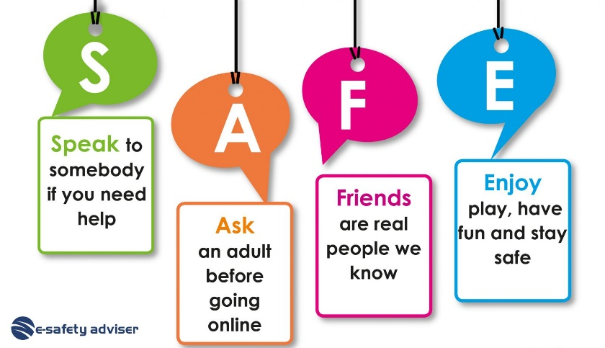

Online safety
Digital literacy
Trusted adults
Safe Searching
Personal information
Technology
Respect
Good choices
Images



It is important to learn from a young age how to stay safe online and to always ask an adult if you are unsure.

You should never share personal information online such as your address or full name.


 | Lesson Question | What you will learn | Learning Review
1 | What is the internet? | You will look at what the internet is and what is has to offer. Do you use the internet for anything? What do you like doing? We will start to talk about how we can stay safe | Name one thing you can do on the internet  _________________________________________________________________
2 | How can I search safely? | You will look at how to search on the internet and how we can stay safe doing this | What did we use to search safely?  _________________________________________________________________
3 | How can I communicate safely? | You will learn how to talk to people safely and when it is not ok. You will know that trusted adults are there to help you | Name one of your trusted adults who could help you with an online problem?  _________________________________________________________________
4 | What is personal information? | You will know what your personal information is and know that this should never be shared online and why it should be kept private | Name one piece of personal information  _________________________________________________________________
5 | Can I help others make good online choices? | You will look at some other people’s online choices and decide if they are making good choices or not. You will be able to explain your reasons | How can you stay safe online?  _________________________________________________________________

