
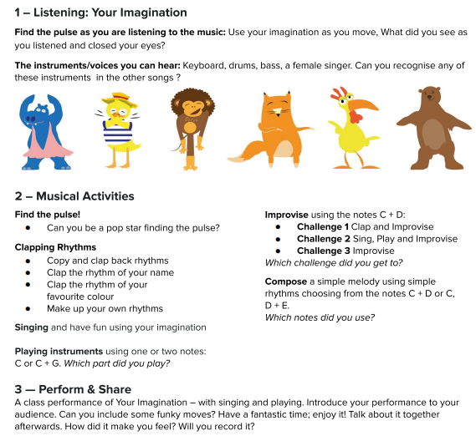
Keyboard
Drums
Bass
Pulse
Rhythm
Pitch
Improvise
Compose
Perform
Audience
Imagination

Lesson | Learning Question | What will you learn | Learning Review
1 | How can I sort musical instruments? | You will learn about different musical instruments and how they sound and be able to sort them into four categories: strike, blow, pluck and shake | 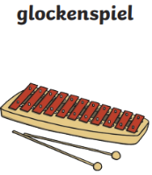  What type of instrument is this? Tick one  Strike Pluck  Blow Shake
2 | I can appraise a piece of music  Do I like the song? | You will appraise our new song, ‘Your Imagination’ and answer some questions after listening to it  You will begin to learn to sing the song | Did you like the song? Circle one  
3 | Can I play an instrument in time with a piece of music? | You will use a glockenspiel to accompany our new song  You will try to stay in time with the music and hit the correct note(s) | 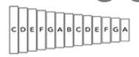  Colour the notes that you played on the glockenspiel.
4 | Can I improvise to a piece of music using one-three notes? | You will use a glockenspiel to improvise using notes C, D and E  You will practise writing down your chosen notes to create a composition | Which notes did you choose to use? Tick the ones you used.  C D E
5 | How can I perform the song? | We will practise singing the song and look to performing it with glockenspiels involved too | Did you like the final performance?

