Important information


Easter, new life,
beginnings
forgiveness salvation
crucifixion resurrection
New Life
Last Supper
Palm Sunday
Crucifixion
God Friday
Resurrection
Easter Sunday
Holy Week
Life Cycle

This unit focuses on Jesus building a bridge to God through his teachings and his example. Christians use these stories in different ways. Some will prepare for Easter during Lent, reading passages from the Easter story and meditating on Jesus’ experience, perhaps particularly on his suffering.
Some Christians read the whole of the Passion narrative in John’s Gospel (Chapters 18-20) in a service; others remember it in the Stations of the Cross, saying prayers recalling different events of Holy Week. This is the most significant Christian festival, remembering and celebrating the salvation offered through Jesus
Contribution to SMSC
Spiritual Development - Developing their own views and ideas on religious beliefs and stories.
Learning about Easter and the Christian Faith.
Moral Development –Thinking about why Forgiveness is important
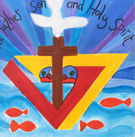


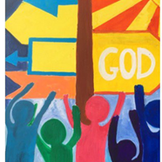
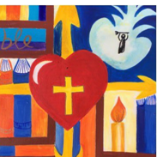


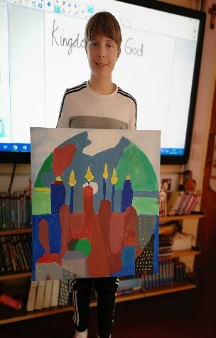
Social Development- Considering how religious and other beliefs lead to particular actions and concerns

 | Each lesson uses the following skills | Lesson | What will you learn | Learning Review
 | What is Hope? (Introduction to Christian Value)  Recognise that God, Incarnation, Gospel and Salvation are part of the ‘big story’ of the Bible  I can recall key events from the Easter Story-  I can ask questions about those events. | 1 | Why does Easter matter to Christians?  Recap the parts of the Easter story  Place pictures from Holy Week onto an Easter story timeline.
 | What is ‘sin’?  Why do Christians see Jesus as a ‘Saviour’?  Tell stories of Holy Week and Easter and make a link with the idea of Salvation (Jesus rescuing people) | 2 | Christians believe the world is spoiled by ‘sin’. People keep wandering away from God. Jesus’ name means ‘he saves’, and he came on a rescue mission to bring people back to God.
 | How do Christians remember Jesus’ as a Saviour?  How do Christians show their beliefs about Jesus as saviour in church worship? Look at the process of a Church service. | 3 | Looking at a church service how do Christians remember Jesus as a saviour in their worship.
 | What does the story make me think about?  How is forgiveness a key part of the Easter Story?  Think, talk and ask questions about whether the text has something to say to them (for example, about whether forgiveness is important), exploring different ideas. | 4 | Forgiving those who have done wrong by us – why do Christians/ Jesus practice and teach forgiveness.
 | How was Jesus forgiving? How did he show this?  Think, talk and ask questions about whether the text has something to say to them (for example, about whether forgiveness is important), exploring different ideas. | 5 | Look at examples of when Jesus forgave others – what happened afterwards? How/ did those people change?
 | What do Christians believe about ‘Salvation’?  Why is prayer important?  Make the link back to the Christian idea that Jesus  came to build a bridge back to God. | 6 | Think about the things you may need to ask forgiveness for or something you would like to be better at e.g. forgiving others.

