This is a sample Long Term Plan for a mixed-form primary school delivering 2 hours of quality PE each week.
If you do not have mixed classes, please refer to our standard sample LTP.
In order to avoid repetition, we recommend that mixed-form schools work from a two year Long Term Plan.

When setting your Long Term Plan, you must consider your school space, facilities, equipment and what will engage your particular children.
The guide on page 3 will help you to consider the variants when setting your Long Term Plan.

You will see that these sports are repeated in Year A and Year B:
Gymnastics, Fitness, Dance, Orienteering, Athletics.
These sports should be covered every year, so you should consider lots of differentiation and progression, and take advantage of the additional time to allow children to practise the activities and games.
There are a range of Dances available on PE Planning, as well as a ‘create your own dance’ unit, so you shouldn’t need to repeat the same Dance unit twice.

NB: Some schools substitute 1 PE lesson per week for swimming.
For classes only taking part in one PE lesson per week, ensure you cover these core sports;
at least 1 unit of Invasion Games, Gymnastics, Dance, Orienteering, Athletics, Net/Wall.

 |  | YEAR A
 | Reception |  | Year 1/2 | Year 3/4 | Year 4/5 | Year 6
Autumn 1 | Me & Myself |  | Football | Football | Football | Football
Autumn 1 |  |  | Handball | Handball | Handball | Handball
Autumn 2 | Movement & Development |  | Gymnastics 1 | Gymnastics 1 | Gymnastics 1 | Gymnastics 1
Autumn 2 |  |  | Fitness | Fitness | Fitness | Fitness
Spring 1 | Throwing and Catching |  | Dance | Dance | Dance | Dance
Spring 1 |  |  | Dodgeball | Dodgeball | Dodgeball | Dodgeball
Spring 2 | Ball Skills |  | Gymnastics 2 | Gymnastics 2 | Gymnastics 2 | Gymnastics 2
Spring 2 |  |  | Orienteering | Orienteering | Orienteering | Orienteering
Summer 1 | Fun & Games |  | Netball | Netball | Netball | Netball
Summer 1 |  |  | Tennis or Badminton | Tennis or Badminton | Tennis or Badminton | Tennis or Badminton
Summer 2 | Working with Others |  | Athletics | Athletics | Athletics | Athletics
Summer 2 |  |  | Rounders | Rounders | Rounders | Rounders
 |  | YEAR B
 | Reception |  | Year 1/2 | Year 3/4 | Year 4/5 | Year 6
Autumn 1 | Me & Myself |  | Hockey | Hockey | Hockey | Hockey
Autumn 1 |  |  | Tag-Rugby | Tag-Rugby | Tag-Rugby | Tag-Rugby
Autumn 2 | Movement & Development |  | Gymnastics 1 | Gymnastics 1 | Gymnastics 1 | Gymnastics 1
Autumn 2 |  |  | Fitness | Fitness | Fitness | Fitness
Spring 1 | Throwing and Catching |  | Dance | Dance | Dance | Dance
Spring 1 |  |  | Golf | Golf | Golf | Golf
Spring 2 | Ball Skills |  | Gymnastics 2 | Gymnastics 2 | Gymnastics 2 | Gymnastics 2
Spring 2 |  |  | Orienteering | Orienteering | Orienteering | Orienteering
Summer 1 | Fun & Games |  | Basketball | Basketball | Basketball | Basketball
Summer 1 |  |  | Volleyball | Volleyball | Volleyball | Volleyball
Summer 2 | Working with Others |  | Athletics | Athletics | Athletics | Athletics
Summer 2 |  |  | Cricket | Cricket | Cricket | Cricket

Net/Wall Activities | Tennis |  |  |  |  | 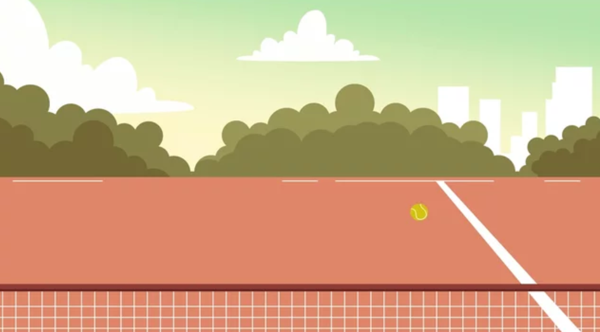
Net/Wall Activities | Volleyball |  |  |  | 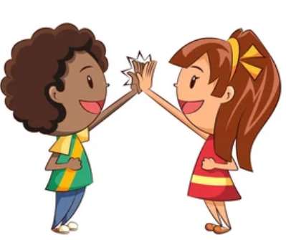
Net/Wall Activities | Badminton
Invasion Games | Football |  | 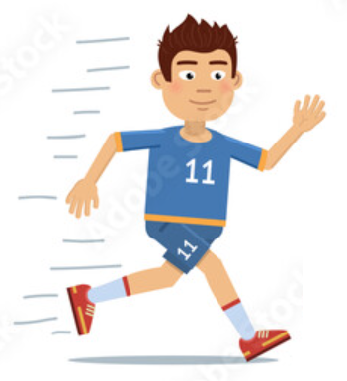
Invasion Games | Tag-Rugby
Invasion Games | Hockey
Invasion Games | Basketball
Invasion Games | Netball
Invasion Games | Handball
Striking & Fielding | Cricket
Striking & Fielding | Rounders
Target Games | Dodgeball
Target Games | Golf
Outdoor & Adventurous | Orienteering
Artistic | Dance
Artistic | Gymnastics
Fundamentals | Athletics
Better Indoors |  | High Intensity |  |  | Team Sport
Better Outdoors |  | Requires Particular Equipment |  |  |  | Requires Space

