Long Term Curriculum Map
2026-2027 Year 4/5
 | Autumn Term |  |  |  | Spring Term |  | Summer Term
 | Autumn 1 | Autumn 2 |  |  | Spring 1 | Spring 2 | Summer 1 |  | Summer 2
Key Texts- VIPERS | 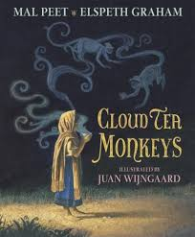 | 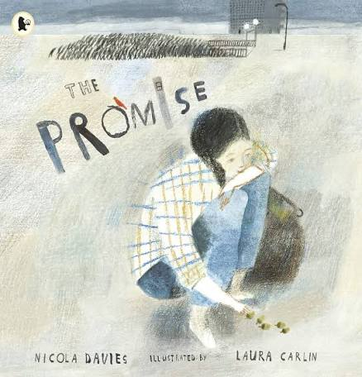 |  |  | Windrush Stories x 3 / SATs papers |  | 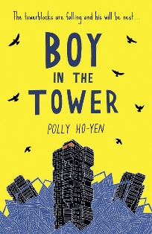
English | Inform: Non-Chronological Report – Monsters  Entertain: Narrative - Cloud Tea Monkeys  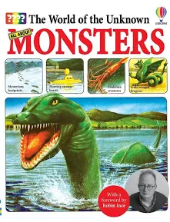 | Entertain: Poetry - Where the Poppies Now Grow  Entertain: Narrative - The Promise or The Adventures of Odysseus  Inform: Biography - Groundbreaking Scientists  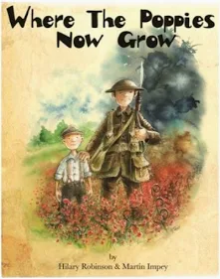 |  |  | Persuade: Letters - Misadventures of Frederick  Inform: Non-Chronological Report - Street Beneath My Feet or The Humans  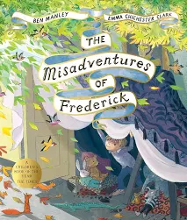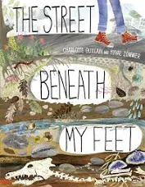 | Entertain: Descriptive Recount - The Watertower  Entertain: Narrative - The Boy in the Tower  Entertain: Poetry - Rhythm and Poetry  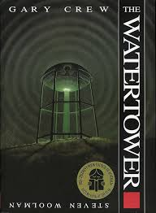 | Inform: Explanation - The Lost Book of Adventure  Persuade: Advertising Campaign - HFL Provided Models  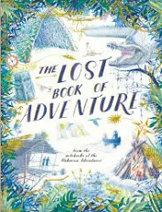 |  | Entertain: Poetry - Cloud Busting or And I Climbed and I Climbed  Discuss: Reviews - HFL Provided Models  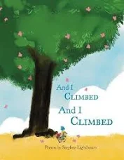  Entertain: Description – Birdsong
Maths  White Rose Maths  Year 4 | Place Value  Addition & Subtraction  Area  Mult & Div |  |  |  | Mult & Div  Length & Perimeter  Fractions  Decimals |  | Decimals  Money  Time  Shape  Statistics  Position & Direction
White Rose Maths  Year 5 | Place Value  Addition & Subtraction  Mult & Div  Fractions |  |  |  | Mult & Div  Fractions  Decimals & Percentages  Statistics |  | Shape  Position and Direction  Decimals  Negative numbers  Converting units  Volume
Science  Year 4 Focus | Physics - Light |  |  | Biology – Habitats | Physics – Sound | Chemistry – Changing Materials | Biology – Ourselves and other animals |  | Chemistry – Properties of materials
Science  Year 5 Focus | Physics – Light |  |  | Physics – Electricity | Chemistry – Changing Materials | Biology – Ourselves and other animals | Biology – Habitats |  | Physics - Sound
Geography  Kapow | Y3/4 Where does our food come from? |  |  |  | What are rivers and how are they used? |  | Biomes around the world: desert, tundra, rainforest, grassland comparison.
History  Kapow | Y3/4 How much did the achievements of the Ancient Maya impact their society and beyond? |  |  |  | Suggested unit:  British Empire/ Who were the Windrush generation? |  | Suggested unit:  What was the impact of 1066 on Britain?
Computing | Networks – The Internet  Unit from Teach Computing  https://teachcomputing.org/curriculum/key-stage-2/computing-systems-and-networks-systems-and-searching  ONLINE SAFETY – PROJECT EVOLVE  Online relationships  Self image and identity |  | Programming – Repetition in Shapes  Unit from Teach Computing  https://teachcomputing.org/curriculum/key-stage-2/programming-a-repetition-in-shapes  ONLINE SAFETY – PROJECT EVOLVE  Online reputation |  | Creating Media – Intro to Vector Diagrams  Unit from Teach Computing  https://teachcomputing.org/curriculum/key-stage-2/creating-media-introduction-to-vector-graphics | Flat file databases  Unit from Teach Computing  Cross curricular opportunity  Data and information – Flat-file databases (teachcomputing.org)  ONLINE SAFETY – PROJECT EVOLVE  Managing online information | Creating Media – Video production  Unit from Teach Computing  https://teachcomputing.org/curriculum/key-stage-2/creating-media-video-editing  ONLINE SAFETY – PROJECT EVOLVE  Health, well-being & lifestyle | Programming - Selection  Unit from Teach Computing  https://teachcomputing.org/curriculum/key-stage-2/programming-a-selection-in-physical-computing  ONLINE SAFETY – PROJECT EVOLVE  Privacy & security  Copyright & ownership
Art & Design  Kapow | Drawing  Robert W Strange (unit devised by school)  Printed Xmas card idea – Collage - Christmas tree/bauble using sweetie wrappers or wrapping paper. Extend the collage lesson. If necessary photocopy and back collage onto black paper. |  |  |  | Painting and mixed media  Light and dark |  | Sculpture and 3D  Mega Materials
Design & Technology  Kapow | Wobble bots-Electrical systems  - Identify some simple elements of a circuit (battery, wires, bulb, motor and switch) and explain their function.  - Explain that for electricity to flow around a circuit, it must be closed.  - Describe a motor as an electrical circuit component that changes electricity into movement.  - Provide examples of motorised products that use movement to rotate or spin different parts.  - Make a product that uses a motor.  - Design a motorised product for a particular purpose.  - Determine appropriate design criteria based on the function of the proposed product.  - Explain design choices based on the desired functionality of a product.  - Create an innovative motorised product based on knowledge of existing products.  - Discuss the effectiveness of a product while considering the design criteria. |  |  |  | Monitoring devices- digital world  - Describe what is meant by monitoring devices and provide an example.  - Explain briefly the development of thermometers from thermoscopes to digital thermometers.  - Research a chosen animal’s key information to develop a list of design criteria for an animal monitoring device.  - Write a program that monitors the ambient temperature and alerts someone when the temperature moves from a specified range.  - Identify errors (bugs) in the code and ways to fix (debug) them.  - State one or two facts about the history and development of plastic, including how it is now affecting planet Earth.  - Build a variety of brick models to invent Micro:bit case, housing and stand ideas, evaluating the success of their favourite model.  - Explain key pros and cons of virtual modelling vs physical modelling.  - Recall and describe the name and use of key tools used in Tinkercad (CAD) software. |  | Pavilions- structures  - Produce a range of free-standing frame structures of different shapes and sizes.  - Design a pavilion that is strong, stable and aesthetically pleasing.  - Select appropriate materials and construction techniques to create a stable, free-standing frame structure.  - Select appropriate materials and techniques to add cladding to their pavilion.
Music  Cumbria Charanga scheme | Recorder Beginners  -Develop breathing and tonguing techniques.  -Recap how to hold a recorder.  -Recap STAF notation reading and play short musical phrases from a treble clef music score. | KS2 Carol performance |  |  | Blues Through History  -Explore the origins of Blues music.  -Explore its influence on modern genres.  -Listen and appraise Blues music.  -Learn a blues music song.  -Identify the features of blues music. | Blues Composers  -Create and perform simple Blues melodies and accompaniments.  -Learn about six note scales and how they can be used to compose blues music.  -Learn to play six note scales on keyboard and glockenspiel.  -Use standard STAF notation to document compositions. | Ukulele Skills  -Learn basic chords, strumming patterns and chord changes.  -Learn chords C, G, Am and F to play a range of popular songs.  -Learn a popular song to sing and accompany themselves on ukulele. |  | Keyboard skills  -Locate notes on the keyboard.  -play simple melodies and accompaniments.  -Understand how chords and melody work together.
PSHE
SCARF

RE  Questful RE | 4.1 – Are values only important to people of faith or are they important to everyone?  Th- Is there a difference between faith values and human values?  Ph –What values do you consider to be important? Why?  HSS- How do values affect the way in which people live their lives? (10) |  | S12-  peace is a fruit of the spirit and a key Christian concept.   there is a connection between values, action and beliefs.   ask important and relevant questions.   express in words and art, their own opinion about the value of peace.   ask and suggest answers to quality questions about values, meaning and  commitment.   use religious vocabulary to talk about peace showing their understanding of  religious text and beliefs. | 4.7- How do Christians celebrate Easter across the world?  Th- How do celebrations at Easter reflect Christian beliefs about Jesus?  Ph –Why do people celebrate the same things in different ways?  HSS- How do celebrations at Easter reflect the culture of the people celebrating? (6) | 4.5- What is the purpose of sacred buildings or places?  Th- Why do people build special buildings like Churches of Temples to pray in?  Ph –Does a building have a purpose because it is a building or because of what happens there?  HSS- What is it that people do in sacred building / place that indicates the significance of the space? (12)  (Joint trip with year 5/6?) | S10 – Proverbs  Proverbs is in the Old Testament and is a book of wise advice written by  Solomon   Solomon chose wisdom as a gift from God  By the end of this unit pupils are expected to be able to:   make connections between the context of the proverbs and Christian Values,  attitudes and behaviour.   interpret a proverb and express an opinion about the advice given.   Apply the wisdom of a proverb to a situation in their own lives | 5.1- How and why do Christians read the Bible?  Th- use religious vocabulary to show understanding of religious texts.  Th make comparisons between the content and treatment of the Holy Books of at least three World Faiths.  Th interpret and discuss quotes from Sacred Scripture in the light of a current situation in the news.  Ph- use religious language to ask relevant questions.  Ph describe what inspires and influences them.  make links between Holy Scriptures and the values, attitudes and beliefs of  believers.
PE  PE Planning | Football  Handball | Gymnastics (1)  Fitness |  | Dance  Dodgeball | Gymnastics (2)  Orienteering | Netball  Tennis OR badminton |  | Athletics  Rounders
MFL  French  Language Angels | Phonetics 2 and Presenting Myself (I) | The Date (I) |  | Do you have a pet? (I) | Goldilocks (I) | My home (I) |  | Clothes(I)

