Reception | Autumn 1 | Autumn 2 | Spring 1 | Spring 2 | Summer 1 | Summer 2
Planned  Themes | Marvellous Me | Space Explorers | Traditional Tales | From bud to blossom | Under the sea | Around the world
Possible  areas of  interest linked  to this: | All about me  All about my  family  My five senses  Where we live/  location  Autumn | Astronauts/  historic heroes  Planets  Aliens  Rockets/Engineers  Gravity/forces | Fairy tales  Mythical creatures.  Kings/Queens  Heroes and villains | Plants  Animals – life cycles  Seasonal changes  Minibeasts  Easter | Sea creatures  Seaside  Water habitats  Food chains  Maps  Treasure island | Holidays  Different foods  Journeys/ transport  Special celebrations
Curriculum  Enrichment/  Key dates | Pumpkin picking  Harvest service | Diwali  Bonfire night  Remembrance day  Children in need  Christmas  EYFS Nativity  Christmas jumper day  Community visits  Christmas crafts | Chinese new year  Whinlatter forest | Easter service  Easter  Farm visit  Growing plants | Aquarium visit or  seaside visit | End of year  celebration
Literacy Core Texts | 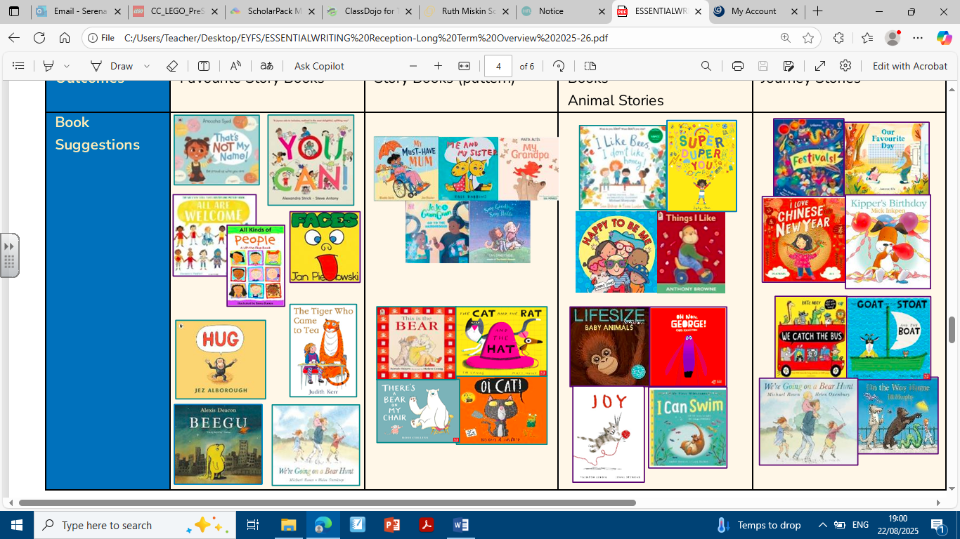 |  | 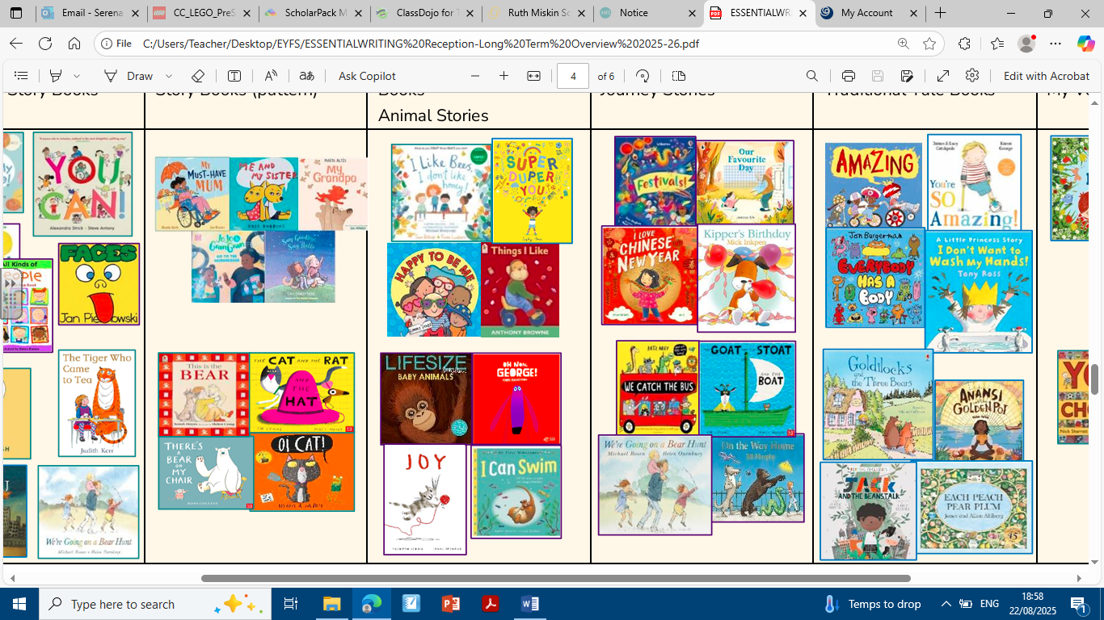 |  | 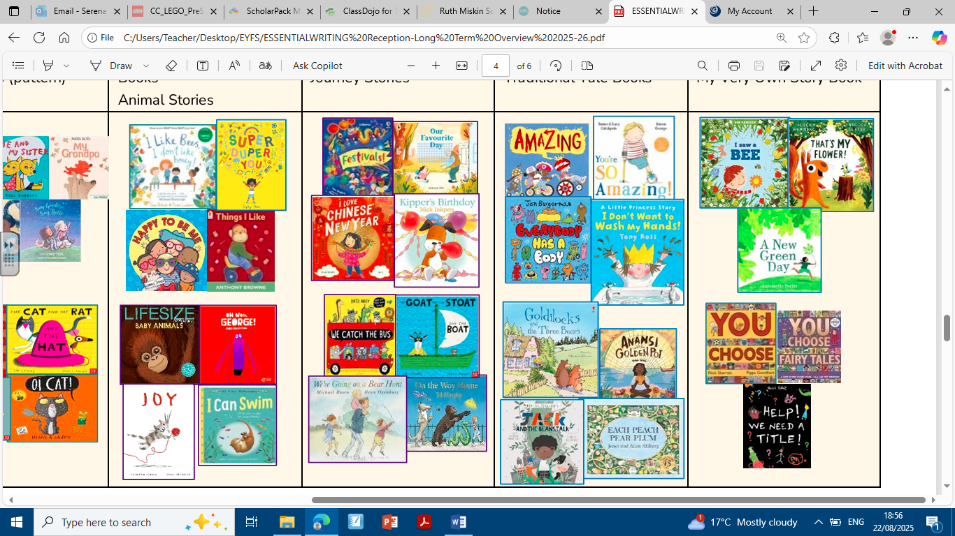

Communication & Language: | Autumn Term | Spring Term | Summer Term
Listening, Attention and Understanding | Understand how to listen carefully and  why listening is important.  Learn new vocabulary.  Engage in story times.  Listen carefully to rhymes and song,  paying attention to how they sound.  Engage with non-fiction books.  people who help us books. | Ask questions to find out more and to  check they understand what has been  said to them.  Listen to and talk about stories to build  familiarity and understanding.  Retell stories once they have developed  a deep understanding of the text, some  as repetition and some in their own  words.  Learn new rhymes, poems and songs.  Listen to and talk about selected non  fiction to develop new knowledge and  vocabulary. | Listen attentively and respond to what  they hear with relevant questions,  comments and actions.  Make comments about what they have heard and ask questions to clarify their understanding. (When being read to and during whole class/ small groups discussions).  Hold conversations when engaged in back and forth exchanges with staff and peers.
Speaking | Use new vocabulary through the day.  Articulate ideas and thoughts in well-  formed sentences.  Connect one idea or action to another  using a range of conjunctions. | Describe events in some detail.  Use talk to help work out problems and  organise thinking and activities.  Use talk to describe how things work  and why they might happen.  Develop social phrases.  Use new vocabulary in different  contexts. | Participate in small group and one-to-  one discussions offering their own  ideas and using new vocabulary.  Offer explanations for why things  might happen, making use of  vocabulary from stories, poem and  rhymes where appropriate.  Express their ideas and feelings about  their experiences using full sentences.  Using past, present and future tenses.  Making use of conjunctions with  modelling and support.

Personal, Social & Emotional Development: | Autumn Term | Spring Term | Summer Term
Self Regulation | Express their feelings and consider the  feelings of others.  Develop appropriate ways to be  assertive.  Talk with others to resolve conflict.  SCARF:AT1: Getting help. | Identify and moderate their own  feelings socially and emotionally.  Think about the perspectives of others.  SCARF SPT1: Keeping my body safe. | Show an understanding of their  feelings and those of others. Begin to  regulate their behavior accordingly.  Being able to wait for what they want  and control their immediate impulses  where appropriate.  Give focused attention when given  instructions.  Show an ability to follow instructions  involving several ideas or actions.  SCARF Sum1: Keeping by body healthy – food, exercise, sleep.
Managing Self  Links to DT | Remember the rules and understand  why they are important.  Show resilience and perseverance.  Be increasingly independent in  meeting their own care needs.  Manage their own needs including  putting on own coat, getting a drink  and going to the toilet.  SCARF AT1: What makes me special.  SCARF AT2: Showing kindness. | Be independent in meeting their own  care needs: washing hands before  lunch/ after the toilet etc.  Talk about ways to look after their  teeth.  To understand the principles of a  varied and healthy diet. Talk about  which foods we should have more/less  of to stay healthy.  To discuss ways to stay safe online  including sensible amounts of screen  time.  SCARF SPT2: Safe secrets and touches. | Be confident to try new activities and  show independence and resilience in  the face of a challenge.  Explain the reasons for rules, know  right from wrong and behave  accordingly.  Manage their own basic hygiene and  personal needs, including dressing  going to the toilet and understanding  the importance of healthy food choices.  Explore the different fruits and  vegetables using senses.  I know where different fruits and  vegetables are grown. A good  understanding of the foods we need to  stay healthy.  SCARF Sum1: Growth Mindset.  SCARF Sum2: Cycles.
Building Relationships | Develop sense of responsibility and  membership of a community.  Become more outgoing in the safe  context of their setting.  Show more confidence in new social  situations.  Build constructive and respectful  relationships.  SCARF AT1: People close to me.  SCARF AT2: Similarities and difference.  SCARF AT2: Celebrating difference. | See themselves as a valuable  individual. Express their feelings and  consider the feelings of others.  SCARF SpT1: People who help to keep  us safe.  SCARF SpT2: Looking after things:  friends, environment, money | Work and play cooperatively, taking turns with others.  Form positive attachments to adults and friendships with peers.  Show sensitivity to their own needs and the needs of others.  SCARF Sum2: Life stages.  SCARF Sum2: Girls and boys: similarities & differences.
Links to PHSE | SCARF AT1: All about me unit.  SCARF AT2: Valuing difference. | SpT1: Keeping safe.  SpT2: Rights and respect. | Sum1: Being my best.  Sum2: Growing and changing.

Physical Development | Autumn Term |  | Spring Term |  | Summer Term
Gross Motor | Revise and refine fundamental  movement skills: rolling, crawling,  walking, jumping, hopping, skipping &  climbing.  Progress towards a more fluent style  of moving.  Developing control and grace. |  | Use their core muscle strength to  achieve a good posture when sitting at  a table or on the floor.  Combine different movements with  ease and fluency.  Further develop and refine a range of  ball skills including: throwing,  catching, kicking, passing, batting and  aiming. |  | Develop overall body strength, co  ordination, balance and agility.  Develop confidence, precision and  accuracy when engaging in ball  games.  Negotiate space and obstacles safely  with consideration for themselves and  others.  Demonstrate strength, balance and  coordination when playing.  Move energetically: running, jumping,  dancing, hopping, skipping and  climbing.
Fine Motor | Use one handed tools for equipment  e.g: paper snips with scissors.  Use comfortable control and a good  grip when using pens and pencils.  Show a preference for a dominant  hand.  Be increasingly independent when  dressing and undressing themselves.  e.g putting on coats and doing up  zips.  Develop small motor skills to use a  wide range of tools competently,  safely  and confidently. E.g. pencils,  paintbrushes, scissors, knives, forks  and spoons. |  | Develop the foundations of a hand  writing style which is fast, accurate  and efficient. |  | Hold a pencil effectively in preparation  for fluent writing – using the tripod  grip in almost all cases.  Use a range of small tools including  scissors, paintbrushes and cutlery.  Begin to show accuracy and care  when drawing.
Links to PE Units | Me & myself | Movement &  development | Throwing &  catching | Ball skills | Fun & games | Working with  others
English | Autumn Term | Spring Term | Summer Term
Word Reading | Develop their phonological  awareness to:  Count or clap syllables in a word.  Recognise words with the same initial sound.  Begin to read individual letters by saying the sounds for them.  Begin to blend sounds in to words so they can read shorts words made of known sounds.  Begin to read CVC words using known letter sounds.  RWI - read all set 1 sounds, blend sounds in to words orally.  Read set 1.3 -1.7 with increasing fluency (after oral blending confidentially). | Develop their phonological awareness to:  Begin to use sound buttons to identify  how many sounds are in a word.  RWI – blend sounds to read words, read  short ditty stories. Intro in to set 2  sounds.  Read set 1.3 – 1.7 with increasing fluency.  Read some red words by sight: the, I, no,  my, of, for, he.  Can supply words with the same initial  sound. Recognise all taught Set 1  including some diagraphs (special  friends).  Re- read phonetically decodable books to  build up their confidence in words  reading, their fluency and their  understanding and enjoyment.  Blend sounds in to words, so that they  can read short words made up of known  letters – sound correspondence.  Read simple sentences containing known  letter sound correspondences containing 1  or 2 common words. | Develop their phonological awareness to:  Recognise and use rhyme in daily  conversation.  Use sounds buttons to segment and read  words.  Can identify words containing the same  diagraph or trigraph e.g. –ay, - may,  -day, – play  Say a sound for each letter in the alphabet  and at least 10 diagraphs inc sh, ch, th,  ck, ll, ff, ss, zz, ng, nk  Read set two sounds and red words.  Read words consistent with their phonetic  knowledge by sound blending.  Read aloud simple sentences and books  that are consistent with their phonetic  knowledge, including some common  exception words.
Comprehension | Ask questions about stories.  Repeat words and phrases from  familiar stories.  Repeat vocabulary in the context of a  story.  Has favourite books and seeks them  out to share with an adult, another  child or to look at alone. | Answer questions about a text that has  been read to them.  Begin to predict what might happen next  in a story.  Begin to use modelled vocabulary during  role play for example in small world,  home corner, role play areas.  Request favourite poems and stories. | Can share a favourite book with a peer,  retelling the story in their own way and  repeating known phrases from the text.  Demonstrate understanding of what has  been read to them by retelling stories and  narratives using their own words and  recently introduced vocabulary.  Anticipate (where appropriate) key events  in stories. Use and understand recently  introduced vocabulary during discussions  about stories, non-fiction, rhymes and  poems and during role-play.
Writing | Form lower case letters and capital  letters correctly.  Use some of their print and letter  knowledge in their early writing.  Spell words by identifying the sounds  and then writing the sounds with the  corresponding letter.  Copy full name either independently  or from a name label.  Physical development – use a range  of small tools competently and  confidently. | Make good attempts at writing a short  sentence with words with known sounds.  To begin to show awareness of a capital  letter and a full stop in independent  writing.  Form many lower case letters correctly.  Begin to use capital letters, finger space  and full stops in independent writing.  Physical development –develop the  foundations of a handwriting style which  is fast, accurate and efficient.  Begin to use tripod grip. | Use a capital letter at the start and a full  stop at the end of a sentence.  Use finger spaces most of the time.  Write recognisable letters, most of which  are correctly formed.  Spell words by identifying sounds in them  and representing the sounds with a letter  or letters.  Write simple phrases and sentences that  can be read by others.  Physical development – hold a pencil effectively in preparation for fluent writing. Use the tripod grip in almost all cases.

Maths | Autumn Term | Spring Term | Summer Term
White Rose Maths | Match, sort and compare  Talk about measure and patterns  It’s me 1, 2, 3  Circles and triangles  1,2, 3, 4, 5  Shapes with 4 sides | Alive in 5  Mass and Capacity  Growing 6,7,8  Length, height and time  Building 9 and 10  Explore 3D Shapes | To 20 and beyond  How many now?  Manipulate, compose and decompose  Sharing and grouping  Visualise, build and map  Make connections  Consolidation
Mastering Number | Subtising: Within 3 and within 5.  Cardinality, Counting and Ordering: Counting sequence Cardinality 1:1 correspondence. Cardinality of 5 Dice patterns Numerals to 5.  Composition: Within 4 and Whole and Part.  Comparison:  More than Fewer than.  Matching. | Subtising: 5 and more Conceptual subitising and doubles.  Cardinality, Counting and Ordering:  Counting beyond 20 Show me (fingers) Link cardinality to numeral.  Within 10 Counting Pattern beyond 20.  Composition:  Within 6 Hidden parts 5 and a bit.  Odd and Even Composition of numbers to 10.  Comparison:  Equal and unequal “howmanyness” of a number.  Position of numbers. | Subtising: When to subitise Different arrangements.  Consolidation.  Cardinality, Counting and Ordering:  Beyond 20.  Consolidation.  Composition:  Composition of numbers to 10.  Consolidation.  Comparison:  Order sets.  Consolidation.

Understanding the World | Autumn Term | Spring Term | Summer Term
Past and Present  Links to NC History  People, Culture & Communities  Links to NC Computing and Geography | Me – my timeline  My family and me – past and present  Remembrance day  Bonfire night  Christmas  Diwali  My community –  Birthdays  Computing – overview | Easter – lent  Transport through time  Kapow – spot the difference, past and present  Kapow – around the world  Computing – overview | Summer – seasonal changes  Seasonal dress/ sun protection  Farm animals, zoo animals, pets, insects, sea creatures, jungle animals
The Natural World  Links to NC Science and Geography | My Body – all about me  Autumn – seasonal changes  Harvest  Winter – seasonal changes  Space and planets  Stars, moon and the sun | Life cycles  Seasonal changes – spring  Habitats  Plants | Habitats- animals on the school ground.  Seaside  Sea creatures  Water habitats

Science | Autumn Term | Spring Term | Summer Term
 | All About Me/Autumn  Understanding the world  Talk about members of their immediate family and community. Name and describe people who are familiar to them. Describe what they see, hear and feel whilst outside. Understand the effect of changing seasons on the natural world around them – leaves falling off trees, cold, frost.  Explore the outdoor environment and  talk about the local area – Rockcliffe  as a village. Talk about key places and  simple routes such as the journey from  home to school.  Space Explorers Understanding the world  Know that planets exist beyond Earth.  Explore different planets and what makes Earth special.  Understand what living creatures need to survive. | Traditional Tales Understanding the world  Using all their senses in hands-on exploration of natural materials  Explore the natural world around them, making observations and drawing pictures of animals and plants. Describe the immediate environment using observation, discussion, stories, non-fiction texts and maps.  Talk about what they see, using a wide vocabulary  Understand some important processes  and changes in the natural world  around them, including the seasons  and changing states of matter.  Bud to Bloom Understanding the world  British Science Week March 6-15, focusing on encouraging people to explore their curiosity about the world and how to find answers.  Explore the natural world around them, making observations and drawing pictures of animals and plants. Understand some important processes and changes in the natural world around them, including the seasons and changing states of matter  Talk about what they see, using a  wide vocabulary.  Plant and observe plants growing. | Under the Sea Understanding the world  Explore the seaside and ocean habitats. Make observations and drawing pictures of animals/ plants and the environment. Describe the immediate environment using observation, discussion, stories, non-fiction texts and maps.  Around the World Understanding the world  Explore the world around them, making observations and drawing pictures.  Describe the immediate environment using observation, discussion, stories, non-fiction texts and maps Explore and compare the world around them, making observations and drawing pictures  Recognise that some environments are different to the one in which they live.  Discuss climate, food and cultures.

Expressive Arts and Design | Autumn Term | Spring Term | Summer Term
Creating with Materials  Links to NC Art & DT | Art: - Autumn Nature wreaths.  - Winter Craft – Threaded snowflakes.  - Christmas Craft – Salt Dough decorations.  DT – Hibernation boxes. | Art –Spring Craft – Petal Mandala sun catchers.  - Spring Craft – Easter: Egg threading.  Drawing – Marvellous marks  DT – Cooking and nutrition – soup | Art – Summer Craft – Salt painting.  Craft and Design – Let’s get crafty  Painting and mixed media – Paint my world  DT – Structures – boats.
Being imaginative & Expressive  Links to NC Music | Music –  Harvest Songs  Me and My Music -Explore pulse, pitch, dynamics and singing voice through play. -Learn key musical language associated with voice. - Sing songs using the voice in different ways.  EYFS Nativity | Music –  Boomwhacker Fun -Keep a steady pulse using boomwhackers. -Recognise colours and patterns and how that changes the sound -Perform simple ostinatos using boomwhackers.  Music Around the World -Listen and respond to music from different cultures and traditions. -Learn to sing songs from different cultures. -look at instruments typically used in different culture’s music  Easter songs  -Spring chicken  -Sleeping bunnies  - I had a little chicken | Music –  Sound Story Composers -Listen to different instruments and see how their sounds change. -Group instruments on how their sounds make people feel. -Select sounds for different occasions.  Animal Orchestra -Learn songs with animal sounds. -Explore how we can use our voices and instruments to sound like animals.

Religious Education | Autumn Term | Spring Term | Summer Term
Key Learning/ Questful RE | EYFS 2 Harvest: Why do people of faith say thank you to God at Harvest time?  EYFS 1 I am Special: Why are we all different and Special?  Unit on Diwali- Why do Hindus light candles at Diwali?  EYFS 4 Christmas: How do Christians celebrate Jesus birthday? | EYFS 5 Stories Jesus heard: What stories did Jesus hear when he was a child?  EYFS 6 Stories Jesus told: Why did Jesus tell stories? | EYFS 9 Special Places: What makes a place holy?  EYFS 10 How do some people of faith talk to God?
Key dates/ Events | 4th-10th Space Week (Awe and Wonder)  October 20th – Diwali  November 1^{s-} All Saints Day  10th-14th November- Anti-bullying week  November 30th- Advent  December 8th- Bodhi Day- Collective Worship Themes: Sharing; leadership; caring for others; self-sacrifice; Buddhism.  December 14-22nd Hanukkah  December 25th Christmas | March 17th-21st Ramadan  March 15th- Mother’s Day  March 18th- Global Recycling Day (Courageous Advocacy?)  April 3rd-5th Easter | May 20th- World Bee Day  (Courageous Advocacy? Can we leave a section of wild grass for the bees/ plant wild flowers?)  June 20th- World Refugee Day  June 21st- Father’s Day  July- Plastic- free July?
Key dates/ Events | Collective Worship Focus  - Harvest Festival – Date tbc  - RE Week- Suggested date 29.09.25  Christianity around the world.  - Week before October half term-  Diwali- Children can share their learning  December 8th Bodhi Day - https://www.bbc.co.uk/teach/school-radio/articles/zy9vp4j  - Christmas Service- Date tbc | Collective Worship Focus-  Ramadan and Eid- https://www.bbc.co.uk/teach/school-radio/articles/z7bt7yc  Easter Service – Date tbc

Computing | Autumn Term |  | Spring Term |  | Summer Term
Key Learning | Barefoot Computing- Awesome Autumn  Technology around us | Barefoot Computing: Winter Warmers.  Toys  Coding Critters | Barefoot Computing: Busy Bodies  Head, Shoulders, Knees and toes  Music Creation | Barefoot Computing  - Springtime  Cooking:  -Pizza  _ Jam sandwich | Barefoot Computing:  Boats Ahoy  Art | Barefoot  Computing: Summer fun  Lego Building  Crazy Characters

