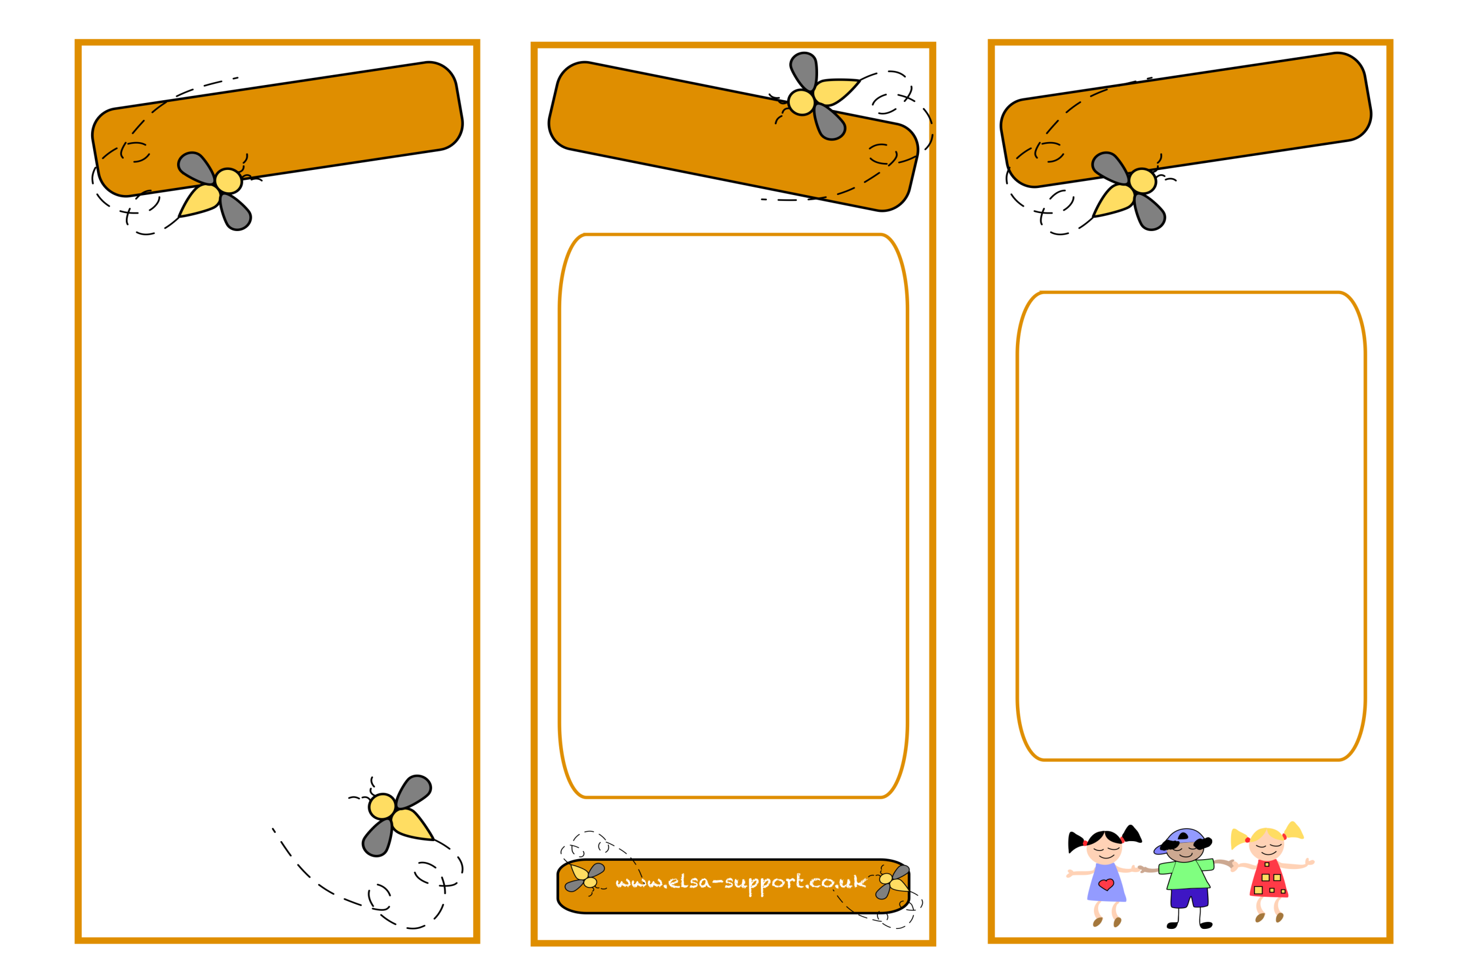
Information for parents/carers
Relationships
Self-esteem
Social skills
Recognising Emotions
Friendships
Understanding Anger
Anxiety
Coping Strategies
Building Resilience
Loss and Bereavement
Relaxation techniques
Emotional
Literacy
Support
Assistant

- Find time to listen to your child.
- Do lots of fun things together.
- Encourage your child to see the positives in every situation.
- Encourage problem solving to find peaceful solutions.
- Help your child to see things from the view of other people.
- Discuss any problems or concerns you have with your child’s teacher/SENCo

What can I do at home?
ELSAs can help with…
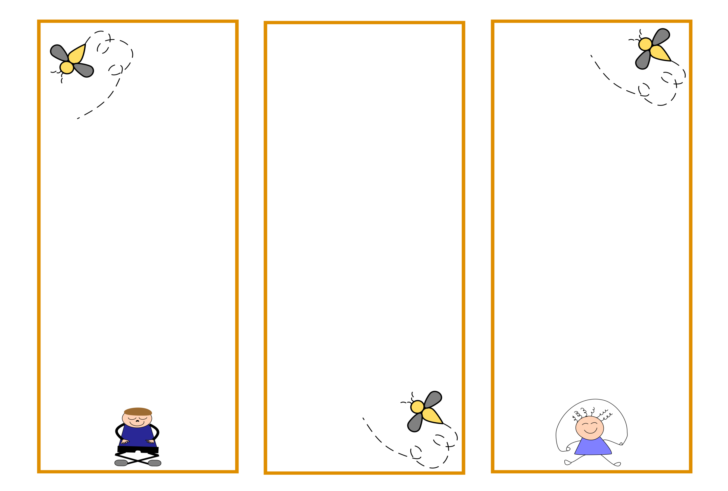

ELSA’s work closely with teachers to set clear targets for pupils. The ELSA will then work on these targets with the pupil individually or in a small group. Activities to support the needs of the pupil will be planned carefully by the ELSA.
ELSA’s will help children learn to understand their emotions and respect the feelings of those around them. They can provide time and space for pupils to think about their personal circumstances and how they can manage them.
ELSA’s have close links with the Child and Educational Psychology Team.

Pupils learn better and are happier if their emotional needs are addressed.
They may learn to:
- Develop coping strategies and talk about difficulties.
- Interact more successfully with others.
- Develop greater self-awareness.
- Manage school better and feel better about themselves.
Research regarding ELSA shows that pupils working with an ELSA feel they have been listened to and supported, commenting that:
“I don’t worry anymore.”
“I have learnt lots about myself.”
“It was nice to talk openly.”

What are the benefits?

What do ELSA’s do?

Who are ELSA’s?
An ELSA is a member of staff who has been trained to work with pupils who may benefit from additional support to develop emotional literacy skills. For example, in managing feelings of anxiety, anger or low self-esteem.
ELSA’s have been chosen for their ability to build good relationships with pupils.

The ELSAs in your school are Mrs Hamnett, Mrs Parker and Miss Sutton.

