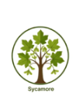
Sycamore
AUTUMN

RELIGIOUS EDUCATION
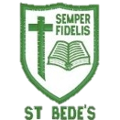
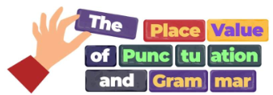
MATHS

We begin our year reflecting on our wonderful world and all of God’s creation. Through different ways of knowing we will listen to, reflect on and discuss scripture and images from the Bible.
We will look at Moses and focus on the two key events of the call and the covenant.
Y4 will read, write, order and compare numbers up to 10,000. Y5 will consolidate our understanding of 5-digit numbers and move on to explore 6-digit numbers. We will focus on recognising the place value of each digit, so we can confidently add tens, hundreds, thousands, ten thousands and hundred thousands mentally. This will support us in confidently reading numbers up to 1 million for Y5.

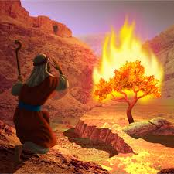
ENGLISH

We will begin our term refreshing our knowledge of punctuation and grammar.

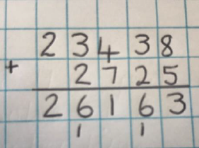
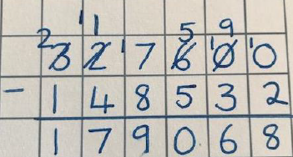
Once secure in our knowledge, we will be using the text Queen of the Falls to write a series of diary entries. We will be focusing on our use of fronted adverbials and the use of paragraphs.
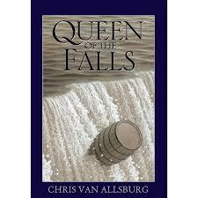
We will explore what a ‘covenant’ is. We will also look at how we can care for God’s creation and how we can be better neighbours.


We will then move onto rounding, negative numbers, addition and subtraction. We will look at a variety of ways to add and subtract numbers mentally. We will then move onto adding and subtracting numbers with more than 4-digits in a written method. Our skills will be applied to reasoning and problem-solving questions throughout this unit.

We will also look at Counting on Katherine and write a fact file about Katherine Johnson, including a short biography. The focus will on using expanded noun phrases to convey meaning .
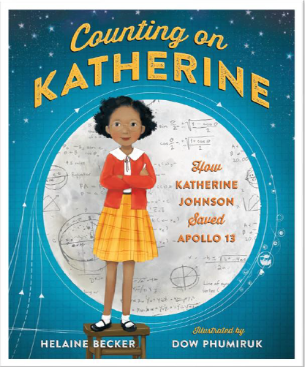
CATHOLIC SOCIAL TEACHING

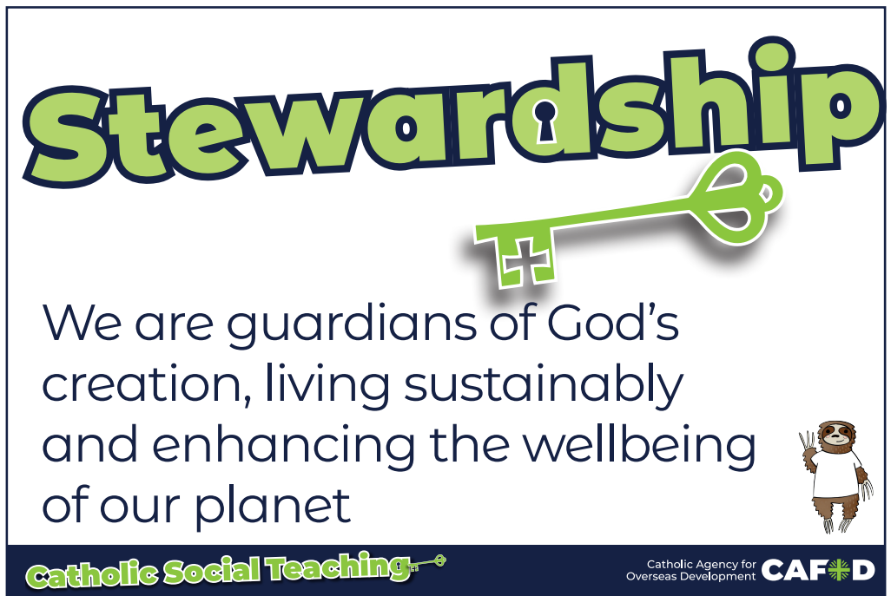
Intertwined with our RE and other topics, we will listen to and explore the Catholic Social Teachings. This term, we will be

In
You all need to know all of our times tables
In reading this term, we will read a selection of text to ask questions to improve understanding and to draw inferences (inferring characters’ feelings, thoughts and motives from their actions); and also justify with evidence. Reading is really IMPORTANT at home too to support the development of skills
up to 12 x 12. Y4 will sit a statutory test in June 2027. Log on to TTRS to keep practicing!

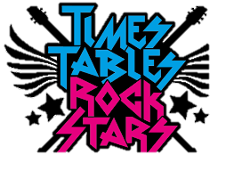

focusing on ‘Stewardship’ which looks at what we can do to help take care of God’s creation.

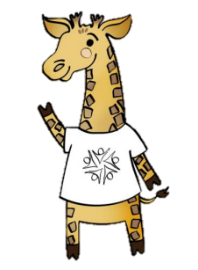

Please ensure your child comes in dressed in suitable PE kit.
- Green school hoodie/jumper
- Green/dark tracksuit bottoms (outdoor) or green shorts
- White t-shirt
- Sport trainers (encourage independence in tying laces)

PE Our PE days are Tuesday and Thursday. Year 4 will be swimming on a Tuesday. Throughout the Autumn term, we will be focusing on invasion games as part of as part of our games curriculum.

SCIENCE

PSHE
We will be using the ‘Zones of Regulation’ to support us in regulating our emotions

ART

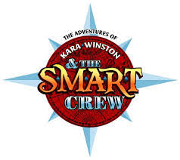
How can we find our own style of drawing?
In this drawing unit, we will explore different styles of drawing to develop our own style.
We will use our observational skills to sketch and select different pencils for different effects.
Y5 Weekly Music Makers - We will learn to play an instrument and begin to read music
Y4 - Pupils will appreciate and understand a range of music drawn from different traditions.
In our History this half term, we will be learning about the Anglo Saxons and Vikings.
We will look at the Anglo-Saxons and Vikings and their achievements from 410 CE to 1066 CE. We will explore life in England after the fall of the Roman Empire and the reasons why the Anglo-Saxons travelled to England’s shores and decided to settle. We will finish by looking at who the Vikings were, why they carried out raids in England and how their arrival impacted the political and social hierarchy of the time.
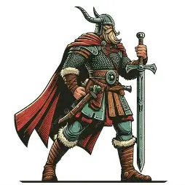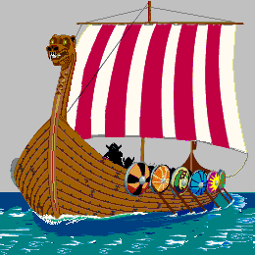

This term, the children will:
- Be able to describe feelings and answer the question ‘how are you?’ with some detail
- Name school subjects and give an opinion on them
Properties and changes of materials
We will learn:
- to compare and group together materials on the basis of their properties (hardness, solubility, transparency, conductivity and response to magnets)
- that some materials will dissolve in liquid to form a solution and describe how to recover a substance from a solution
- to use our knowledge of solids, liquids and gases to decide how mixtures might be separated
- the particular uses of everyday materials
- to demonstrate that dissolving, mixing and changes of state are reversible changes
- that some changes result in the formation of new materials, and that this kind of change is not usually reversible
MUSIC

FRENCH

DT
Our focus will be on Textiles and we will make a wall hanging using different types of stitching and applique.



HISTORY
STO RY

COMPUTING
E-Safety
The year will begin with us learning how to stay safe online. We will use the SMART crew to support us with this.
We will then move onto using hardware for quizzing and coding.

