
St Bede’s Catholic Primary School
Reception Autumn Term 1
Other Important Information/Top Tips for Reception: Children need to bring;- a water bottle filled with water and their book bag with reading books and reading journal. Please read with your child 4x per week at home and record in their reading journal. Children in Reception are entitled to free school meals and free fruit at playtimes. Packed lunches must be healthy, balanced with no chocolate and no nuts. Our PE day is Thursday – the children will leave their PE kit in school for the half term and will get changed in class to promote their independence. The PE kits will be sent home at the end of every half term to be washed.

fruit at playtimes. Snacks and packed lunches must be healthy,

balanced, with limited sugar, no chocolate and NO NUTS.

Communication & Language
Communication and Language is developed throughout the year through high quality speaking and listening interactions, daily group discussions, sharing circles, PSHE sessions, story sessions, singing, speech and language interventions, assemblies and weekly interventions.
Phase 1 phonics skills, games, stories and rhymes to promote listening skills and understanding.
Introduce circle times to promote positive interactions with their new peers and adults.

Settling in activities and carpet times.
To learn nursery rhymes, poems and songs.
To use language to imagine and play.
Adults modelling language throughout the day.
Introduction of talking partners to promote talk
within focused activities.
Develop discussions during snack time using Picture News.
Individual speech assessment (WELLCOMM).
Personal, Social & Emotional Development
Personal, Social & Emotional Development (PSED) focuses on helping children build a positive sense of self, develop strong relationships, and manage their emotions effectively. It's a crucial area for future well-being and learning, encompassing how children interact with others and how they understand and express their own feelings. The key aspects to PSED are self-regulation, managing self and building relationships.
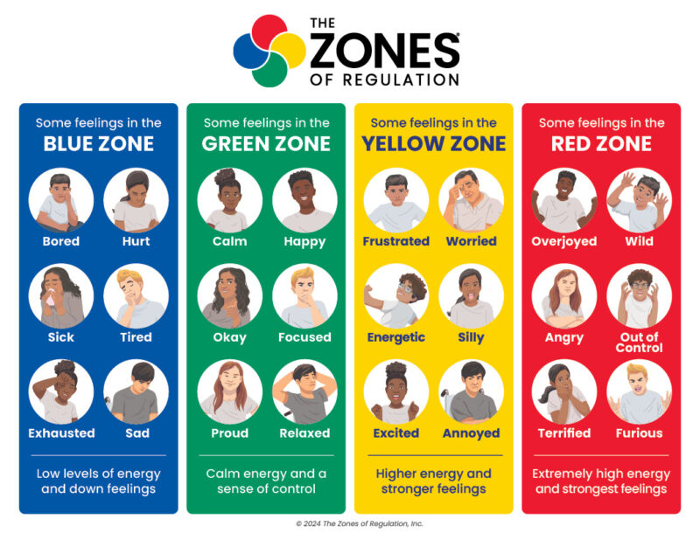
Children will be supported by adults to settle into their new school routines, with lots of short circle times and activities to ensure the children feel happy and secure in their new setting. To follow class rules and show responsibility, to be able to follow simple instructions, to have confidence to manage their own needs and to regulate their own feelings and behaviours.
We will be using ‘Zones of Regulation’ where we will be introducing the 4 zones.

Prime Areas
Physical Development
Physical Development in the early years refers to the growth of the body and brain from birth through early childhood. This includes changes in body size, muscle strength, balance, co-ordination, sensory development, and skills such as movement and handling. It focuses on developing and refining gross motor skills (like running, climbing, balancing) which uses the whole body and fine motor skills (like holding a pencil, using tools for writing, and managing clothing fasteners) which involve the small muscles in our bodies.
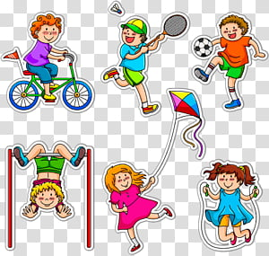  Gross Motor:  Cooperation games i.e., parachute games.  Climbing on outdoor equipment.  Using bikes.  Different ways of moving to be explore (rolling, crawling, walking, jumping, running, hopping, skipping, climbing).  Developing good personal hygiene. | 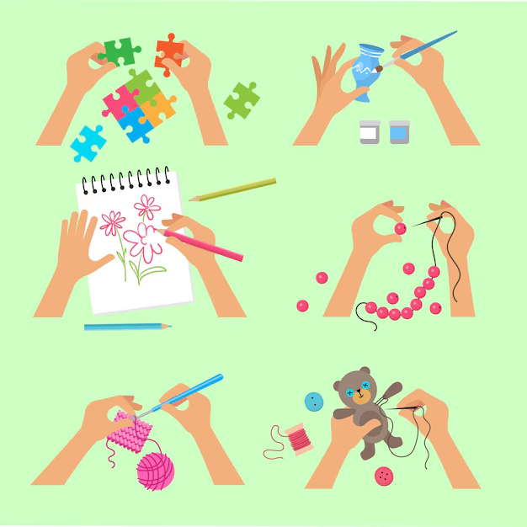  Fine Motor:  Dough Disco  Daily name writing activities.  Threading, cutting, weaving, playdough, finger gym activities.  Manipulate objects with good fine motor skills.  Show preference for dominant hand.  Draw lines and circles using gross motor movements.  Hold pencil/paint brush beyond whole hand grasp.  Getting changed for PE, navigating buttons.
We follow ‘Complete PE’ and within our PE sessions, we will be:
Exploring playing with equipment safely. Taking turns. Using equipment and other objects to travel.
Mathematics
Mathematics in the early years involves building foundational skills through play and everyday activities, focusing on number, measurement, shape, and patterns to develop problem-solving and spatial awareness. Key activities include counting objects, sorting, recognising numerals, estimating quantities, comparing sizes, and using mathematical vocabulary to make sense of the world.
We follow ‘First 4 Maths’ and we will be covering:
Cardinality & Counting -
Accurate counting of sets of objects 1-5.
Subitising 1-3.
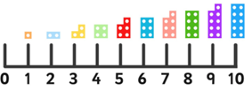
Numeral recognition to 5.
Composition -
Conceptual subitising.
Comparison -
Compare sets 1-5.
Measures -
Height.
Religious Education

Creation and Covenant:
- The words and actions of the sign of the cross.
- God created the world and said, “Indeed it is very good” (Gensis 1:31).
- The whole of creation shows God’s love for us (‘Laudato Si’).
- God made each one of us a unique person and we are part of a family.
- We enter God’s family, the Church, through baptism.
- We must look after God’s gifts.
- Catholic Social Teaching – Stewardship.
Specific Areas
Literacy
Literacy in the early years focuses on building foundational language, communication, and pre-reading/writing skills, rather than teaching children to read or write before they are ready. It involves activities like talking, singing, shared book reading, and early mark-making to develop spoken language, phonological awareness (understanding sounds in words), print awareness, and physical skills for writing.
It is crucial for children to develop a life-long love of reading. Reading consists of two dimensions: language comprehension and word reading.
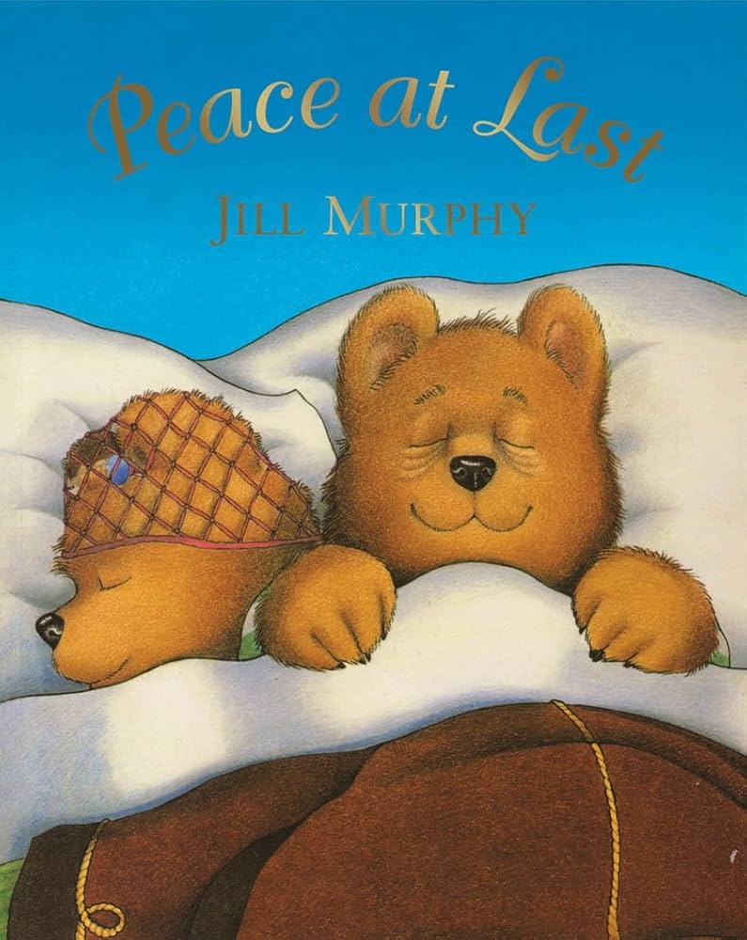  We follow Pathways to Write, and our text is ‘Peace at Last’ by Jill Murphy.  We will be depicting the main events of the story using images and mark making next to each image. | 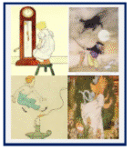  We follow Pathways to Poetry and our text is ‘A Bundle of Rhymes’ by Mother Goose.  We will be reciting rhymes and using them to build a narrative. | 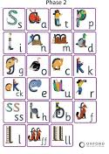  We follow ‘Essential Letters and Sounds’ and we will be doing phonics every day, covering phase 2.
Understanding the World
covers past & present, people, culture & communities and the natural world. It involves guiding children to make sense of their physical world and their community. It covers history, geography, science, geography and computing.
History -
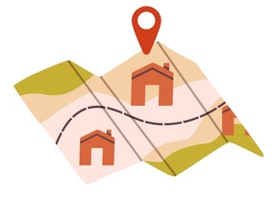
All About Me & My Family

Science –
Our bodies/our senses
Light & Dark
Nocturnal Animals
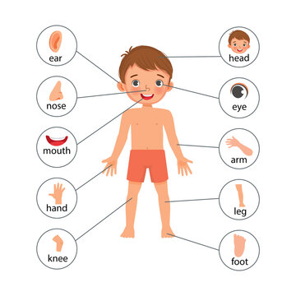

Geography –
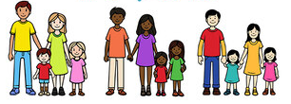
All About Me – Where do I live?
Computing –
Online Safety
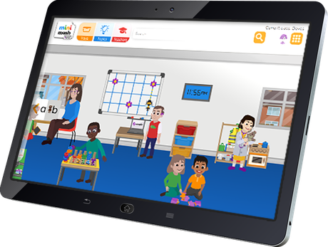
Introduction to Purple Mash (Mini Mash)
Expressive Arts & Design - This focuses on fostering children's creativity, imagination, and self-expression through various artistic and design activities. It involves providing children with opportunities to explore and experiment with different materials, media, and techniques, encouraging them to communicate their thoughts, ideas, and feelings through creative and imaginative play.
Art & Design - Self Portraits Van Gogh (The Starry Night)
Design & Technology – Design a Shadow Puppet
Music Express – Our Senses Animals

