RELIGIOUS EDUCATION
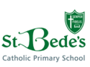
Oak Class Curriculum Map
Autumn 2025
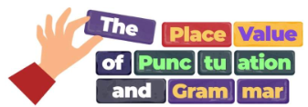
MATHS

ENGLISH

The
In our first unit, the children will explore key stories from Genesis, from creation to the beginnings of God's covenant with His people. The unit highlights themes of faith. Hope and love, helping children understand their connection to His covenant today.
Place Value
The focus for our maths learning this term is

Y3 will read, write, order and compare numbers up to 1,000, Year 4 to 10,000. They will also round whole number to varying degrees of accuracy and use negative numbers in context, and calculate intervals across zero. We will also focus on addition, subtraction, multiplication and division methods. Column multiplication and short division methods will be taught to the children. In all the areas there will be a focus on mental calculations, including with mixed operations and large numbers. They will solve some 2-step problems in contexts, deciding which operations and methods to use for efficient calculation.
We will also cover perimeter and area of shape this term.

We will begin our term refreshing our knowledge of punctuation and grammar.
After half term, we will journey first through key Old Testament events and learn about some key people. They learn about the life of the prophet Elijah. They then move to the New Testament to learn about John the Baptist and the season of Advent.

Once secure in our knowledge, we will be using the text Leon and the Place Between to extend our range of sentences, build a rich and varied vocabulary and use the possessive apostrophe accurately.
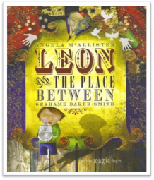

In reading this term, we will be studying The Windrush SStory and learn how to draw inferences, and ask questions to improve understanding.
We will also be reading The Nothing To See Here Hotel.
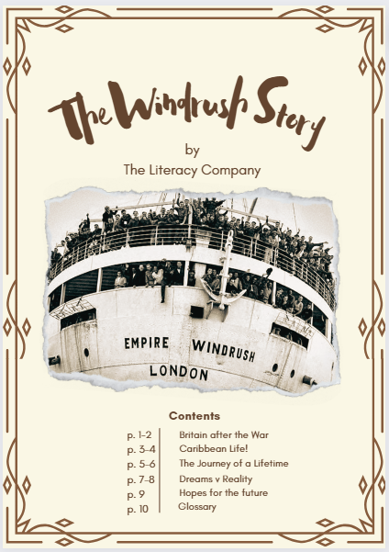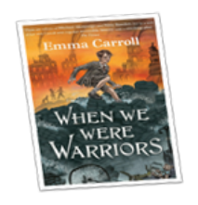
CATHOLIC SOCIAL TEACHING

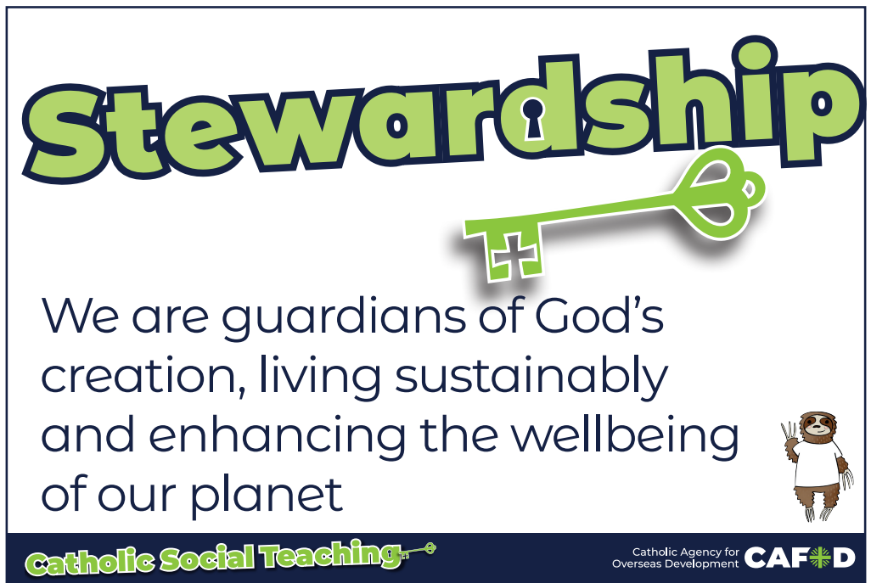
Intertwined with our RE and other topics, we will listen to and explore the Catholic Social Teachings. We will reflect on how we

By the end of Year 4 children need to be confident with all times tables and all the children should be accessing TTRS at home as well as in school to ensure they are keeping these skills sharp. Soundcheck is the best game to practice

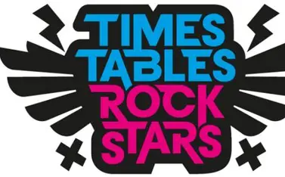
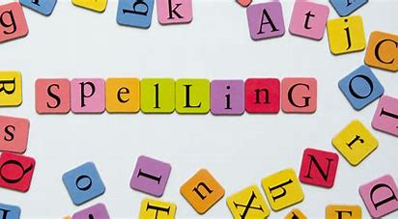
Handwriting will be taught weekly linked to our weekly spelling pattern and this needs to be reinforced at home.
can live the gospel in today’s world, thinking about how we can take care of our world and the creatures and people within it.

PE Our PE days are Tuesday and Thursday this term. We aim to be outside so it is important to come to school prepared to take part in an outdoor lesson. In netball, tag rugby and hockey, we will be building on the skills of passing, moving to space, attacking and defending, as well as shooting.

Please ensure your child comes in dressed in suitable PE kit.
- Green school hoodie/Jumper
- White t shirt and green shorts with green/dark tracksuit bottoms in colder weather
- Sport trainers

SCIENCE

ART
In this drawing unit, the children will learn specific skills and techniques to confidently use line, shape and value to create their own artwork. They will use pencils and ballpoint pens to explore shading, blending and mark-making and will have developed a proficiency at controlling and selecting the appropriate tools. They will be able to articulate their observations. They will evaluate their own work as well as that of their peers.

PSHE
‘Picture News’ weekly topical discussion; Zones of Regulation




COMPUTING

Is it safe to share personal information online? Even with friends?
What is meant by my digital footprint?
How can I ensure I am not sharing inappropriate content online?
Why is it important to think about how much time use a screen for?

What is a spreadsheet used for?
How do you carry out a multiplication calculation?
How does using the SUM function save time?

HISTORY

This unit looks at the Anglo-Saxons and Vikings and their achievements from 410 CE to 1066 CE. The first lessons explore life in England after the fall of the Roman Empire and the reasons why the Anglo-Saxons travelled to England’s shores and decided to settle. This moves on to finding out how England was ruled during the settlement of the Anglo-Saxons and how they kept control of the 7 different kingdoms across the land. It finishes with a look at who the Vikings were, why they carried out raids in England and how their arrival impacted the political and social hierarchy of the time.

States of Matter
During this unit of work, the children will learn about the properties of solids, liquids and gases. They will learn that matter can change state through heating and cooling, carrying out some simple experiments of their own.
The children will then learn about the water cycle.


MUSIC
Pupils appreciate and understand a range of music drawn from different traditions. Listen to music and discuss musical elements, instruments and matching rhythms musical language. Compose music planned for a given purpose and mood effectively

- We will start the year thinking about how to stay safe online:
- Emails
- Unpacking hardware and software

DT
Children will learn about Fair Trade and sustainability. They will focus on the journey of chocolate from bean to bar and will create their own chocolate product designs
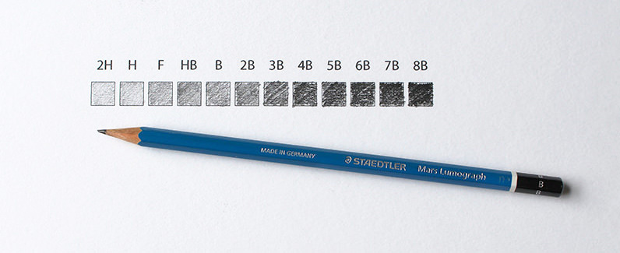
In this drawing unit, children will learn how artists create perspective, how they use line, shape, and value to create a sense of form, and about different shading techniques. They will learn from the work of great painters, modern artists, and collagists. They will become more confident while creating their own more divergent outcomes.
How do artists draw perspective?

Electricity
During this unit of work, children will construct simple series circuits and draw them using scientific symbols. They will conduct investigations to determine how the way in which a circuit is set up affects the brightness of a bulb. They will learn about electrical safety and about conductors and insulators in a circuit. They will learn how a switch makes and breaks a circuit and design working switches of their own.

During this term the children will cover:
Greetings
Days and months
Learn classroom commands
School rooms
Classroom objects
Fireworks
Places in town
Christmas shopping

FRENCH




