**YEAR 5**

**AUTUMN**

**RELIGIOUS EDUCATION**

[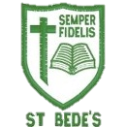](https://pbs.twimg.com/profile_images/532288766774218753/a3q47RO2.jpeg)

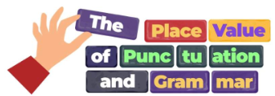

**MATHS**

We begin our year reflecting on our wonderful world and all of God’s creation. Through ***different ways of knowing*** we will listen to, reflect on and discuss scripture and images from the Bible.

We will look at Moses and focus on the two key events of the call and the covenant.

Using a range of equipment, we will consolidate our understanding of 5-digit numbers before moving on to explore 6-digit numbers. We will focus on recognising the place value of each digit, so we can confidently add tens, hundreds, thousands, ten thousands and hundred thousands mentally. This will support us in confidently reading numbers up to 1 million.

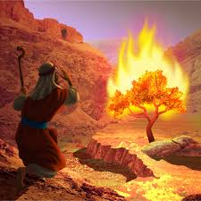

**ENGLISH**

We will begin our term refreshing our knowledge of punctuation and grammar.

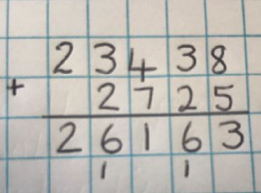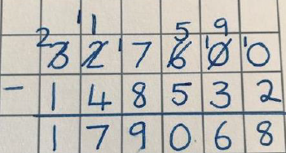

Once secure in our knowledge, we will be using the text ***Queen of the Falls*** to write a series of diary entries. We will be focusing on our use of fronted adverbials and the use of paragraphs.

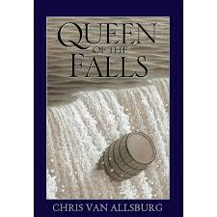

We will explore what a ‘covenant’ is. We will also look at how we can care for God’s creation and how we can be better neighbours.



We will then move onto addition and subtraction, where will look at a variety of ways to add and subtract numbers mentally. We will then move onto adding and subtracting numbers with more than 4-digits in a written method. Our skills will be applied to reasoning and problem-solving questions throughout this unit.

We will then move onto the book ***The Lost Happy Endings*** which is a magical tale. We will build up to writing our own version of the tale. Our focus will be on building an atmosphere using expanded noun phrases and including correctly punctuated speech.

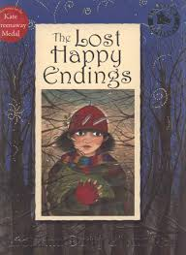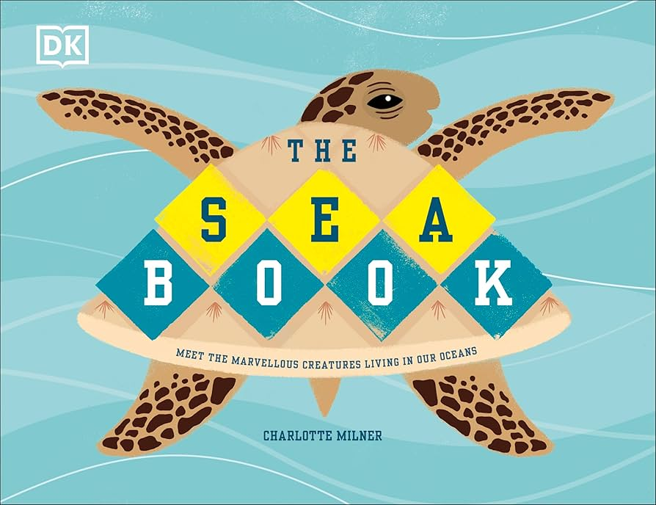

**CATHOLIC SOCIAL TEACHING**

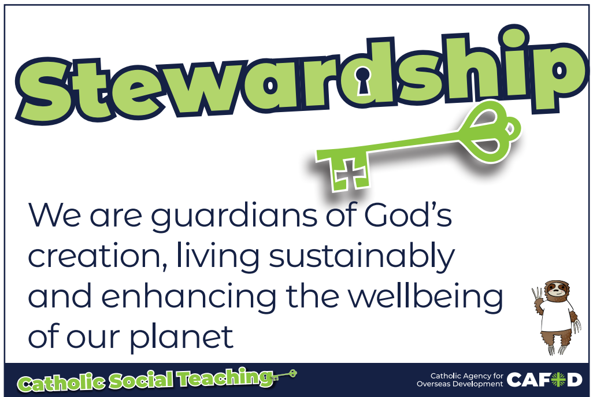

Intertwined with our RE and other topics, we will listen to and explore the Catholic Social Teachings. This term, we will be

In Year 5, we need to know all of our times tables

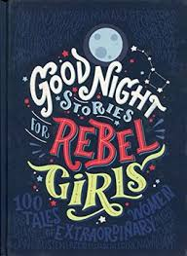

In reading this term, we will be improving our inference skills using the text ***Goodnight Stories for Rebel Girls*** which is a book full of inspirational women.

up to 12 x 12. Log on to **TTRS** to keep practicing!

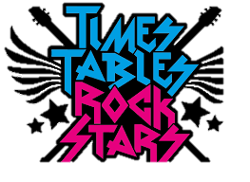

focusing on ‘Stewardship’ which looks at what we can do to help take care of God’s creation.

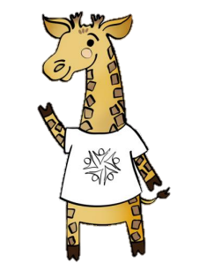

**Please ensure your child comes in dressed in suitable PE kit.**

* Green school hoodie/jumper
* Green/dark tracksuit bottoms (outdoor) or green shorts
* White t-shirt
* Sport trainers (encourage independence in tying laces)

**PE**  Our PE days are **Monday** and **Wednesday**. Throughout the Autumn term, we will be doing netball and football as part of our games curriculum. We will also be looking at how to stay fit and healthy in our ‘Health Related Exercise’ unit, and will work on our map skills with orienteering.

**SCIENCE**

**PSHE**

We will be using the ‘Zones of Regulation’ to support us in regulating our emotions

**ART**

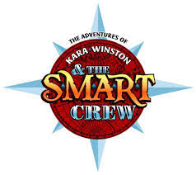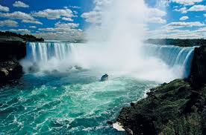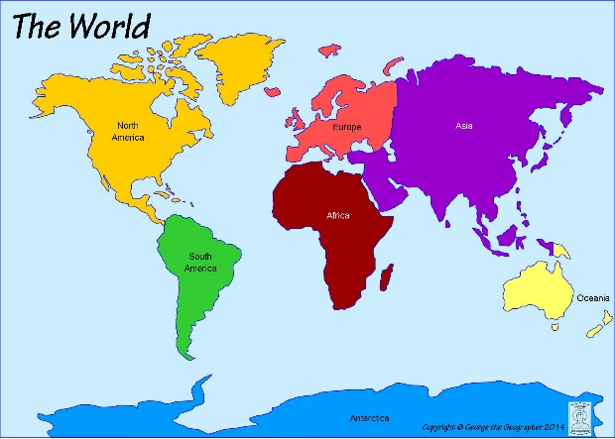

**This term, the children will:**

* Be able to describe feelings and answer the question ‘how are you?’ with some detail
* Name school subjects and give an opinion on them

**Properties and changes of materials**

**We will learn:**

- to compare and group together materials on the basis of their properties (hardness, solubility, transparency, conductivity and response to magnets)

- that some materials will dissolve in liquid to form a solution and describe how to recover a substance from a solution

- to use our knowledge of solids, liquids and gases to decide how mixtures might be separated

- the particular uses of everyday materials

- to demonstrate that dissolving, mixing and changes of state are reversible changes

- that some changes result in the formation of new materials, and that this kind of change is not usually reversible

**How can we find our own style of drawing?**

In this drawing unit, we will explore different styles of drawing to develop our own style.

We will use our observational skills to sketch and select different pencils for different effects.

In our Geography this half term, we will be learning about the continent **North America.**

We will identify the countries of North

America and learn about some of the

famous man made and natural

geographical features. For example:

the Great Lakes, Niagara Falls, the Grand Canyon.

Then we will look more closely at the USA and some of its states. We will then compare an area in North America to where we live.

We will learn to play an instrument and begin to read music

**MUSIC**

**FRENCH**

**DT**

This term, we will be using our culinary skills to visit Central America.



**GEOGRAPHY**



**COMPUTING**

**E-Safety**

The year will begin with us learning how to stay safe online. We will use the SMART crew to support us with this.

We will then move onto databases, where we will learn to search for information in a database, before creating our own.