A KSJ Approach to Lockdown 2

In case you are wondering what online learning is like during this lockdown, here is an overview of life for the children of Kingsley St John’s CE Aided Primary School.

Most of our KSJers have been learning form home instead of coming into school since January 5th.
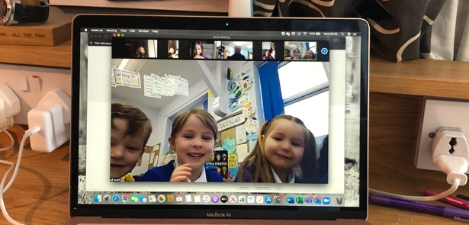

It has been a bit of a shock and an adjustment, but the teachers have been working incredibly hard to try to keep the days as normal as possible.
Each class have a morning zoom session. This is where we can all start the day off with positivity and listen to the explanation of the day’s planned work.
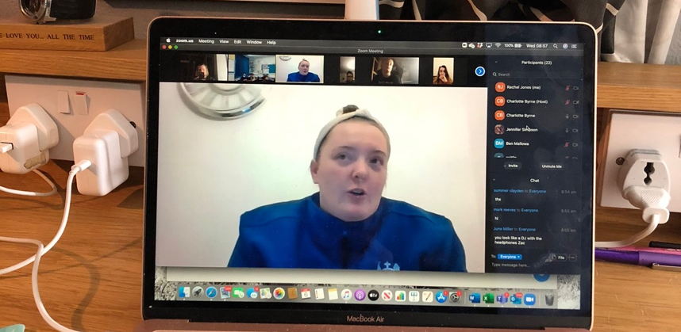

The children then have a set of tasks to complete – as close to the normal curriculum as possible. The children can complete the tasks in their own time and share it with the teacher via email.
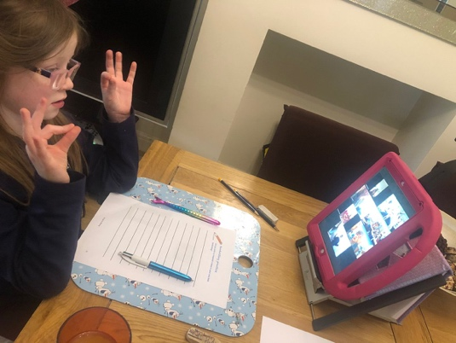

Then there is another zoom in the afternoon for the classes to say a prayer and share their learning. Some classes also have a story at this time.

On a Friday there is a celebration zoom for everyone in our school family to attend and look at the brilliant and hard work that has been completed in the week and to celebrate some achievements. It is also a chance to say thank you to our parents for their support and patience.

Learning online, during lockdown is tiring, but it is still fun. And we are all continuing to learn together, to see hope in the future and keep each other safe and happy.

