Kingsley St John’s Curriculum Statement
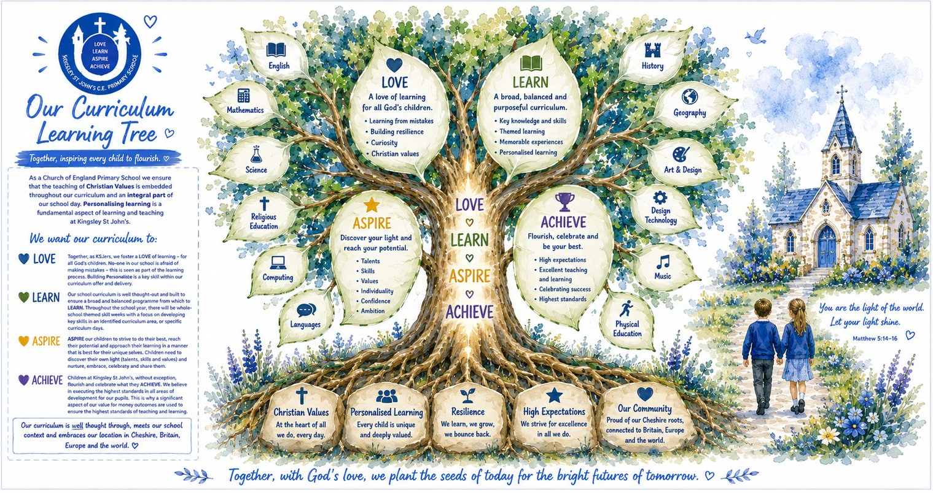
‘Believe in the light, whilst you have the light, so that you may become children of light.’ John 12:36
Intent
At Kingsley St John’s, our curriculum is rooted in our Christian vision and values. We aim to provide a broad, balanced and ambitious curriculum that enables every child, without exception, to flourish.
Our curriculum is designed around our commitment to LOVE, LEARN, ASPIRE and ACHIEVE.
LOVE – Together, as KSJers, we foster a love of learning for all God’s children. We want our pupils to be curious, enthusiastic and confident learners who understand that making mistakes is an important part of learning. We nurture resilience so that children are willing to persevere, take appropriate risks and learn from challenges.
LEARN – We provide a carefully considered, broad and balanced curriculum which develops children's knowledge, skills and understanding. Learning is purposeful, engaging and relevant, enabling pupils to make connections and build upon what they already know.
ASPIRE – We encourage every child to strive to do their best and fulfil their unique potential. Children are supported to discover their own light – their talents, skills and values – and are encouraged to nurture, embrace, celebrate and share these with others.
ACHIEVE – We have high expectations for every pupil and are committed to ensuring that all children have opportunities to flourish and celebrate their achievements. We strive for the highest standards of teaching and learning while recognising and valuing each child's individual starting points and strengths.
Our curriculum reflects the context of our school and embraces our place within Cheshire, Britain, Europe and the wider world, helping children develop an understanding of their community and their place within an increasingly interconnected world.

Implementation – How do we deliver our curriculum?
Our curriculum is carefully planned and sequenced so that pupils progressively develop their knowledge, vocabulary and skills as they move through the school. Teachers build upon prior learning, make meaningful connections between learning and provide opportunities for children to revisit and apply what they have learned.
High-quality teaching is at the heart of our curriculum. Learning is personalised so that children can access appropriate challenge and support, enabling all pupils to make progress from their individual starting points.
Our Christian values are embedded throughout curriculum delivery and everyday school life. Children are encouraged to demonstrate these values through their learning, relationships and contribution to the wider school community.
We enrich the curriculum through purposeful experiences, including whole-school themed skill weeks and specific curriculum days, which provide opportunities to deepen learning and develop key skills across identified curriculum areas.
Teachers create classrooms in which questioning, curiosity and discussion are encouraged. Children are taught that mistakes are valuable opportunities for learning, helping them develop resilience, independence and confidence.
Our curriculum also makes meaningful use of our local context and wider connections. Children learn about their locality in Cheshire while developing their knowledge and understanding of Britain, Europe and the wider world.
Assessment is used purposefully to identify what pupils know and understand, recognise misconceptions and gaps, and inform subsequent teaching. This enables teachers to adapt learning so that pupils can know more, remember more and increasingly apply their knowledge and skills independently.

Impact – What difference does our curriculum make?
The impact of our curriculum is seen in children who LOVE, LEARN, ASPIRE and ACHIEVE.
Children develop a genuine love of learning and demonstrate curiosity, resilience and confidence. They understand that mistakes form part of the learning process and are increasingly able to persevere when they encounter challenge.
Pupils develop secure knowledge, understanding and skills across a broad range of curriculum areas. They can make connections with previous learning, articulate what they have learned and increasingly apply their knowledge and skills in different contexts.
Children have high aspirations for themselves. They recognise their individual talents, skills and values – their own light – and have the confidence to nurture, celebrate and share these with others.
Our pupils achieve well from their individual starting points and take pride in both their academic and personal development. They demonstrate the Christian values that underpin school life and show respect and consideration for others.
Ultimately, children leave Kingsley St John’s as confident, resilient and compassionate learners who understand themselves, value others and are well prepared for the next stage of their education and their place within their community and the wider world.
At Kingsley St John’s, our curriculum enables every child to discover their light: to LOVE learning, to LEARN with purpose, to ASPIRE to fulfil their potential and to ACHIEVE with confidence.

