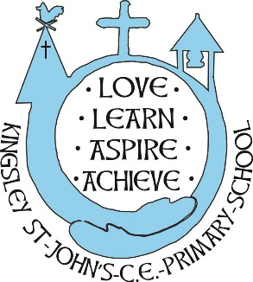
Kingsley St John’s CE Primary School
Term Time and Holiday Dates
2027-2028

Term | Date school opens | Date school closes
Autumn | Thursday 2nd September 2027 | Friday 22nd October 2027
Autumn | Half Term: Monday 25 October – Friday 29 October
Autumn | Tuesday 2nd November 2027 | Friday 17th December 2027
Autumn | Christmas Holiday: Monday 20 December – Monday 3 January
Spring | Wednesday January 5th 2028 | Friday 11th February 2028
Spring | Half Term: Monday 14 February – Friday 18 February
Spring | Monday 21st February 2028 | Friday 31st March 2028
Spring | Spring Break: Friday 3 April – Monday 17 April
Summer | Tuesday 18th April 2028 | Friday 26th May 2028
Summer | Half Term: Monday 31 May – Friday 4 June
Summer | Tuesday 6th June 2028 | Thursday 20th July 2028
Summer | Summer holidays: Friday 21 July – Monday 4 September

INSET DAYS
Wednesday 1st September 2027
Monday 1st November 2027
Tuesday 4th January 2028
Monday 5th June 2028
Friday 21st July 2028

