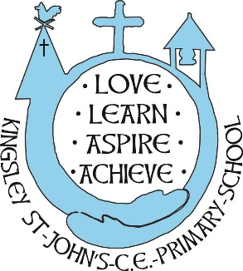
Kingsley St John’s CE Primary School
Term Time and Holiday Dates
2026-2027

Term | Date school opens | Date school closes
Autumn | Wednesday 2nd September 2026 | Friday 23rd October 2026
Autumn | Half Term: Monday 26 October – Friday 30 October
Autumn | Tuesday 3rd November 2026 | Friday 18th December 2026
Autumn | Christmas Holiday: Monday 21 December – Friday 1 January
Spring | Tuesday January 5th 2027 | Friday 12th February 2027
Spring | Half Term: Monday 15 February – Friday 19 February
Spring | Monday 22nd February 2027 | Wednesday 24th March 2027
Spring | Spring Break: Thursday 25 March – Friday 9 April
Summer | Monday 12th April 2027 | Friday 28th May 2027
Summer | Half Term: Monday 31 May – Friday 4 June
Summer | Monday 7th June 2027 | Tuesday 20th July 2027
Summer | Summer holidays: Wednesday 21 July – Tuesday 31 August

INSET DAYS
Tuesday September 1st 2026
Monday November 2nd 2026
Monday January 4th 2027
Thursday March 25th 2027
Wednesday July 21st 2027

