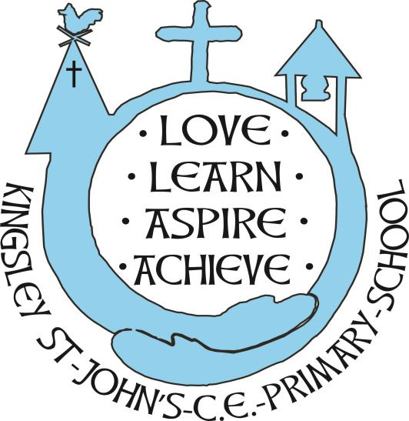
Kingsley St John’s CE Aided Primary
Healthy Food and Drink Policy

In our school we are committed to giving all our pupils consistent messages about all aspects of health to help them understand the impact of particular behaviours and encourage them to take responsibility for the choices they make.
- Kingsley St John’s CE Primary School is a healthy school. It is important that we consider all elements of our work to ensure that we promote health awareness in all members of the school community and can provide a valuable role model to pupils and their families. Through effective leadership, the school ethos and the curriculum, all school staff can bring together all elements of the school day to create an environment which supports a healthy lifestyle. Eating at Kingsley St Johns should be a pleasurable experience.
Aims and Objectives
- To ensure that the school gives consistent messages about food and health
- To give our pupils the information they need to make healthy choices
- To promote health awareness
- To contribute to the healthy physical development of all members of our school community
- To encourage all children to think about their food choices and maintain a balanced diet
- To meet the requirements of the EYFS safeguarding and welfare requirements for nutrition guidance.

As part of the Government initiative all our under 5s are provided with free milk for the first 2 terms of their reception year, KS1 children receive free fruit/vegetables during the day. KS2 children are allowed to bring in a snack of fruit or a fruit bar for playtimes. There is also the opportunity for all children to purchase, toast, teacakes, crumpets, milk and juice at morning break time.
School lunches and packed lunches
All our school meals are provided by a contracted caterer, who has a healthy food policy as part of their tender. Where possible, this includes the use of fresh fruit and vegetables each day as a choice for the children. They provide a free hot meal for all of our FS/KS1 pupils and KS2 pupils can purchase a hot meal. All of which pays regard to nutritional balance and healthy options.
Many children bring packed lunch to school. We do not allow sweets, chocolate bars (although chocolate covered biscuits are allowed) or fizzy drinks. Crisps are also discouraged in packed lunches.
Water for all
Cooled water is freely available throughout the school day to all members of the school community. No water fountains are located inside toilet blocks. All children can purchase a water bottle. Children may drink their water at any time except when a teacher is talking. FS and KS1 children are also reminded to drink water. Foundation Stage are provided with semi-skimmed milk.
Food across the Curriculum
In FS, KS1 and KS2, there are a number of opportunities for pupils to develop knowledge and understanding of health, including healthy eating patterns and practical skills that are needed to understand where food comes from such as shopping, preparing and cooking food. During cookery sessions children are taught food hygiene, healthy eating and food preparation techniques.
Literacy provides children with the opportunity to explore poetry, persuasion, argument and narrative work using food and food related issues as a stimulus, eg writing to a company to persuade them to use non-GM foods in children's food and drink etc.
Maths can offer the possibility of understanding nutrition labelling, calculating quantities for recipes, weighing and measuring ingredients.
Science provides an opportunity to learn about the types of food available, their nutritional composition, digestion and the function of different nutrients in contributing to health and how the body responds to exercise.
RE provides the opportunity to discuss the role of certain foods in the major religions of the world. Children experience different foods associated with religious festivals.
ICT can afford pupils the opportunity to research food issues using the internet and other electronic resources. Pupils design packaging and adverts to promote healthy food choices.
Food Technology as part of DT provides the opportunity to learn about where food comes (school allotment) from and apply healthy eating messages through practical work with food, including preparation and cooking.
PSHCE encourages young people to take responsibility for their own health and well-being, teaches them how to develop a healthy lifestyle and addresses issues such as body image. Pupils are able to discuss issues of interest to young people, eg advertising and sustainable development.
Geography provides a focus on the natural world and changing environment, offering the chance to consider the impact our consumer choices have on people across the world who rely on growing food as their source of income. History provides insight into changes in diet and food over time.
Physical Education provides pupils with the opportunity to develop physically and to understand the practical impact of sport, exercise and other physical activity such as dance and walking.
School visits provide pupils with activities to enhance their physical development eg to activity centers.
Partnership with parents and carers
The partnership of home and school is critical in shaping how children and young people behave, particularly where health is concerned. Each must reinforce the other. This is not always easy but our school is well placed to lead by example.
Parents are asked not to send in fizzy drinks and are reminded that only water may be drunk during the school day, except at lunch when children may drink juice or squash.
An important aspect of our philosophy is a personalised approach to learning. This is for all aspects of a child’s development, including eating. Individualised support can be put into place for any child, in consultation with the family.
The Eatwell guidance is shared and signposted for parents.
Meeting the Needs of all children
Kingsley St John’s is committed to catering for the cultural and dietry needs of the children.
There is a clear food allergy plan in place, regularly updated and close communication with Edsential cook. Food tolerances are well understood and we liaise carefully with parents.
Staff know families well and there is a clear plan for food preferences according to cultural or religious beliefs.
Some children may have specific dietary needs because of physical or developmental difficulties. We consider pupils with sensory needs in relation to food also.
Role of the Governors
Governors monitor and check that the school policy is upheld and can also offer guidance where a member of the body has particular expertise in this area.
Subject coordinators are responsible for the curriculum development of the Food Policy. The Headteacher and PSHCE coordinator are responsible for supporting colleagues in the delivery of the Food Policy. Cheshire West and Chester is responsible for ensuring the quality of the food offered as part of the contract with the caterer.

