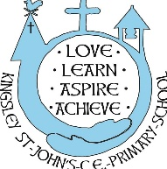
Annex C: Kingsley St John’s CE Primary School
Nursery places Chargeable extras
Description | Unit | Unit price | Total
Free entitlement hours – 15 or 30 hours per week  State funded offer  Term Time: 15 hours per week/30 hours per week in one continuous block  Monday to Friday 9.15am to 3.15pm | 15 hours  30 hours | Free | Free
Additional hours purchased  Full day 8.45am to 3.15pm – 6.5hours  2.5 hours extra per week | Daily  Hourly | £26  £4.00 | £26  £10.00
Meals/Snacks  Morning snack provided – included in care costs  Milk – state funded  A school lunch can be purchased at £3.15 per day. | N/A | N/A | N/A
Consumables  Nappies, sun cream etc – provided by parent | N/A | N/A | N/A
Additional voluntary services  Forest school  Trips | Monthly  Ad hoc | Free  Cost per visit | Free  Cost per visit

Childcare vouchers can be used to claim back costs and are accepted on our parent pay system – please contact the school office for more information about this.

