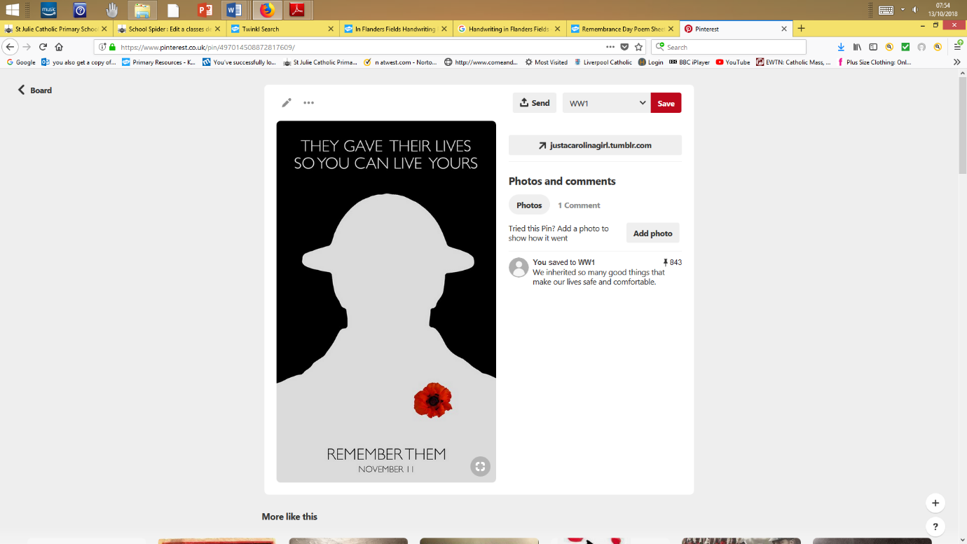
1914-1918
St Julie Remembers

