
St Julie’s Acts of Kindness Advent Calendar. “A caring family school, where we learn, grow and walk in the footsteps of Jesus.”

 | Monday | Tuesday | Wednesday | Thursday | Friday | Saturday | Sunday
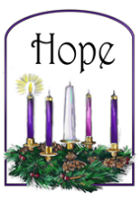 |  |  |  | 1st  Write a list of things that you Hope for in the world this Christmas. | 2nd  Greet people today saying that you hope they have a great day! | 3rd  Create a prayer of hope for just one thing you hope for in the world. | 4th  With an adult, research the work of Teardrops. Make a poster about how they give people Hope.
 | 5th  Smile at everyone you meet today to spread peace around you. | 6th  Offer to help a grown up either at home or in school today. | 7th  Have a day without digital devices. Have a peaceful day talking with your family. | 8th  Create peace in your house by tidying your room without being asked. | 9th  Wash the dishes at home so that you can let your family have some peace and quiet. | 10th  Do something to help planet Earth – picking up litter, recycling, switching off lights. | 11th  The dove is a symbol of peace. Create dove artwork to display in your home.
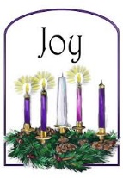 | 12th  Bring joy to everyone you meet today by giving them a compliment. | 13th  Leave a happy note for someone to find. | 14th  Leave some food outside to help look after the wildlife God has created. | 15th  Draw a Christmas picture for a friend in school to bring them joy. | 16th  Share a Christmas story with someone at home. | 17th  Research Christmas traditions in Spain to find out about the joy of celebrating Jesus in another country. | 18th  Make a Christmas card for someone you care about to bring them joy.
 | 19th  Draw a heart and write the names of all the people who give you love in your life. | 20th  Pray for someone less fortunate than you this Christmas to show them your love. | 21st  Write a thank you note to someone in your family to show them how much you love them. | 22nd  Get comfortable and watch a Christmas film with someone you love. | 23rd  With an adult, bake something festive. Spend time with the people you love. | 24th  It’s Christmas Eve! Be kind to yourself by doing something you love. | 