★ OUR SCHOOL NEWS ★  St Julie's Catholic Primary School | FRIDAY 18th September 2026  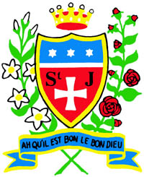
A caring family school where we learn, grow and walk in the footsteps of Jesus.
💬 HEADTEACHER'S MESSAGE
It has been another wonderful week at St Julie’s, and I have been incredibly proud of all our children. As I have visited classes across the school, it has been a pleasure to see the children working hard, striving to do their very best and demonstrating such positive attitudes to their learning. It was also lovely to hear the many complimentary remarks from our parishioners following our 60th Celebration Mass. They spoke warmly about the children’s exemplary behaviour and the respect they showed throughout the occasion. Our children are fantastic ambassadors for St Julie’s and continue to make us immensely proud. Thank you, as always, to our families for your continued support
WELCOME TO OUR NEW PARENT GOVERNOR  We are delighted to welcome Mr Mark Hobin as our newly elected Parent Governor, following the election held at the end of the summer term. We look forward to working together and thank Mark for volunteering his time, skills and commitment to support our children, families and wider school community. | 

⭐ CELEBRATING OUR CHILDREN ⭐
CLASS |  | ⭐ STAR OF  THE WEEK |  | 📚 READER OF  THE WEEK |  |  |  | 🔢 MATHEMATICIAN  OF THE WEEK |  | 🍎 LUNCHTIME  SUPERSTAR
EYFS |  | Charli |  | Max |  |  |  | Clara |  | Eliza
Year 1 |  | Felicity B |  | Violet |  |  |  | Albie |  | Cody
Year 2 |  | Felicity |  | Noah |  |  |  | Matilda |  | Charlotte
Year 3 |  | Evie |  | Faith |  |  |  | Grace |  | Isla
Year 4 |  | Daniel |  | Charlotte |  |  |  | Lilia |  | Isaac
Year 5 |  | Joel |  | Theo L |  |  |  | Ella |  | Eliza H
Year 6 |  | Harry |  | Sam |  |  |  | Nuala |  | Jaxon
✝ SUNDAY'S GOSPEL — GENEROSITY & GOD'S LOVE
💙 LIVING OUT OUR MISSION
Our buddies have been doing a wonderful job helping and supporting our early years children at playtime and lunchtime. They have shown kindness, patience and care, helping our younger children to feel happy, safe and included. This is a lovely example of our mission in action and what it means to be a caring family school, walking together in the footsteps of Jesus.
Sunday 20 September 2026  25th Sunday in Ordinary Time  Matthew 20:1–16  🌿 The Workers in the Vineyard  Visit The Wednesday Word on our RE page for Scripture reflections and family resources. |  |  |  |  |  | Jesus reminds us that God's generosity is for everyone. We are called to be thankful for what we have, celebrate the good things others receive and show generosity in the way we treat one another.  💙 How can I be generous with my time, kindness and friendship?
✝ PUPIL CATHOLIC LIFE SURVEY
Thank you to the children who completed our Catholic Life Survey. The results were overwhelmingly positive, with most children agreeing or strongly agreeing that Jesus is at the heart of our school and that they enjoy learning, praying and growing in faith together. Pupils particularly value learning about Jesus, attending church and living out our Gospel and school values. We will continue to create opportunities for children to help plan and lead Celebration of the Word

🌈 CELEBRATING LIFE AT ST JULIE'S
WHAT'S BEEN HAPPENING THIS WEEK?

🥣 THANK YOU — MARY'S MEALS
We are delighted to award St Julie Catholic Primary School the Gold Primary Geography Quality Mark. It is clear from the submission that geography has a high profile across the school and is supported by a strong vision, purposeful leadership and a commitment to enabling pupils to become active and engaged geographers.
Thank You, Mrs. Kernick, for all of your hard work.
A huge thank you to everyone who supported our Mary’s Meals Breakfast we raised a massive £164. Thank you for your kindness, support and generosity. A special thank you to our staff and Mini Vinnies for helping to make the event such a success.
.
Together we raised an amazing £164. Thank you for your wonderful
generosity and support.

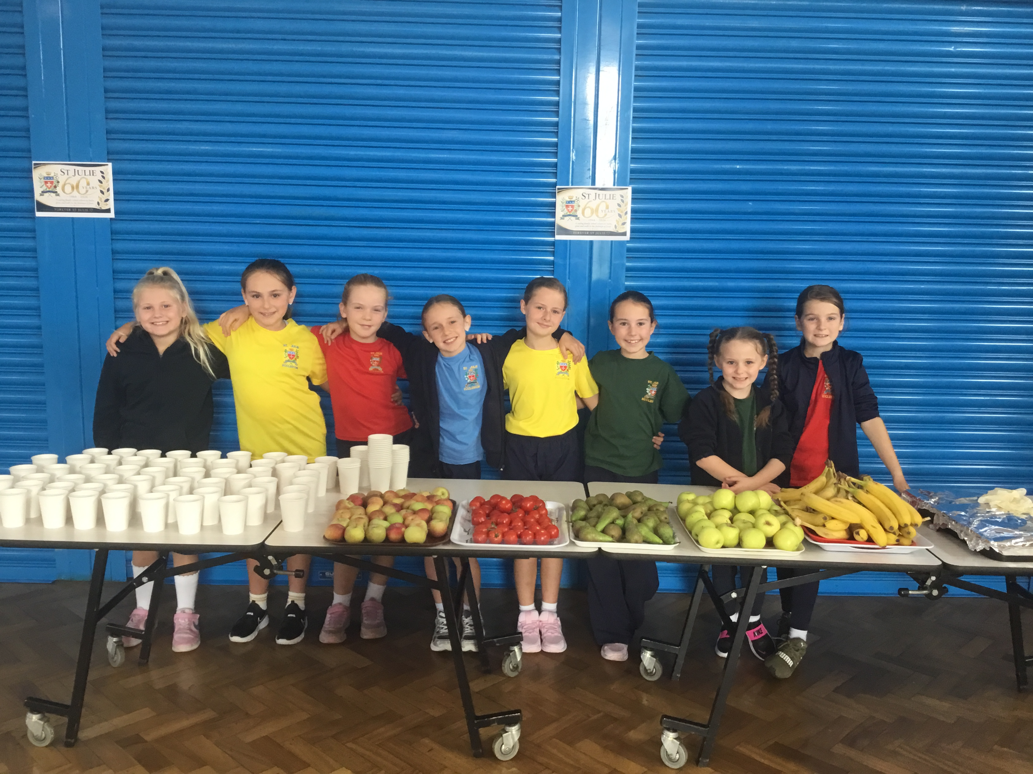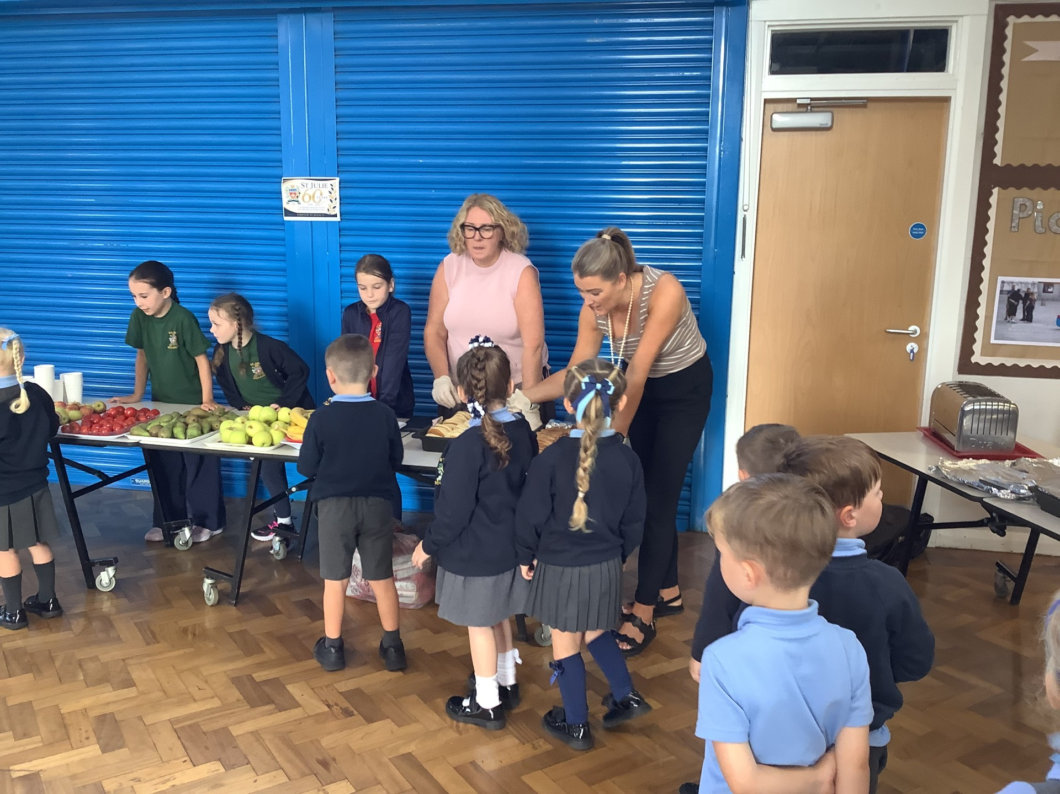
DATES, NEWS & REMINDERS
DATES FOR YOUR DIARY
DATE |  |  |  |  |  | EVENT
Tuesday 29th September |  |  |  |  |  | Whole School Flu Immunisations
Thursday 1st October |  |  |  |  |  | Year 6 Parish Mass — 9:30am in church
Wednesday 7th October |  |  |  |  |  | Headteacher Meet & Greet — 9:30am in the school hall
Wednesday 7th October |  |  |  |  |  | Parents' Evening – 3.40pm details to follow
🚶‍♀️ 🚲 🛴 WALK TO SCHOOL

We encourage families to walk, cycle or scoot to school whenever possible. It is a healthy way to start the day and helps reduce traffic around school.
Please help us show care and respect for our parish by treating the church grounds respectfully. Children using bikes and scooters should do so safely and considerately. Thank you for helping us look after our shared community spaces.
📱 FOLLOW OUR SCHOOL JOURNEY

Follow our journey on our official Facebook St-Julies Primary Eccleston and Instagram stjuliesprimary pages.
🏆 ATTENDANCE — EVERY DAY COUNTS
EYFS | Y1 |  | Y2 |  | Y3 |  | Y4 |  | Y5 |  | Y6
97.41 % | 98.33 % |  | 99.09 % |  | 79.31 % |  | 98.89 % |  | 90.29 % |  | 93.43 %
📌 KEEP UP TO DATE

Please see the Autumn Term Planner sent out to families and the calendar on our school website for additional dates and information.

💙 Together we learn • Together we grow • Together we walk in the footsteps of Jesus 💙

