St Julie Catholic Primary School - DT
DT – Spring Term | Year: 1 | Unit Title: Food: Garden Salad

Vocabulary
explore | Look carefully and investigate to understand
grate | Cut food into tiny pieces by rubbing on a grater
peel | Remove the skin from fruit and vegetables.
healthy | Being fit and well
ingredients | Parts of a recipe or mixture
claw grip | A common method used when cutting to protect fingers.
bridge hold | A common method especially used when cutting rounded foods.

What should I already know?
Children will have made fruit salads in Reception Class. They will be familiar with the names of some fruit and vegetables.
Prior Vocab:
design, evaluate.
Can I make a healthy garden salad for a lunchbox?
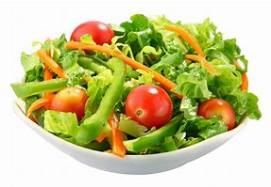



Jamie Oliver
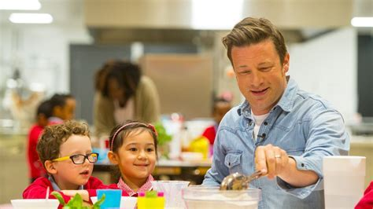
- British celebrity chef.
-known for his television shows, cook books and retaurants.
- Practised cooking in his parent’s restaurant when he was younger.
- Started his ‘school dinners’ campaign in 2005 to improve the quality of food fed to pupils in schools.
Common methods when cutting foods
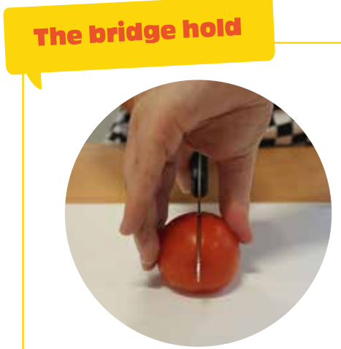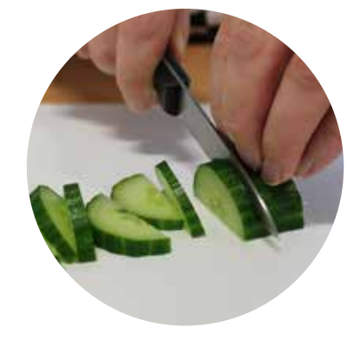
Claw grip Bridge hold

Curriculum links:
PSHE: Keeping healthy including what we eat and personal hygiene.
Science: Animals including humans; omnivores/ senses.
Skills recap:
-Designing for a purpose (Who is the product for?)
-Importance of personal hygiene and food handling
DT Skills:
- Design purposeful, functional, appealing products for themselves and other users based on design criteria.
- Select from and use a wide range of materials and components, including construction materials, textiles and ingredients, according to their characteristics.
- Explore and evaluate a range of existing products
- Evaluate their ideas and products against design criteria.

How do I create a garden salad?
1 -Can I think of healthy ingredients to use in my salad?
2 -Can I explore, taste and describe a variety of fruit and vegetables?
3 -Can I plan my garden salad?
4 -Can I make a garden salad?
5 -Can I evaluate the salad making process?

