St Julie Catholic Primary School - DT
DT – Autumn Term | Year: 1 | Unit Title: Free standing structures: Playground equipment

What should I already know?
-Experience of using construction kits to build walls, towers and frameworks.
-Experience of using of basic tools e.g. scissors or hole punches with construction materials e.g. plastic, card.
-Experience of different methods of joining card and paper.
Vocabulary
design | A plan for the construction of an object
construction | Something built or stuck together
textiles | A fibre that can be made into a cloth
structures | Something built or structured in a definite way
evaluate | To say what is good or needs improving with your design

Can I design and make playground equipment for a Lego person? 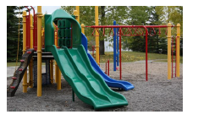



Curriculum links:
Mathematics – use appropriate standard and non-standard measures. Recognise and name common 2-D and 3-D shapes.
Science – think about the properties of materials that make them suitable or unsuitable for particular purposes.
Geography – use simple fieldwork and observational skills to study the geography of their school and its grounds and the key physical features of its surrounding environment.
How do I create a piece of playground equipment?
- Can children identify different pieces of playground equipment?
- Can children choose appropriate materials and explore different ways of combining them for a particular purpose?
- Can children draw labelled diagrams of their designs?
- Can children follow their designs to create their playground equipment?
- Can children join materials together appropriately to create sturdy structures?
- Do children know what evaluation is and why it is important?

Skills recap:
-Using construction kits to make towers and frameworks
-Use of scissors and hole punches
-Joining card using different methods
DT Skills:
-Generate ideas based on simple design criteria and their own experiences, explaining what they could make.
-Develop, model and communicate their ideas through talking, mock-ups and drawings.

Luca Boscardin
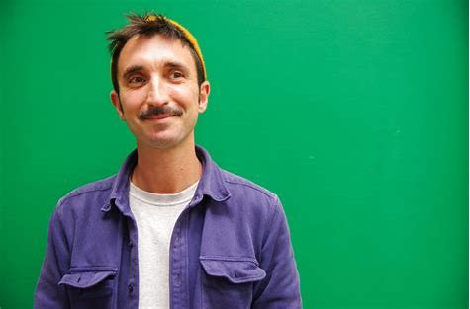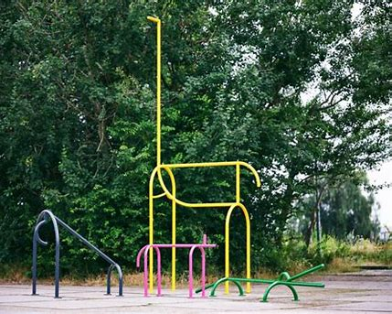
- Italian designer based in Amsterdam.
- Designed a modern play park in 2020 called animal factory.
- Uses simple structures to encourage imagination.
- Uses his imaginitive drawings and designs to create toys.
