St Julie Catholic Primary School - Art
ART – Summer Term | Year: 2 | Unit Title: Drawing - Seaside
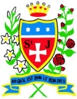
What should I already know?
-I can draw using my finger in sand.
-I can hold a pencil and make a mark.
-I can draw an enclosed shape with a pencil.
-I can make a representation of a subject using a pencil.
-I can make a variety of marks with a pencil.
-I can hold my pencil in different ways to make different marks.
-I can produce an observational drawing of a subject.

Prior Vocabulary - Pencil, tracing, rubbing, mark, straight, wavy, texture, drawing, artist, hatching, cross-hatching, stippling, blending, experiment.
Vocabulary
shape | An area defined by a line that starts and ends at the same point. Shapes are 2D.
Pattern | An arrangement of shapes, lines or colours that can be repeated or used again and again.
Shadow | A dark area on a bright surface. It is caused by something blocking a source of light
Observation | To look and record what you see
Composition | The way the parts of something, like a drawing, are put together or ordered.
Proportion | The relationship in size of two things or sets of things
Texture | How something feels or looks (visual texture).

Pablo Picasso Amiria Gale
Still Life Drawing
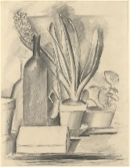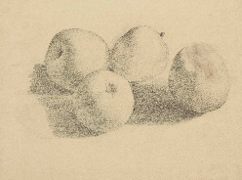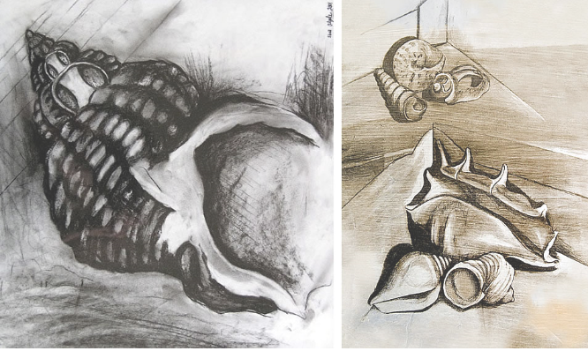

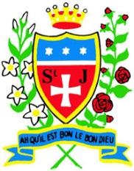

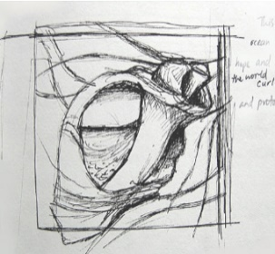
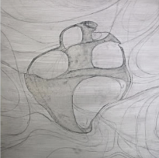
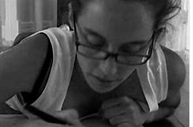
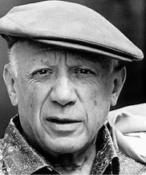
How do I create artwork like Picasso and Gale?
-Research artists
-Observations of the seaside
-Explore mark making
techniques using different
materials
-Drawing of different groups
of natural seaside materials
-Drawing of shells using new
techniques. (shadow,
proportion, texture)
Art Skills
- Can I make a variety of marks with pencil and pastels?
- Can I produce an accurate drawing from direct observation?
- Can I consider proportion in my drawing?
- Can I express texture in my drawings?

Knowledge

.

Pablo Picasso.
-Pablo Picasso was a Spanish artist.
-He was born in 1881 and died in 1973.
-Picasso is one of the greatest and most influential artists of the 20th century.
Curriculum links:
Science - Materials
Geography -Seaside
Amiria Gale

-Amiria Gale is an artist and teacher from New Zealand.
-Her shell paintings are inspired from growing up near to the beach.

