Colour
ART – Spring Term | Year: 2 | Unit Title: Colour – Green Spaces
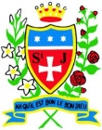
Vocabulary
Primary colour | The three basic colours of the spectrum from which all other colours can be made (red, yellow, and blue)
Secondary colour | A colour resulting from the mixing of two primary colours (orange, purple and green)
bright | Bright colors are colors that command attention due to their hue, brightness or both
warm | Warm colour is used to describe any colour that is vivid or bold. Warm colours include red, yellow and orange
dull | Not bright, not interesting or exciting.
tones | How light or dark something is.

Paul Klee
Colour – Green Spaces
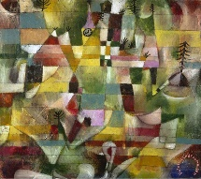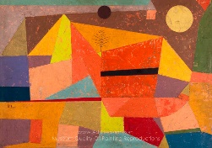

What should I already know?
- I can use my finger to apply paint to paper in different ways.
- I can select appropriate colours for different paintings.
- I can select colours.
- I can blend colours.
- I can recognise Primary colours and use them to mix secondary colours.
- I can make different marks on paper using paint.
Vocabulary - All primary colour names and secondary colour names, mix, blending, characteristics, hue.

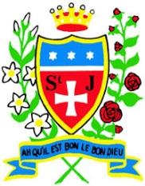

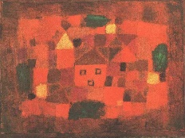
Paul Klee
Curriculum links:
Geography –Eccleston –Green Spaces
Art Skills
- Can I recognise different tones of one colour (tertiary)?
- Can I mix colours effectively using paint?
- Can I blend colours effectively? Paint, coloured pencil, pastels.
- Can I use appropriate colours to create a desired effect?

Knowledge
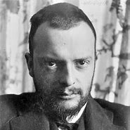

- Paul Klee was born in Switzerland.
- Paul Klee was an abstract artist influenced by other modern artists.
- Primary colours can be combined to make secondary colours.
red + blue = purple
blue + yellow = green
yellow + red = orange
- Tertiary colours = different tones of one colour.
How do I create artwork like Paul Klee
- Research primary, secondary and tertiary colours.
- Experiment with colour mixing and blending colours effectively.
- Investigate shapes in a photograph of Eccleston – create simplified version with 2D shapes.
- Collage with
textiles/paper
/tissue/foil/felt
- Plan final
composition

