St Julie Catholic Primary School - Art
ART – Autumn Term | Year: 2 | Unit Title:Printing – Natural Materials

Rachel Dein
Printing- Natural materials
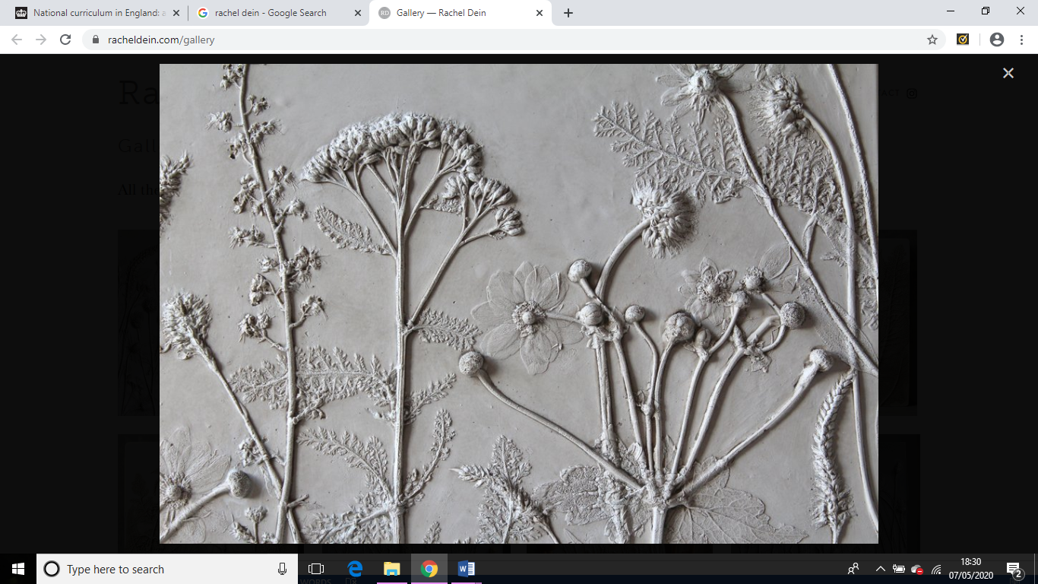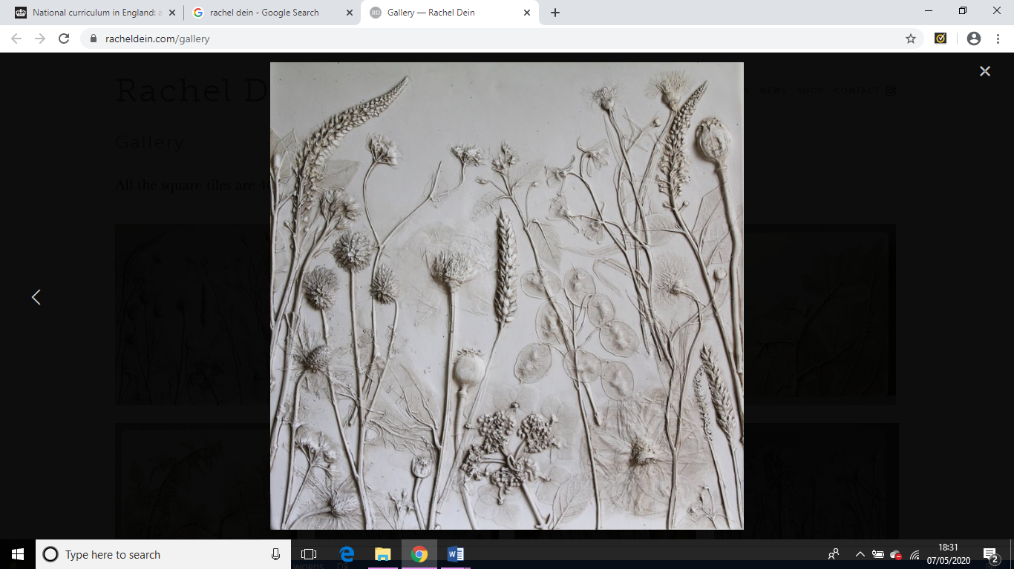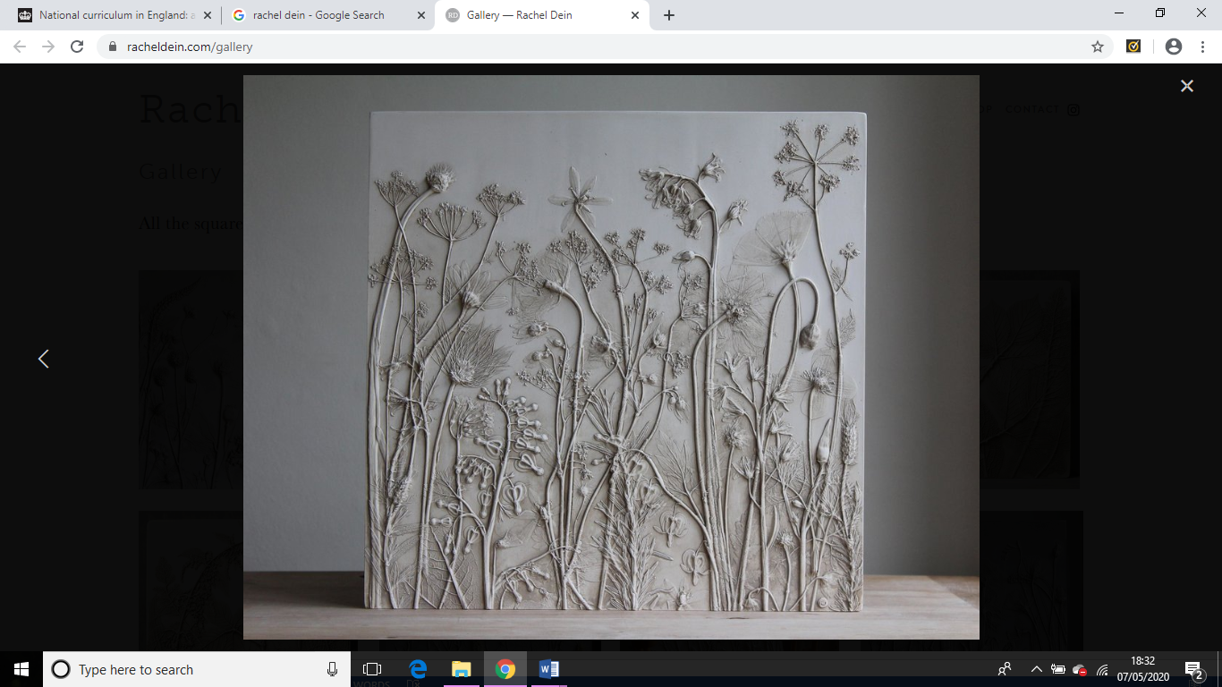

Vocabulary
clay | a natural earthy material that is used for making bricks, pottery, etc.
design | to plan and fashion the form and structure of an object, work of art, decorative scheme, etc.
imprint | a mark made by pressure; a mark or figure impressed or printed on something.
natural | Formed by nature
textured | the visual and especially tactile quality of a surface:
tools | an instrument that is usually held with the hands and helps one to do something.
pressure | A steady force upon a surface

What should I already know?
- I can use your hands to mould a material into different simple shapes.
- I can create a representation of a subject using mouldable material.

Vocabulary - Mould, shape, mark, line, press, nature, flower, plant, roll, squeeze, composition.

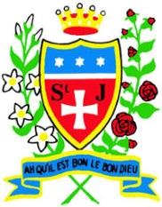

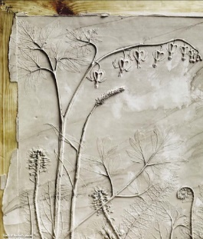
Curriculum links:
Science - Plants
Geography -Landscapes
Art Skills
- How to roll clay to create a square tile of equal thickness.
- How to create different textures using clay by making marks.
- How to create different textures by adding additional clay to a tile.

How do I create artwork like Rachel Dein?
- Exploring mark making and printing- natural objects.
- Explore texture on a clay tile.
- Exploring imprinting into clay using plants and flowers.
- Use natural materials to imprint
into my own tile
design.

Rachel Dein
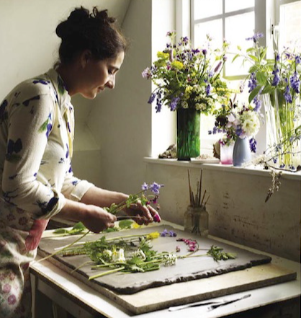

- Rachel Dein is a British artist living in London.
- Rachel Dein creates artwork using nature to imprint and then cast.
- Rachel Dein imprints into clay.
- Clay can be moulded to create different textures.
- Characteristics of clay and its limits as a material

