★ OUR SCHOOL NEWS ★  St Julie's Catholic Primary School | FRIDAY  11th SEPTEMBER  2026  
A caring family school where we learn, grow and walk in the footsteps of Jesus.
♥ OUR 60TH CELEBRATION ♥
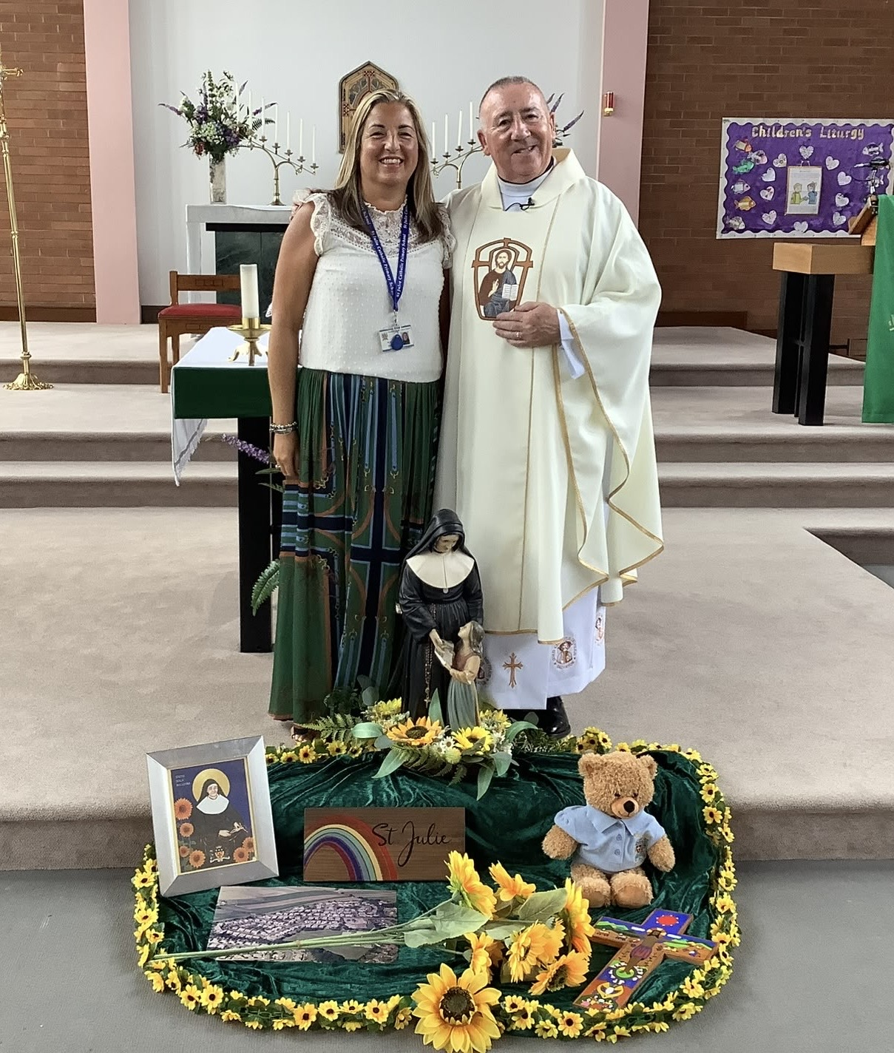 |  | 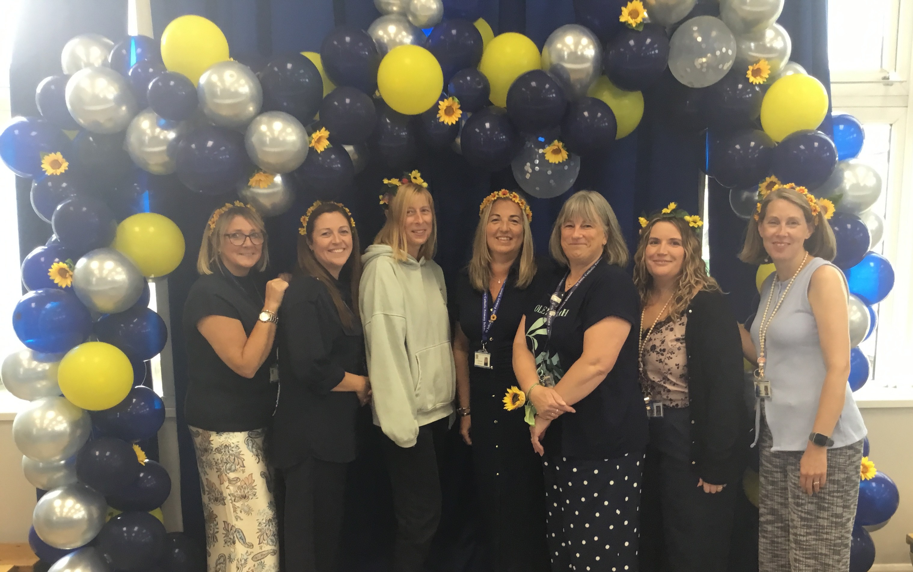  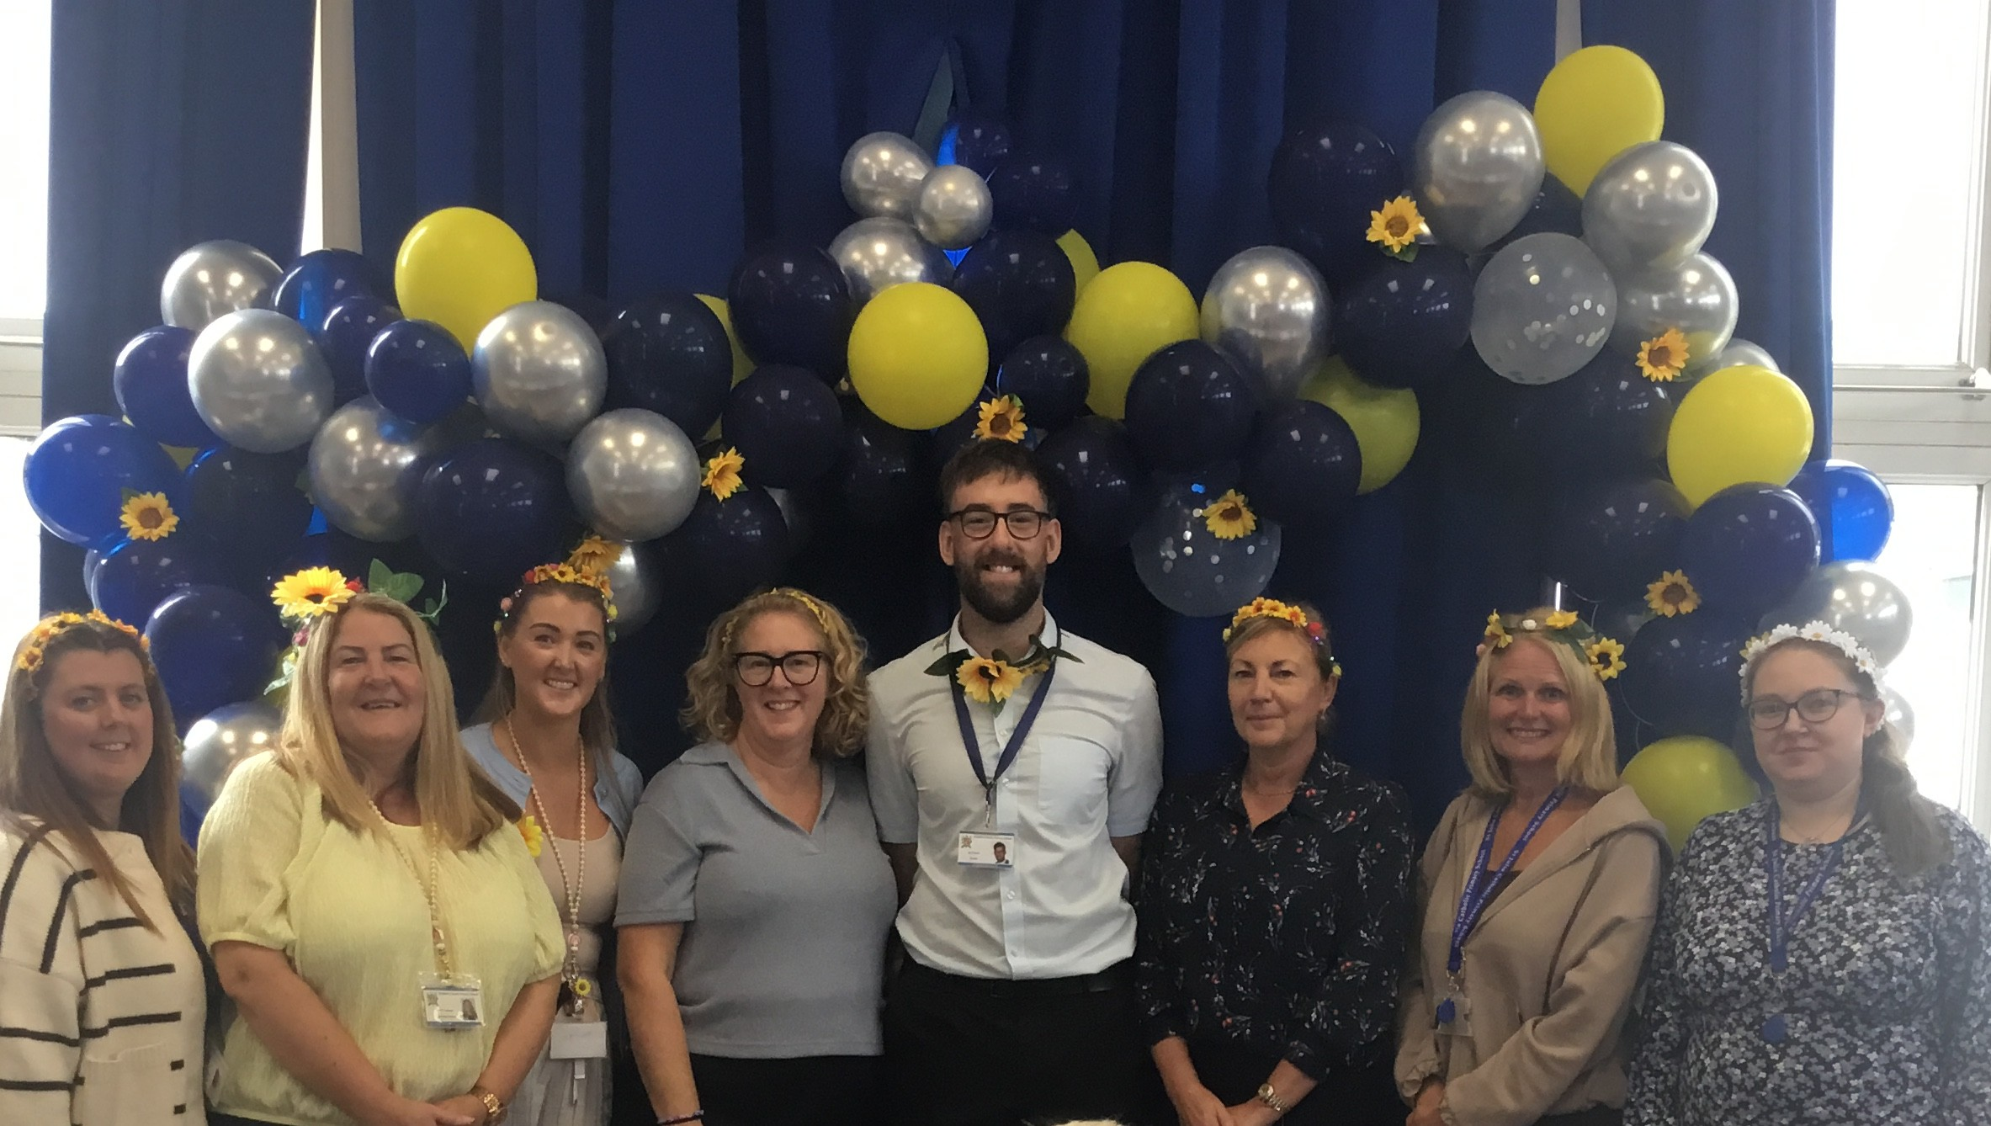 |  |  |  | 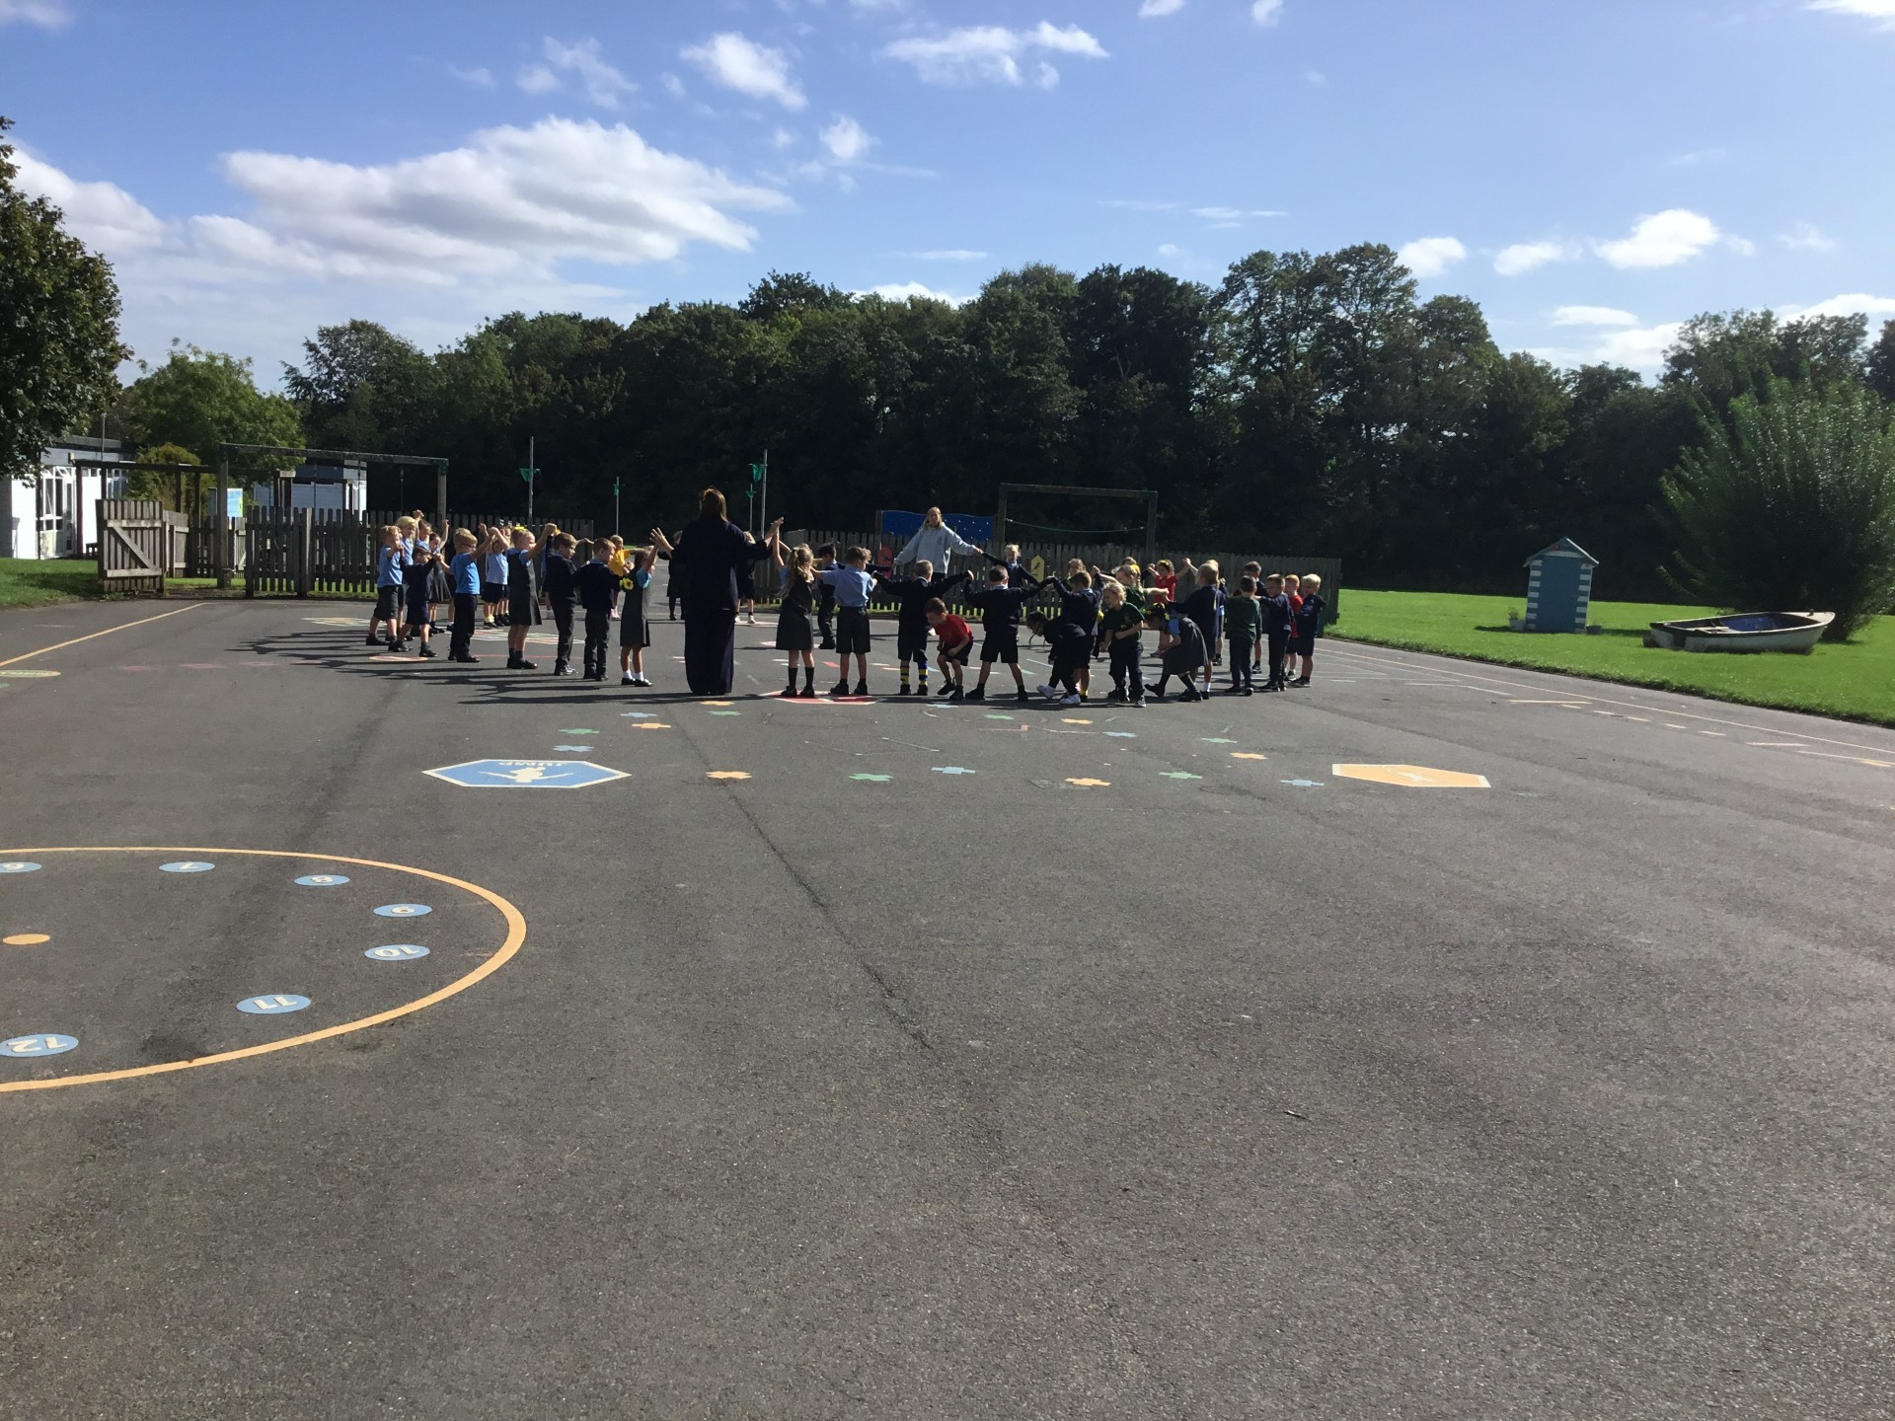
THANK YOU, ST JULIE FAMILY!
Thank you to everyone who made our 60th celebration so special. We shared a lovely Mass, children learned about the life of St Julie, had fun playing games and activities, and families enjoyed looking through old photographs and sharing memories.
A huge thank you to our P.F.A. for the amazing balloon arch, refreshments and fantastic support!
★ CELEBRATING OUR CHILDREN ★
CLASS | ⭐ STAR OF  THE WEEK |  | 📚 READER OF  THE WEEK |  | 🔢 MATHEMATICIAN  OF THE WEEK |  | 🍎 LUNCHTIME  SUPERSTAR
EYFS | All of EYFS |  |  |  |  |  | Henry
Year 1 | Felicity B |  | Luca G |  | Olive |  | Nihan
Year 2 | Charlotte |  | Felicity |  | Oliver |  | Jacob
Year 3 | Isabelle |  | Jack |  | Jessica |  | Toby
Year 4 | Reggie |  | Matthew |  | Poppy |  | Florence
Year 5 | Sienna |  | River |  | Gia |  | Callum
Year 6 | Sam |  | Zara |  | William |  | Olivia
SUNDAY'S GOSPEL  Sunday 13 September 2026  24th Sunday in Ordinary Time  Matthew 18:21-35  Visit The Wednesday Word on our RE page for Scripture reflections and family resources. |  |  |  | THIS WEEK'S GOSPEL MESSAGE  “I do not say to you seven times, but seventy times seven.”  Jesus teaches us that forgiveness is at the heart of following him. Just as God shows us love and mercy, we are called to forgive others.  This week we can ask:  ♥ Can I forgive someone? Can I make peace?  ♥ Can I show mercy and forgiveness, just as Jesus asks us to?

★ DATES, EVENTS & FAMILY TIME ★
🥣 MARY’S MEALS BREAKFAST  Tuesday 15 September  Following the success of our sponsored run, we are pleased to continue supporting Mary's Meals.  At break time, we will be holding a Mary's Meals Breakfast. Children are invited to bring £1 to purchase toast, pancakes or fruit.  All proceeds will support Mary's Meals in providing nutritious meals to children around the world.  Thank you for helping us support this important cause. 💙 |  |  |  | WELCOME TO OUR NEW FAMILIES & SUPPORT MACMILLAN  Friday 25 September  ⛪ Welcome Service  Join us in church at 2:00pm as we warmly welcome our new families to the St Julie's community. We look forward to celebrating together and welcoming you into the life of our school.  ☕🍰 Macmillan Coffee Afternoon  Following the service, please join us in the School Hall for tea, coffee and cakes as we raise money for Macmillan Cancer Support.  Everyone is warmly welcome. We hope you can join us for this special afternoon of community, friendship and fundraising.
🎭 M&M PRODUCTIONS
Friday 25 September
We are delighted to welcome M&M Productions to school for a special performance in the School Hall. We’re looking forward to an exciting morning of live theatre and plenty of fun! 🎭✨
★ CENTRE OF EXCELLENCE REPORT - SOMETHING TO CELEBRATE ★
We are delighted to share our latest Centre of Excellence Report.
“St Julie’s Catholic Primary School is a highly inclusive and caring learning community where relationships are at the heart of success. Its commitment to ensuring that every child feels valued, listened to and able to achieve is evident throughout the school.”
We are incredibly proud of this recognition, which reflects the dedication of our staff, pupils, families and governors.
The full report is available on our website under SEND & Inclusion. 💙
📚 SHARE A STORY SESSIONS
 Family Story Time  Parents and carers are warmly invited to come into school and share a story with their child.  All sessions will take place in the School Hall from 2:40pm.  Our aim is to encourage a love and enjoyment of reading — enjoying books, talking about stories and sharing special reading time together.  We look forward to welcoming you! 💛
  YEAR GROUP | DATE
  EYFS | Wed 30th Sept
  Year 1 | Thu 1st Oct
  Year 5 | Fri 2nd Oct
  Year 6 | Mon 5th Oct
  Year 3 | Tue 6th Oct
  Year 4 | Wed 7th Oct
  Year 2 | Thu 8th Oct
🏆 ATTENDANCE — EVERYDAY COUNTS
EYFS | Y1 | Y2 | Y3 |  | Y4 | Y5 | Y6
99.26 % | 98.75 % | 98.18 % | 97.24 % |  | 98.15 % | 98.82 % | 97.14 %
📅 Please see the Autumn Term Planner sent out to families and the calendar on our school website for additional dates.
♥ Together we learn • Together we grow • Together we walk in the footsteps of Jesus ♥

