Key vocabulary
roots | Anchor a plant in place. The roots also absorb water and nutrients from the soil.
stem/trunk | Transports water and nutrients around the plant. It also holds the leaves/flowers up in the air.
leaves | They use sunlight and water to produce the plant’s food.
photosynthesis | The way in which plants make food in their leaves.  air
pollen | This is a very fine powder that is produced by the male part of the flower.
pollination | When pollen is transferred to female parts of a flower. This can be done by wind or insects.  room
seed formation | Seeds can develop after pollination. They can be found in berries or fruits.
seed dispersal | Seeds can be dispersed in different ways, for example, wind, animals or water.
germination | When a seed sprouts a root and shoot.
Significant scientists
What should I already know?
Observe and describe how seeds and bulbs grow into mature plants.
Find out and describe how plants need water, light and a suitable temperature to grow and stay healthy.
Joseph Dalton Hooker  (1817-1911)  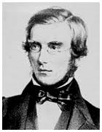 | Joseph Hooker was a doctor and travelled to many places. He was a plant collecter and botanist and brought many plants back to the UK. Joseph was interested in finding out why plants grow in the locations they do.

How a plant takes in water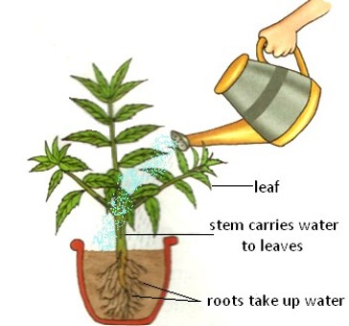
Plants need certain things to grow:

light
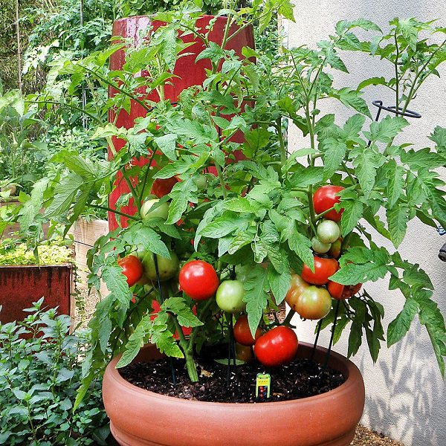
nutrients from the soil
water

Pollination
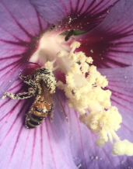 | Insects like bees and wasps transfer the pollen from the male part of a flower to the female part of other flowers.



Methods of seed dispersal

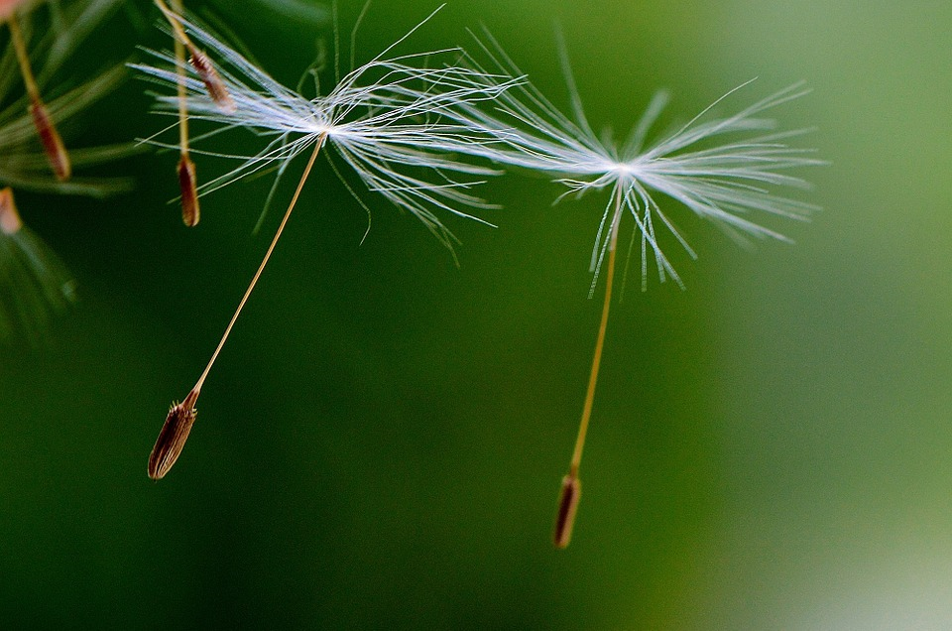 | 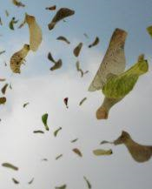  by wind
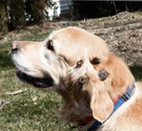
on animal’s fur
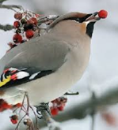 | in water  by animal’s eating them
 | 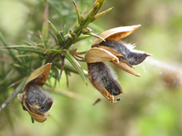  when the seed pod explodes

What will I learn during this topic?
Identify and describe the functions of different parts of flowering plants; roots, stem/trunk, leaves and flowers.
Investigate the way in which water is transported within plants.
Explore the part that flowers play in the life cycle of flowering plants including pollination; seed formation and seed dispersal.

