Soils
The property of soils is affected by the:
- type of rock
- size of rock pieces
- amount of organic matter in it.
Peat  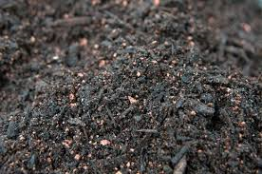 | - water-logged  - contains partially decomposed plant material  - soft and easily compressed
Sandy soil  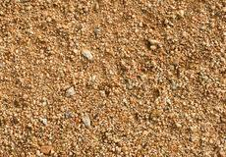 | - light and dry  - lots of air gaps so water drains through quickly
Chalky soil  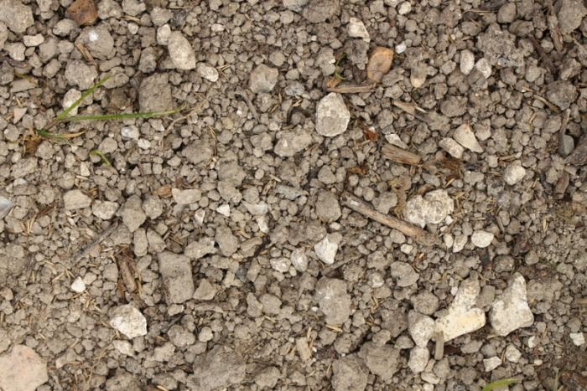 | - stony and water drains through quickly  Words to describe the appearance of rocks:  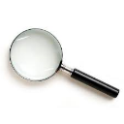  - found in areas with lots of chalk  hard or soft  grains  absorb water or not  texture  crystals  layers
Clay soil  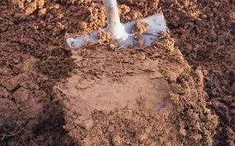 | - very sticky when wet  - a heavy soil  - water does not drain through it quickly
Significant scientists
Mary Anning  (1799-1847)  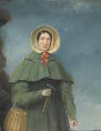 | Mary Anning was an English palaeontlogist and fossil collecter. She became known around the world for important finds she made in Jurassic fossil beds in Dorset.
Key vocabulary
rock | A naturally occurring material made of minerals. They can be different sizes:  - stones  - pebbles  - boulders
fossil | The bones or other remains of living things are sometimes preserved in rocks as fossils.
soil | Ground up rock mixed with plant and animal remains.
Fossil formation
Fossils were formed millions of years ago.
1 Plants and animals died and sank to the seabed. |  |  | Animal fossil  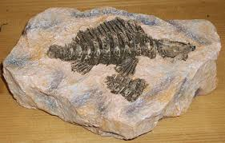  Plant fossil  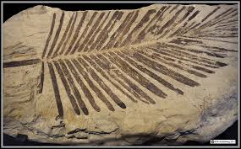
2 The soft parts decayed away leaving the hard parts.
3 The hard parts were covered and squashed by many layers of sand and other materials.
4 The animal/plant matter dissolves and is replaced by minerals, leaving a replica of the original bone called a fossil.
What will I learn during this topic?
I can compare and group together different kinds of rocks on the basis of their appearance and simple physical properties.
I can describe in simple terms how fossils are formed when things that have lived are trapped, within rock.
I can recognise that soils are made from rocks and organic matter.

Types of rocks
Sedimentary
 | sandstone  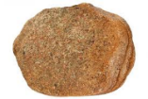 | limestone  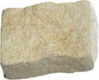
 | chalk  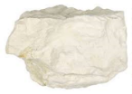 | Chalk is used for drawing because it is crumbly and soft.
 | Metamorphic
 | quartzite  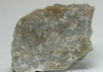 | slate  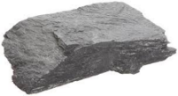
 | marble   | Marble is good for gravestones because it does not rub away.
 | Igneous
 | basalt  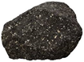 | pumice  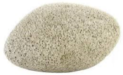
 | granite  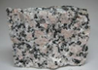 | Granite is good for worktops because it is hard and does not absorb water.

