St Julie Catholic Primary School - Art
ART – Summer Term | Year: 6 | Unit Title: Colour – National Parks
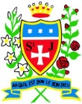
Vocabulary
Abstract | Does not represent reality in art but uses shapes colours & textures.
Vivid | Intense deepness or bright colour.
Harmonious | Colours that work together.
Saturation | Intensity - the dominance of hue in the colour.
Perspective | 3 or 2 dimensional.
Luminous | Brightly coloured.

What should I already know?
- I can show control of paint in my final
artwork including blending shades together.
- I can consider mood in relation to
colour. I can represent extreme heat
and extreme cold through colour.
- I can mix a variety of shades of the
same colour.
- I can use paint to express light/tone in
a subject to give a 3D impression.
Carolyn Brettell and David Hockney
Colour – National Parks
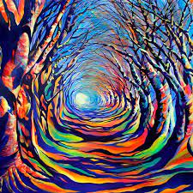

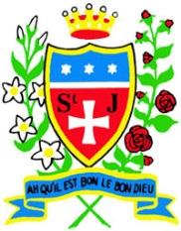

Skills recap:
- How to choose effective colours to create impact.
- How can I consider the layout and design of an art piece?
- How I can use scale/proportion to impact the viewer.
Art Skills
- Can I apply paint with care and consider colour choices to improve accuracy or dramatic effect in my representation?
- Can I create a detailed composition, considering the background and foreground?
How do I create colour landscape art?
- Research & practice the skills of the artists.
- Combine colour and control my use of medium.
- Use tone, shade and vary colours.
- Photograph & display your finished colour art.
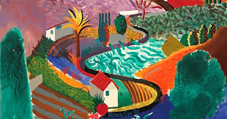
Carolyn Brettell and David Hockney
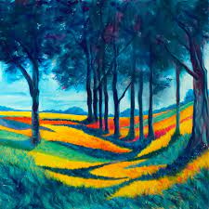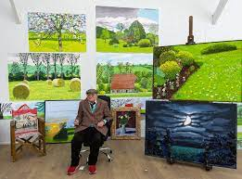
- Brettell is a British contemporary landscape artist.
- She was brought up in Africa and Greece, so the vibrant colours inspire her.
- Hockney is an English painter, draftsman, printmaker, stage designer, and photographer.
- He is important contributor to the pop art movement of the 1960s, he is considered one of the most influential British artists of the 20th century.
Curriculum links:
Geography - What is a National Park? Science - Light

