St Julie Catholic Primary School - Art
ART – Spring Term | Year: 6 | Unit Title: Drawing - Narratives
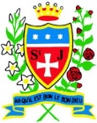
Vocabulary
Monochromatic | Containing or using only one colour.
Blending | Intermingling two or more colours to create a gradual transition or to soften lines.
Angular | Sharpest angle formed in drawing, two edges that meet.
Illustrative | Depiction made by an artist.
Graduated | Transitioning from one colour hue to another.

What should I already know?
- I can consider scale and proportion in my drawings.
- I can create an effective composition.
- I can understand perspective and express it in my drawing.
- I can consider light, tone and negative space in my drawing.
Pieter Bruegel the Elder
Drawing – Narratives
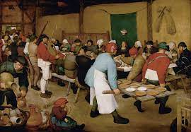

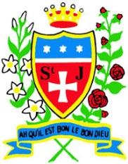

Skills recap:
- How to consider the layout and design of a narrative drawing.
- How to apply all skills learnt to drawings.
- How to select key themes from a story or play and interpret them into one artwork.
- How to convey narrative in a drawing
Art Skills
- Can I consider narrative in my drawings?
- Can I interpret written stimulus into visual imagery?
- Can I explore a theme or subject imaginatively?
- Can I create an effective composition?
Curriculum links:
History - Aspects of life from 1066. PSHE – Cultures, Work & Life.

How do I create a narrative drawing?
- Research & discuss the themes of the narratives of the artist.
- Select & explore the art of the narrative.
- Compose a narrative drawing using the skills studied.
- Refine and develop my narrative.
- Display and review my narrative.
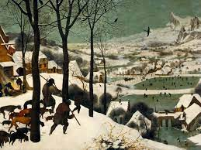
Pieter Bruegel the Elder
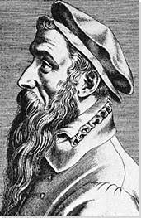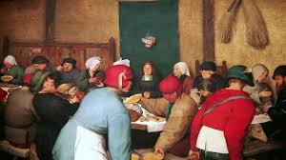
- The Peasant Wedding is a 1567 genre painting by the Dutch and Flemish Renaissance painter and printmaker Pieter Bruegel the Elder.
- He enjoyed painting peasants and different aspects of their lives in his paintings.
- Many of his paintings have a symbolic meaning as well as a moral aspect.
- His paintings show us about life at that time.
- His medium was oil on panels.

