St Julie Catholic Primary School - Art
ART – Autumn Term | Year: 6 | Unit Title: Water Collage
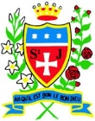
Vocabulary
Collage | Art created by combining photos, materials, clippings or small objects onto a surface.
Textured | Materials that are rough or uneven surface or consistency.
Layering | Materials on top of each other
Combine | Join or merge materials.
Perspective | 3 or 2 dimensional.

What should I already know?
- I can create a collage using drawings,
text and photographs.
- Vocabulary - Direct observation, accurate, proportion, scale, perspective, layering, combination, depth.
Katsushika Hokusai and Matthew Cusick
Water Collages
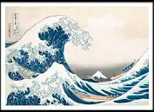

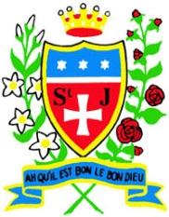

Skills recap:
- How to cut/tear materials accurately and the different effects achieved by each.
- Which materials work effectively together.
- How text impacts the viewer/adds
meaning and provides thinking.
Art Skills
- Can I cut and tear materials with accuracy?
- Can I combine different materials effectively in one artwork?
- Can I add text to my design?
- Can I create a representation of a subject using collage?
- Can I convey meaning through collage?
Curriculum links:
Geography - What is a river? DT - Materials.

How do I create a water collage?
- Research & collect materials that are effective for a water collage.
- Explore the techniques of the artist.
- Combine materials that represent water.
- Select materials that will provide meaning.
- Photograph & display your finished collage.
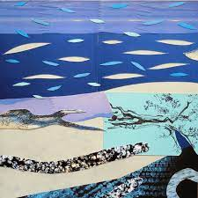
Katsushika Hokusai and Matthew Cusick.
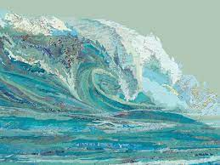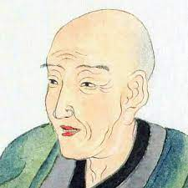
- Cusick is an American artist born 1970.
- He is a multi-media artist.
- He is best known for his map collages and intricate portraits of landscapes.
- Hokusai is a Japanese artist.
- His prints were formed by wood block printing techniques.
- His art contains views of Mount Fuji which includes the internationally iconic print The Great Wave off Kanagawa.

