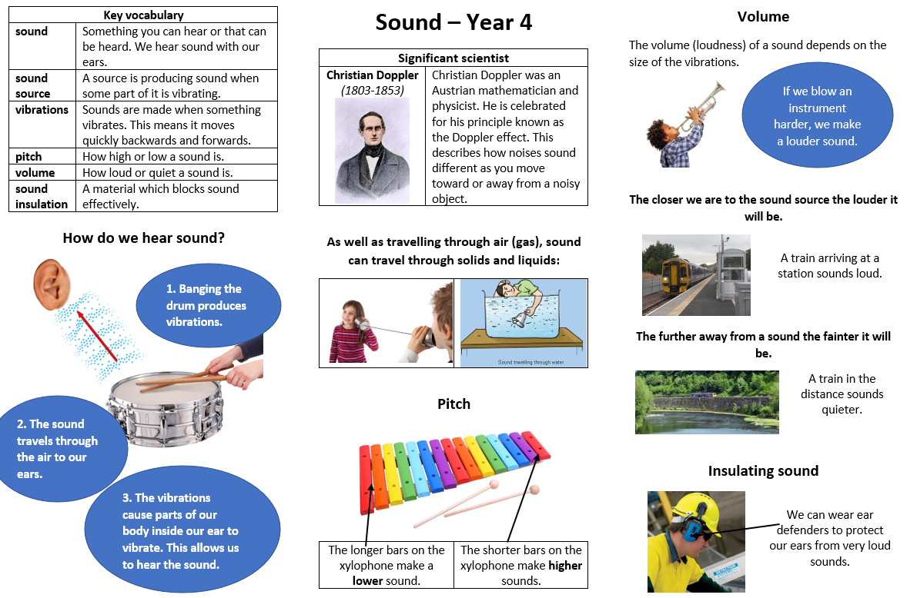
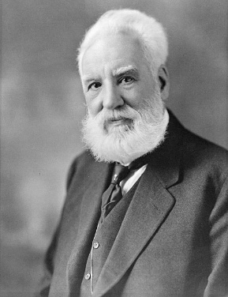

Scientific skills. I will: make observations, make predictions, plan for investigations, look for patterns, ask questions.
What I will learn in this topic:
• Know how sounds are made, associating them with vibrating.
- Know how sound travels from a source to our ears.
• Know what happens to a sound as it travels from its source to our ears.
• Know the link between:
- the volume of a sound and the strength of the vibrations that produced it.
- pitch and the object producing a sound.
Sticky knowledge:
- Know that sound travels from its source in all directions and we hear it when it travels to our ears.
- Know sound travel can be blocked.
- Know sound spreads out as it travels.
- Know changing the shape, size and material of an object will change the sound it produces.
- Know sound is produced when an object vibrates.
- Know sound moves through all materials by making them vibrate.
- Know changing the way an object vibrates changes it’s sound.
- Know bigger vibrations produce louder sounds and smaller vibrations produce quieter sounds.
- Know aster vibrations (higher frequencies) produce higher pitched sounds

- Born Edinburgh, Scotland
- Invented the first practical telephone
- He became interested in sound because his mother was losing her hearing.

Alexander Graham Bell
1847-1922
I already know
- that objects make different sounds.
- that I use ears to hear sounds.
- In music, different instruments make different sounds
- I can change the volume of a sound

