St Julie Catholic Primary School
History | Year: 2 | Strand: Significant events beyond living memory
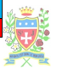
What should I already know?
- London is the capital city of England
- Queen Elizabeth II is the current Queen of England.

 | Key Vocabulary
The past | Any time before now.
Eye-witness | A person who see something and can describe it.
London | The capital city of England
River Thames | The River in London
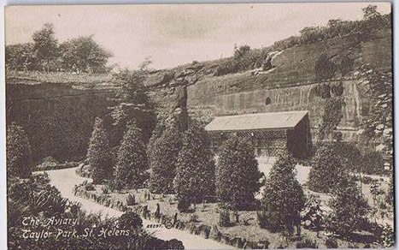  bakery | A place that makes bread and cakes.
diary | A book that people write about their lives.
St Paul’s Cathedral | A very large church in London that was destroyed in the fire. A new St Paul’s was built after the fire.
Firebreak | A gap that stops a fire spreading to nearby buildings.
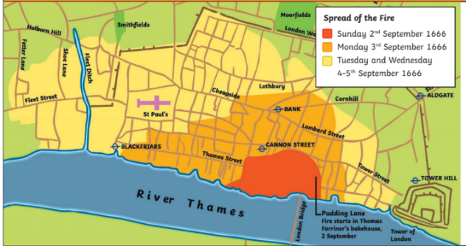
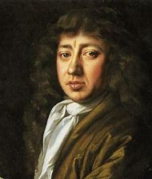

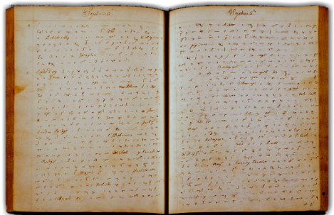
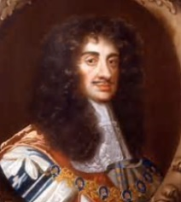

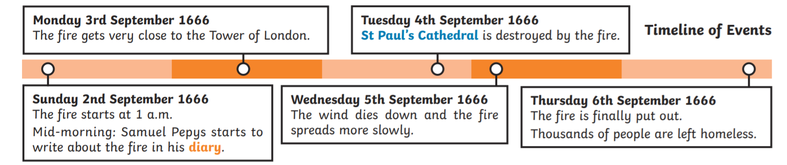
Why did the Great Fire of London spread so quickly?
Sticky Knowledge
- Fire starts on Sunday 2nd September 1666 in Thomas Farriner’s Bakery on Pudding Lane.
- In 1666, buildings were made of wood and straw, and were very close together, making it
easy for flames to spread.
- It had been a hot, dry summer so the buildings were dry.
- Strong winds were blowing, which helped the flames to spread.
- People used leather buckets and water squirts to put the fire out, but these did not work.
- Later in the week, King Charlies II ordered buildings to be pulled down to create a firebreak.
By Thursday 6th September, the wind had died down so people were able to put out the flames.

diary
History Skills
I can identify the reasons why the fire spread so quickly.
I can sequence the events of the fire on a timeline.

