St Julie Catholic Primary School - Art
ART – Autumn Term  What should I already know?  - I can recognise Primary colours and use them to mix Secondary and Tertiary colours.  - I can use different painting techniques in my artwork.  - I can use coloured pencil and/or paint in my artwork with control.  - I can blend colours effectively.  - I can carefully select colours to use  - I can use vibrant colours to create an abstract artwork | Year: 5 | Unit Title: Colour/drawing Colour- Earth and Space
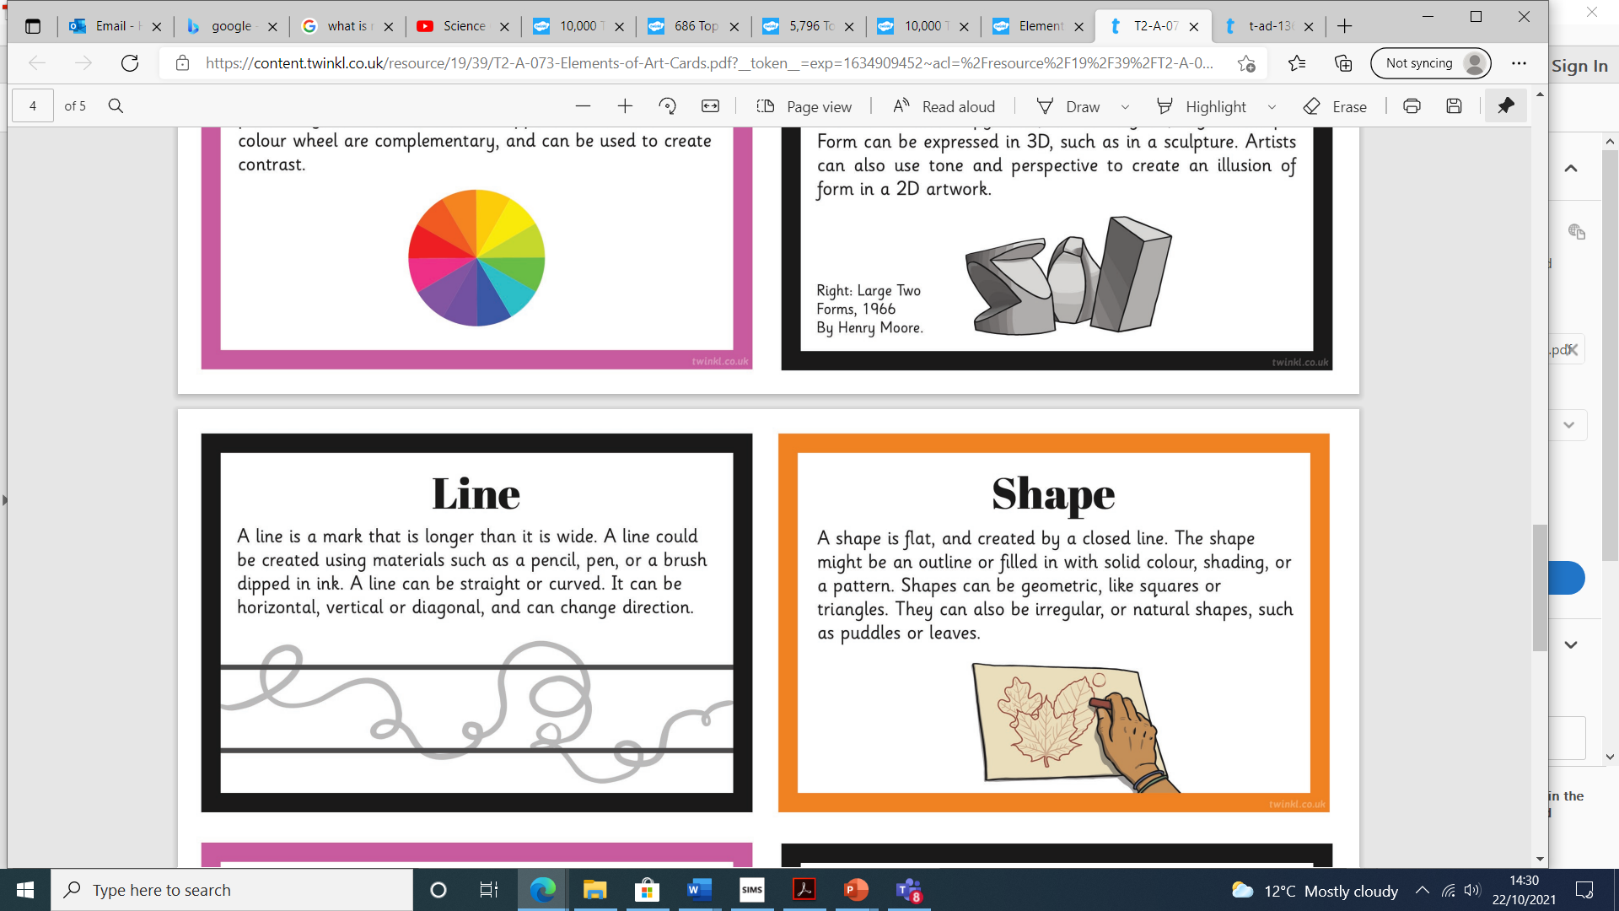
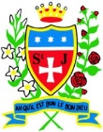
Vocabulary
Van Gogh

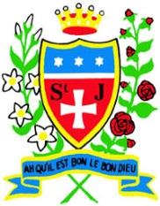
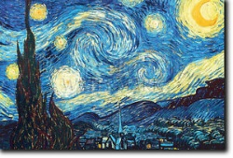
Mark Rothko
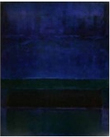

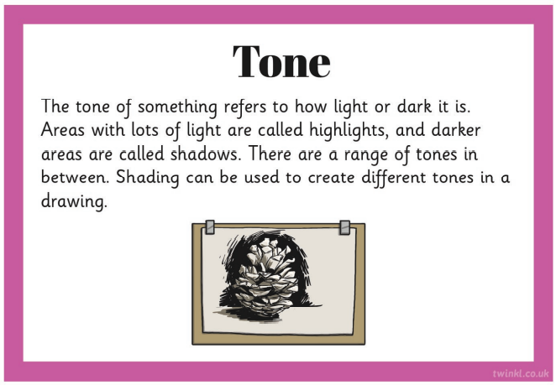
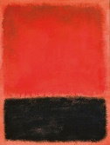
Van Gogh 1853-1890
- Dutch artist.
- He painted portraits and landscapes.
- He used watercolours and oil paints.
- Famous for using bright colours and bold brushstrokes.
- Painting style: Post-Impressionism.

Mark Rothko 1903-1970
- Born in Russia in 1903
- Moved to America when he was 10.
- Used colour to show his feelings
- Painted in simple blocks and lines on very big canvases.
- This kind of painting was called ‘Colour Field’.

This art work links with my work in Science – Earth and Space
How do I create paintings like Van Gog
and Mark Rothko ?
I can:
- research pages- Van Gogh and Mark Rothko. Background, pieces and comparison.
- Explore colour mixing inc colour wheel- warm/cold.
- Experiment with different ways of applying the paint to the paper- cardboard, rollers, thicker/thinner and paper texture.
- Make observational drawings/paintings of spheres, concentrating on light and tone.
- Research planet and space - sketches- pastels/chalks.

