Living with worry and anxiety amidst global uncertainty
What is worry?
Human beings have the amazing ability to think about future events. 'Thinking ahead’ means that we can anticipate obstacles or problems, and gives us the opportunity to plan solutions. When it helps us to achieve our goals, ‘thinking ahead’ can be helpful. For example, hand washing and social distancing are helpful things that we can decide to do in order to prevent the spread of the virus. However, worrying is a way of 'thinking ahead' that often leaves us feeling anxious or apprehensive. When we worry excessively, we often think about worst case scenarios and feel that we won't be able to cope.
What does worry feel like?
When we worry it can feel like a chain of thoughts and images, which can progress in increasingly catastrophic and unlikely directions. Some people experience worry as uncontrollable – it seems to take on a life of its own. It is natural that many of us may have recently noticed ourselves thinking about worst-case scenarios. The example below illustrates how worries can escalate quickly even from something relatively minor. Have you noticed any thoughts like this? (confession: we both have!)
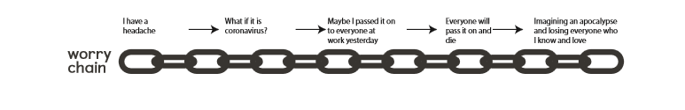
Worry isn’t just in our heads. When it becomes excessive we feel it as anxiety in our bodies too. Physical symptoms of worry and anxiety include:
• Muscle tension or aches and pains.
• Restlessness and an inability to relax.
• Difficulty concentrating.
• Difficulty sleeping.
• Feeling easily fatigued.
What triggers worry and anxiety?
Anything can be a trigger for worry. Even when things go right, you might manage to think to yourself "but what if it all falls apart?". There are particular situations where worry becomes even more common, though. Strong triggers for worry are situations that are:
• Ambiguous – open to different interpretations.
• Novel and new – so we don’t have any experience to fall back on.
• Unpredictable – unclear how things will turn out. Does any of this sound familiar at the moment?
The current worldwide health situation ticks all of these boxes, and so it makes sense that people are experiencing a lot of worry. It is an unusual situation with much uncertainty, which can naturally lead us to worry and feel anxious.
Are there different types of worry?
Worry can be helpful or unhelpful, and psychologists often distinguish between worries concerning ‘real problems’ vs. ‘hypothetical problems’.
• Real problem worries are about actual problems that need solutions right now. For example, given the very real concern about the virus at the moment, there are helpful solutions which include regular handwashing, social distancing, and physical isolation if you have symptoms.
• Hypothetical worries about the current health crisis might include thinking about worst-case scenarios (what we might call catastrophising). For example, imagining worst case scenarios such as most people dying.
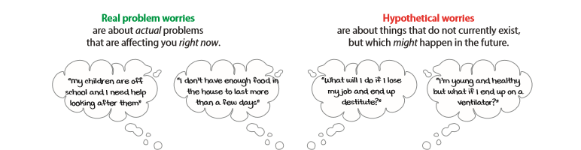
When does worry become a problem?
Everyone worries to some degree, and some thinking ahead can help us to plan and cope. There is no 'right' amount of worry. We say that worry becomes a problem when it stops you from living the life you want to live, or if it leaves you feeling demoralised and exhausted.
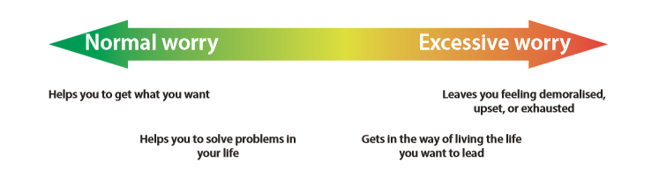
What can I do about worry?
It is natural for you to worry at the moment, but if you feel that it's becoming excessive and taking over your life – for example if it's making you anxious, or if you're struggling to sleep – then it might be worth trying to find ways to limit the time you spend worrying, and taking steps to manage your well-being. In the next section of this guide, we have included a selection of our favourite information handouts, exercises, and worksheets for maintaining well-being and managing worry. These can help you to:
• Maintain balance in your life. Psychologists think that well-being comes from living a life with a balance of activities that give you feelings of pleasure, achievement, and closeness. Our information handout Look After Your Wellbeing By Finding Balance discusses this in more detail. The Activity Menu on the following page contains suggestions of activities to help you to distract yourself and stay active. Remember that we're social animals – we need connections to thrive and flourish. We would recommend trying to do at least some activities that are social and involve other people. In times like these you might have to find some creative ways to do social things at a distance. For example, by keeping in touch online or by phone.
• Practise identifying whether your worry is 'real problem' worry, or 'hypothetical worry'. The Worry Decision Tree is a useful tool for helping you to decide what type your worry is. If you're experiencing lots of hypothetical worry, then it's important to remind yourself that your mind is not focusing on a problem that you can solve right now, and then to find ways to let the worry go and focus on something else. You might also use this tool with children if they are struggling to cope.
• Practise postponing your worry. Worry is insistent – it can make you feel as though you have to engage with it right now. But you can experiment with postponing hypothetical worry, and many people find that this allows them to have a different relationship with their worries. In practice, this means deliberately setting aside time each day to let yourself worry (e.g. 30 minutes at the end of each day). It can feel like an odd thing to do at first! It also means that for the other 23.5 hours in the day you try to let go of the worry until you get to your 'worry time'. Our Worry Postponement exercise will guide you through the steps you need to give it a try.
• Speak to yourself with compassion. Worry can come from a place of concern - we worry about others when we care for them. A traditional cognitive behavioural therapy technique for working with negative, anxious, or upsetting thoughts is to write them down and find a different way of responding to them. Using the Challenging Your Thoughts With Compassion worksheet you can practise responding to your anxious or worrying thoughts with kindness and compassion. We have provided a worked example to get you started.
• Practice mindfulness. Learning and practicing mindfulness can help us to let go of worries and bring ourselves back to the present moment. For example focusing on the gentle movement of your breath or the sounds you hear around you, can serve as helpful 'anchors' to come back to the present moment and let go of worries.

