St Julie Catholic Primary School - Computing
Computing – Summer Term 2 | Year: 6 | Unit Title: Programming – sensing movement.

What should I already know?
- How to identify variables.
- How variables hold a place value.
- How to improve a game using variables.
Sticky Knowledge
I know to design a project that uses inputs and outputs on a controllable device.
I know how to use a conditional statement to compare a variable to a value.

Sensing Movement

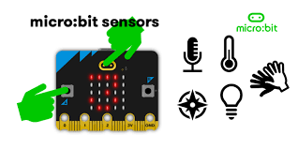



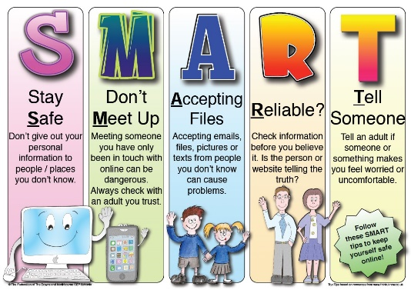
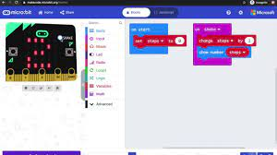
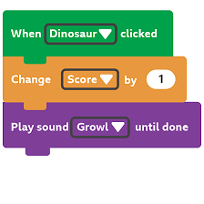
Vocabulary
Micro-bit | A pocket-sized computer that introduces you to how software and hardware work together.
Step Counter | It counts how many times the micro-bit has been shaken. It stores this number in a variable called 'steps'.

What I will Learn.
1 What is the micro-bit?
2 How to Go with the flow?
3 How to sense inputs?
4 Howe to find your way?
5 How to design a step counter.
6 How to make a step counter?

