St Julie Catholic Primary School - Computing
Computing – Summer Term 1 | Year: 6 | Unit Title: Creating Media – 3D Modelling.

Sticky Knowledge
I know how to recognise that you can work in three dimensions on a computer.
I know how to identify that digital 3D objects can be modified.
I know how to create a 3D model for a given purpose.

What should I already know?
- That I can make a video.
- That I can manipulate graphics.
- That I can storyboard and sequence scenes.
- That I can understand vector graphics.
3D Modelling
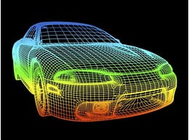


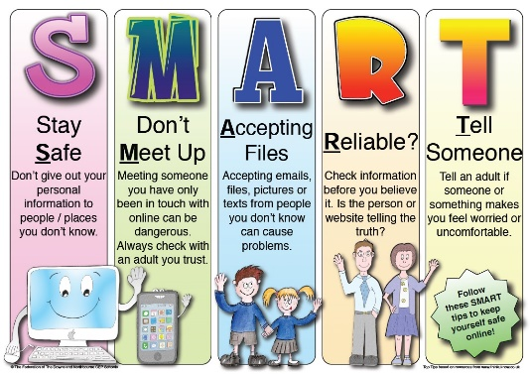
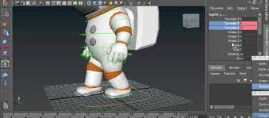
Vocabulary
3D | Three dimensional.
3D Modelling | The process of creating a 3D representation of any surface or object.
Dimension | A measurable extent of a particular kind, such as length, breadth, depth, or height.
Manipulating | Changing the size, angle, lift or lower.

What I will Learn.
1 What is 3D modelling?
2 How do you modify 3D objects?
3 How can I make a name badge?
4 How to make a desk tidy?
5 How to plan a 3D model?
6 How to make our own 3D model?

