St Julie Catholic Primary School - Computing
Computing – Spring Term 2 | Year: 6 | Unit Title: Data & Information – Spreadsheets.

What should I already know?
- That I can use a form to record information.
- That I can compare paper and computer-based databases.
- That I can navigate a flat-file database to compare different views of information.
Sticky Knowledge
I know how to create a data set in a spreadsheet.
I know how to explain that formulas can be used to produce calculated data.
I know how to apply formulas to data.

Spreedsheets
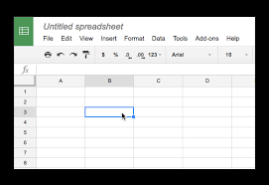


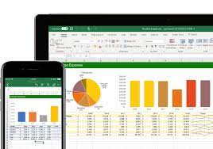
Vocabulary
Spreadsheet | A computer program that can capture, display and manipulate data arranged in rows and columns.
Collect | A process of gathering, measuring, and analysing accurate data.
Formula | an expression telling the computer what mathematical operation to perform upon a specific value.

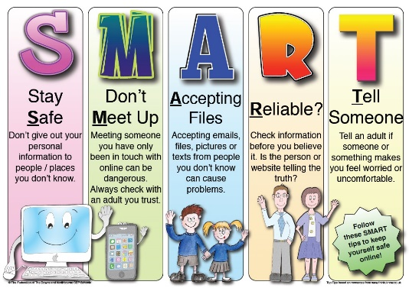
What I will Learn.
1 What is a spreadsheet?
2 How to modify spreadsheets.
3 What's the formula?
4 How to calculate and duplicate.
5 How to event plan.
6 How to present data.

