St Julie Catholic Primary School - Computing
Computing – Spring Term 1 | Year: 6 | Unit Title: Programming – variables in games.

What should I already know?
- That I can combine output components. important.
- That I can control conditions.
- That I can draw designs.
- That I can write and test algorithms.
Sticky Knowledge
I know how to identify variables.
I know how variables hold a place value.
I know how to improve a game using variables.

Variables in games



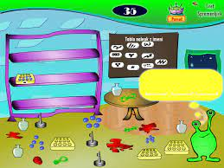

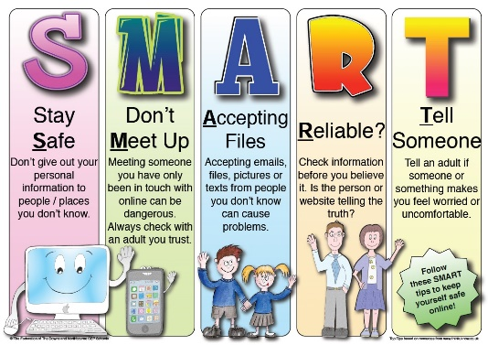
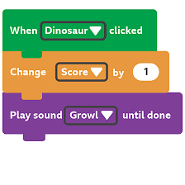
What I will Learn.
1 What are variables?
2 What are variables in programming?
3 How to improve a game?
4 How to design a game?
5 How to design to code?
6 How to improve and share?
Vocabulary
Variable | is a value that can change.
Value | A data type or known quantity.
Outcome | The results of an activity.
Simulation | Mathematic modelling.

