St Julie Catholic Primary School - Computing
Computing – Autumn Term 2 | Year: 6 | Unit Title: Creating Media – Web Page Creation.

Sticky Knowledge
I know the common features of a web page.
I know what is meant by the term ‘fair use’.
I know how to make multiple web pages and link them using hyperlinks.
I know how to create hyperlinks to link to other people's work.

What should I already know?
- What makes a video effective?
- That a digital device can record video.
- That you can create a story board.
- That video can be improved through reshooting and editing.
Web Page Creation



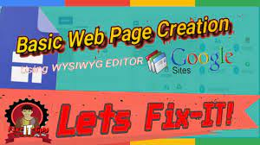
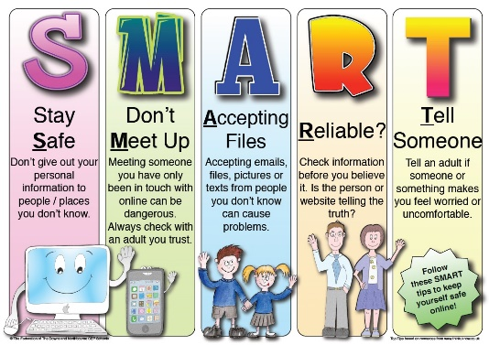
What I will Learn.
1 What makes a good website?
2 How would you lay out your web page?
3 Copyright or copyWRONG?
4 How does it look?
5 Follow the breadcrumbs.
6 Think before you link!
Vocabulary
Copyright | The legal protection for software.
Breadcrumbs | A type of secondary navigation scheme that reveals the user's location in a website or Web application.
Links/Hyperlinks | An item like a word or button that points to another location to navigate a webpage.

