St Julie Catholic Primary School - Computing
Computing – Autumn Term 1 | Year: 6 | Unit Title: Computer systems & networks – Communication & Collaboration.

Sticky Knowledge
I know how computers use addresses to access websites.
I know that all data transferred over the internet is in packets.
I know that the internet allows different media to be shared.
I know that there are a variety of ways to communicate over the internet.

What should I already know?
- That computers can be connected to form systems.
- That tasks are managed by computer systems.
- How to web search to find specific information
- That a search engine follows rules to rank results.
Communication & Collaboration



What I will Learn.
1 What are internet addresses?
2 What are data packets?
3 How to work together.
4 What is shared working?
5 How we communicate.
6 How to communicate responsibly?

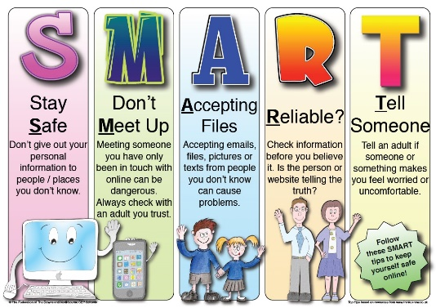
Vocabulary
Data Packets | A small segment of a larger message sent over computer networks.
Collaboration | Technology tools that facilitate and enhance group work that exists through distributed technology.
Website addresses | Contains information about the location of the webpage (called a URL.)

